**DD RPA**

**USER GUIDE**

**Table Of Content**

**Workspace 1**

Run and open Workspace 1

Create new project 1

Create workflow 2

Actions 3

Web 3

Browser Back 3

Browser Forward 4

Click By XPath 4

Click Web Element 5

Double Click Web Element 6

Download To 7

Email 7

Read web Element 8

Read Xpath 9

Refresh Web Page 9

Save Table 10

Set Web Wait Timeout 11

Type On Element 11

Type Web Element 12

Upload To 13

Web 13

Web API 14

Mouse & Keyboard 15

Bring Focus (Not included in this version) 15

Click UI 16

Click UI By Image 17

Close Application 18

Hover UI 18

Hover UI By Image 19

Keyboard 20

Keyboard Input 20

Keyboard Type Input 21

OCR - Click 22

Open Application 23

Open File 23

Save File 24

Set Focus 25

Windows Run 26

Excel Interop 26

Close Work Sheet 26

Copy Data 27

Copy Excel 28

Copy Excel Path 29

Delete Excel Data 30

Open Excel 31

Read Excel 31

Read Excel Rows 32

Write Excel 33

Excel 34

Add Column 34

Add New Sheet 35

Add Row 36

Cell Format 37

Clear Sheet 38

Color Cell 39

Delete Column 40

Delete Row 41

Delete Sheet 42

Import Data By Column 43

Insert Formula 44

Merge Cell 45

Remove Duplicates 46

Rename Sheet 47

Write To Cell 48

File/Saving 49

Copy Move File 49

Delete File 50

Move Rename File 50

Read File 51

Read FIle To 52

Rename FIle 53

Write FIle 54

Write To File 55

Helper Function 56

Close Window 56

Copy Text 56

Paste Text 57

Run CMD 57

Run JS 58

Run Python 59

Run R 60

Run Sikuli 61

Set Clipboard 61

Miscellaneous 62

API Basic 62

Custom Script 63

For Loop 63

Loop 64

OCR - Read From Image 65

OCR - Read Screen By Region 66

Outlook - Compose Email 67

Read Text File 68

Set Value 69

Snap 70

Split Text 70

Substring 71

Tesseract OCR 72

Timestamp 73

Vault - Get Secret 74

Wait 75

Whatsapp DD (Not included in this version) 75

PDF 76

Print PDF - Excel 76

Print PDF - Word 77

Read PDF 78

Run Options 78

Showing Outputs 79

Echo 79

Echo Text 80

Using Variable 80

Word 81

Create Word Doc 81

Insert Text 81

Open Word 82

Read Text From Word 83

Replace String 83

Save Document 84

Save & Close 85

Conditions 86

Ifelse 86

Database 87

Select From Database 87

Terminal 88

Capture Screen 88

Connect 89

Disconnect 90

Login 90

Send Key 91

Send Text 92

Terminal PUB400 92

Collections 93

Create List 93

Loop From To 94

Loop Sub - Click On Element 95

Loop Sub - Type On Element 96

**Central 97**

Login Page 97

Home Page 98

Dashboard Page 99

Agents Page 100

User Management > Users 102

User Management > Roles 105

User Management > Access Group 106

Setup > Public Holiday 107

Setup > Mailing List 108

Show Details 109

Secret Vault 110

Reporting page 111

My License page 112

**Bot 113**

Additional Functions 113

# **Workspace**

## **Run and open Workspace**

1. Go to the folder “vlatest” with the file path “C:\DDRPA\Workspace\vlatest”.
2. Double click on the “RPADesigner.exe” to run it.
3. A command prompt will appear, minimize it.
4. Go to the Workspace website ( <http://localhost:5000/fetch-project> ).

## **Create new project**

1. Click on the “Create New Project” button located on the top left side of the website.

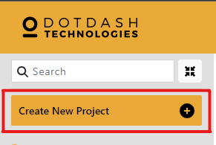

*Image 1 Create New Project button*

1. A new project will be created under the “Create New Project” button. Enter a name into the text field and press “enter”..

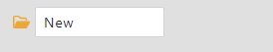

*Image 2 Newly created project*

1. Click on the newly created project once to show its content. Hover the mouse over the project and click the “+” button that is on the right of the project name.

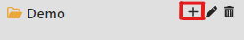

*Image 3 “+” button*

1. Enter the new folder’s name in the text field and press “enter”

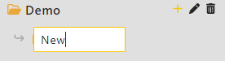

*Image 4 Newly created folder*

1. Click on the “New Workspace” button to create a new workspace.

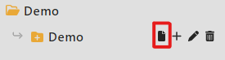

*Image 5 “New Workspace” button*

## **Create workflow**

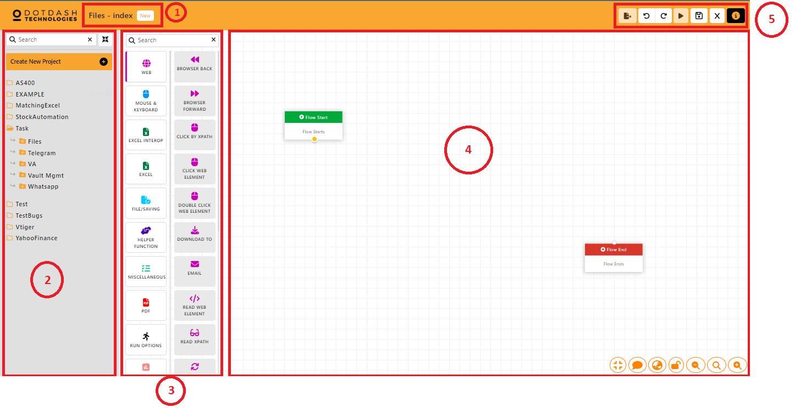

*Image 6 Workspace layout*

| 1. | File Name | File name that you are editing. |
| --- | --- | --- |
| 2. | Projects & Files | Projects & Files that you created. |
| 3. | Action Bar | Different automation’s actions. |
| 4. | Canvas | Drag a required action from the action bar to the canvas to start your automation. |
| 5. | Buttons | **Export**  Export current canvas file as ddp file and use this ddp file to schedule on central.  **Undo**  Undo the canvas.  **Redo**  Redo the canvas.  **Run**  Run the actions on canvas.  **Save**  Save the actions connected on canvas.  **Close**  Close current canvas.  **Information**  About the Workspace. |

1. Connect two actions by dragging from the yellow circle of the first action to the white circle of the second action.

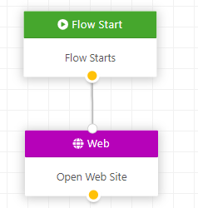

*Image 7 Connected actions*

1. Repeat the step 1 to 2 until all actions have been added to the workflow. Then connect the last action to the “Flow End” action.
2. Click the “save” button to save the workflow. If it is saved successfully, the run button and export button will become clickable and not grayed out.

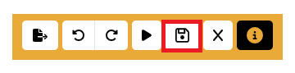

*Image 8 Save button*

1. To run the workflow, click the “run” button next to the “save” button.



*Image 9 Run button*

1. To export the workflow, click the “export” button and it will be exported to a .ddp file.

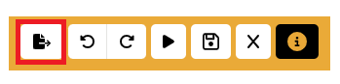

*Image 10 Export button*

## 

## **Actions**

### Web

#### Browser Back

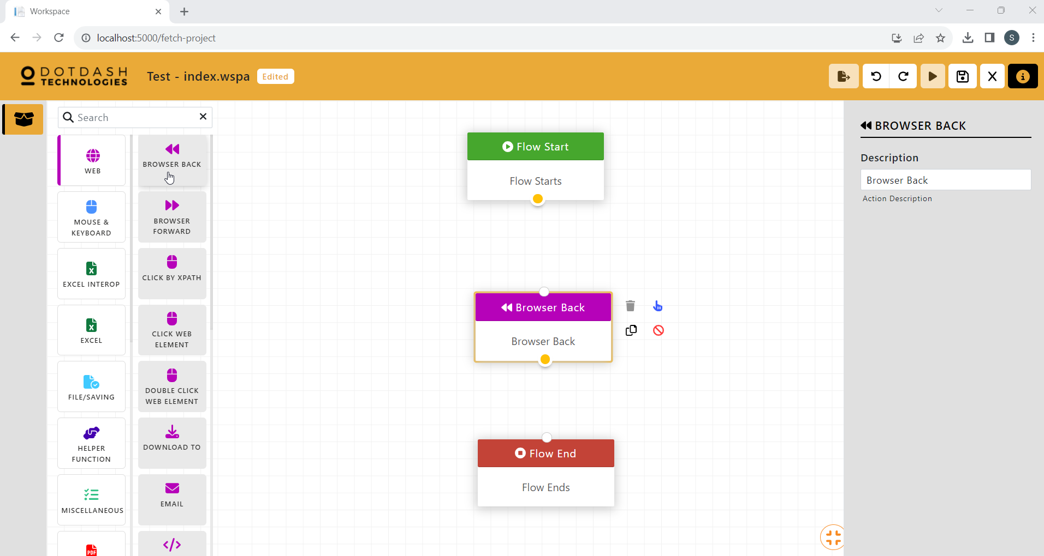

Function: Go to the previous browser page

#### Browser Forward

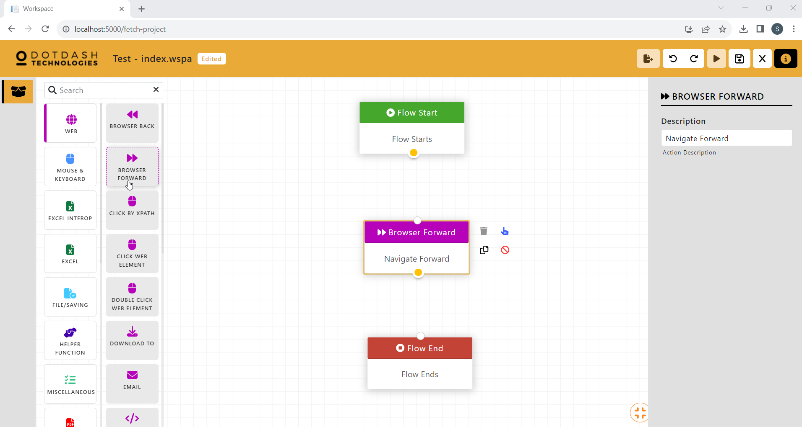

Function: Go forward one browser page

#### Click By XPath

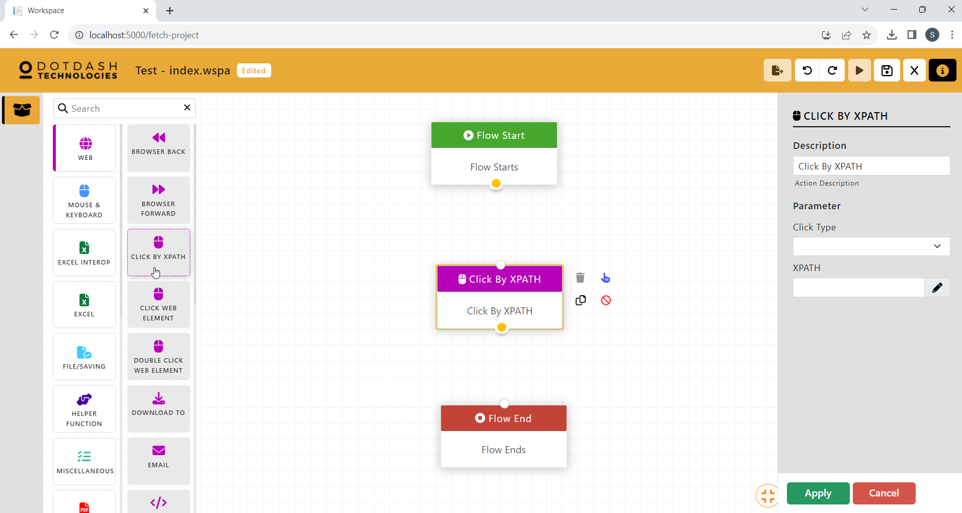

Function: Click on a web element using XPath

| Parameter | Description |
| --- | --- |
| Click Type | Choose left click, right click, or double click. |
| XPATH | Put the xPath of the web element. |

#### Click Web Element

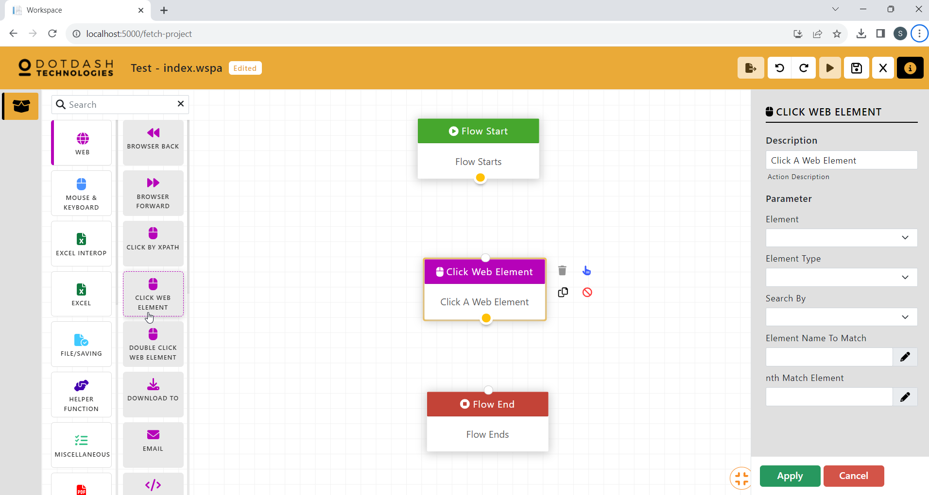

Function: Click on a web element.

| Parameter | Description |
| --- | --- |
| Element | Choose the correct Child, Child & Grandchild for the xPath. |
| Element Type | Choose the type of web element. |
| Search By | Choose what xPath you are copying. |
| Element Name To Match | Put the name to match with the “Search By”. |
| Nth Match Element | Put the element after the element name. |

#### Double Click Web Element

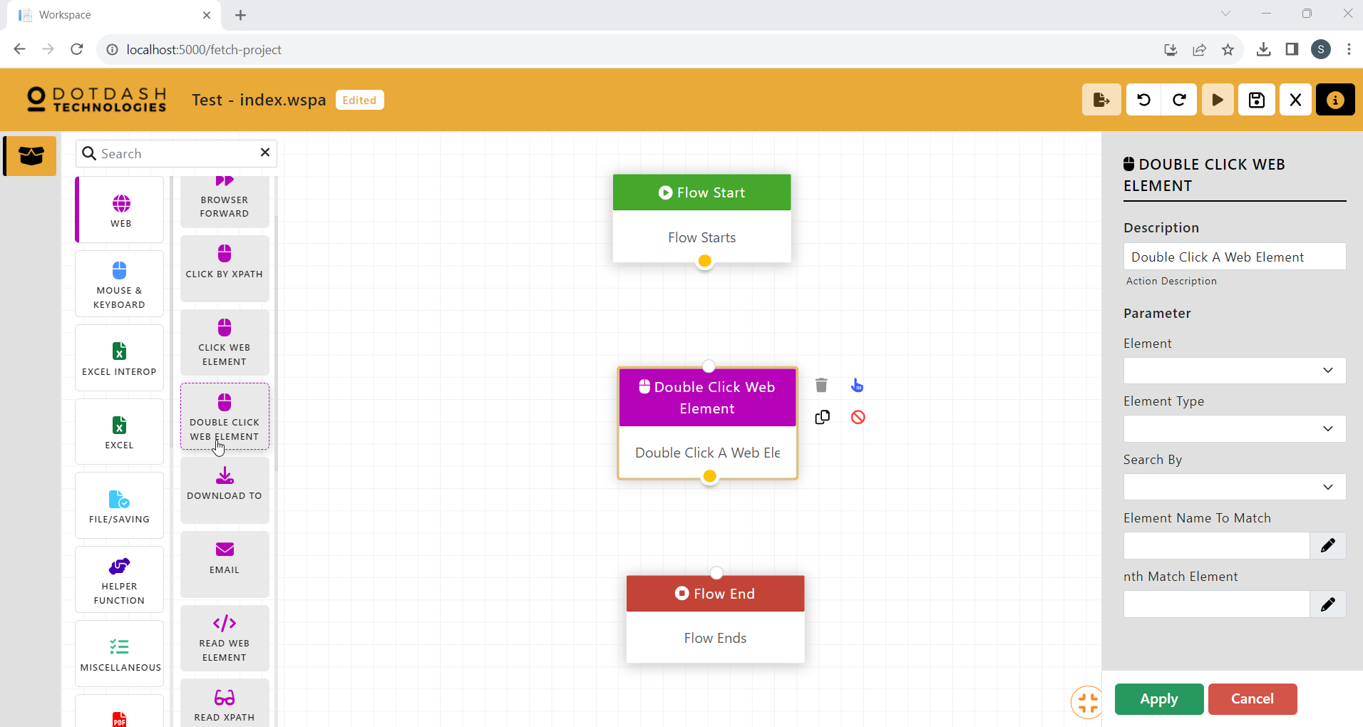

Function:

| Parameter | Description |
| --- | --- |
| Element | Choose the correct Child, Child & Grandchild for the xPath. |
| Element Type | Choose the type of web element. |
| Search By | Choose what xPath you are copying. |
| Element Name To Match | Put the name to match with the “Search By”. |
| Nth Match Element | Put the element after the element name. |

#### Download To

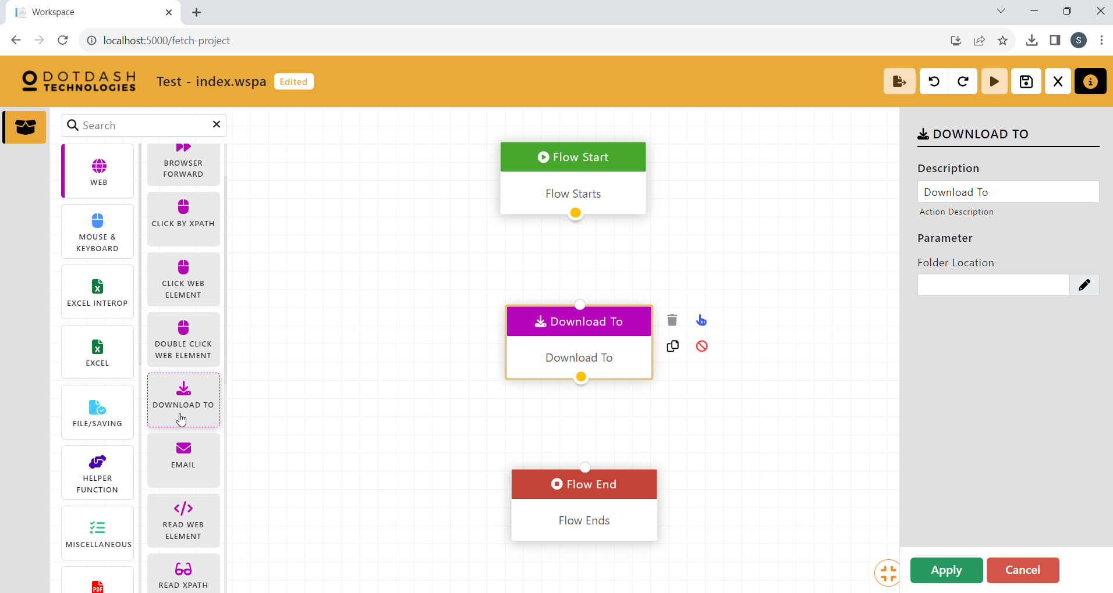

Function: Declare the path to store downloaded files instead of the default download folder

| Parameter | Description |
| --- | --- |
| Folder Location | To put your folder location that you want the file to download to. |

#### Email

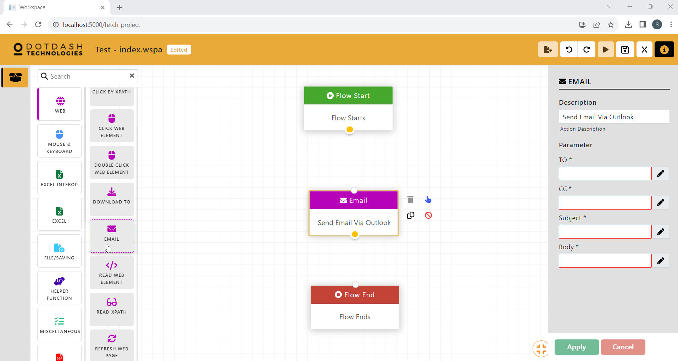

Function: Send an email using outlook website

| Parameter | Description |
| --- | --- |
| To | The receiver of the email. |
| CC | The emails that will receive a cc of the email. |
| Subject | The subject of the email. |
| Body | The body of the email. |

#### Read web Element

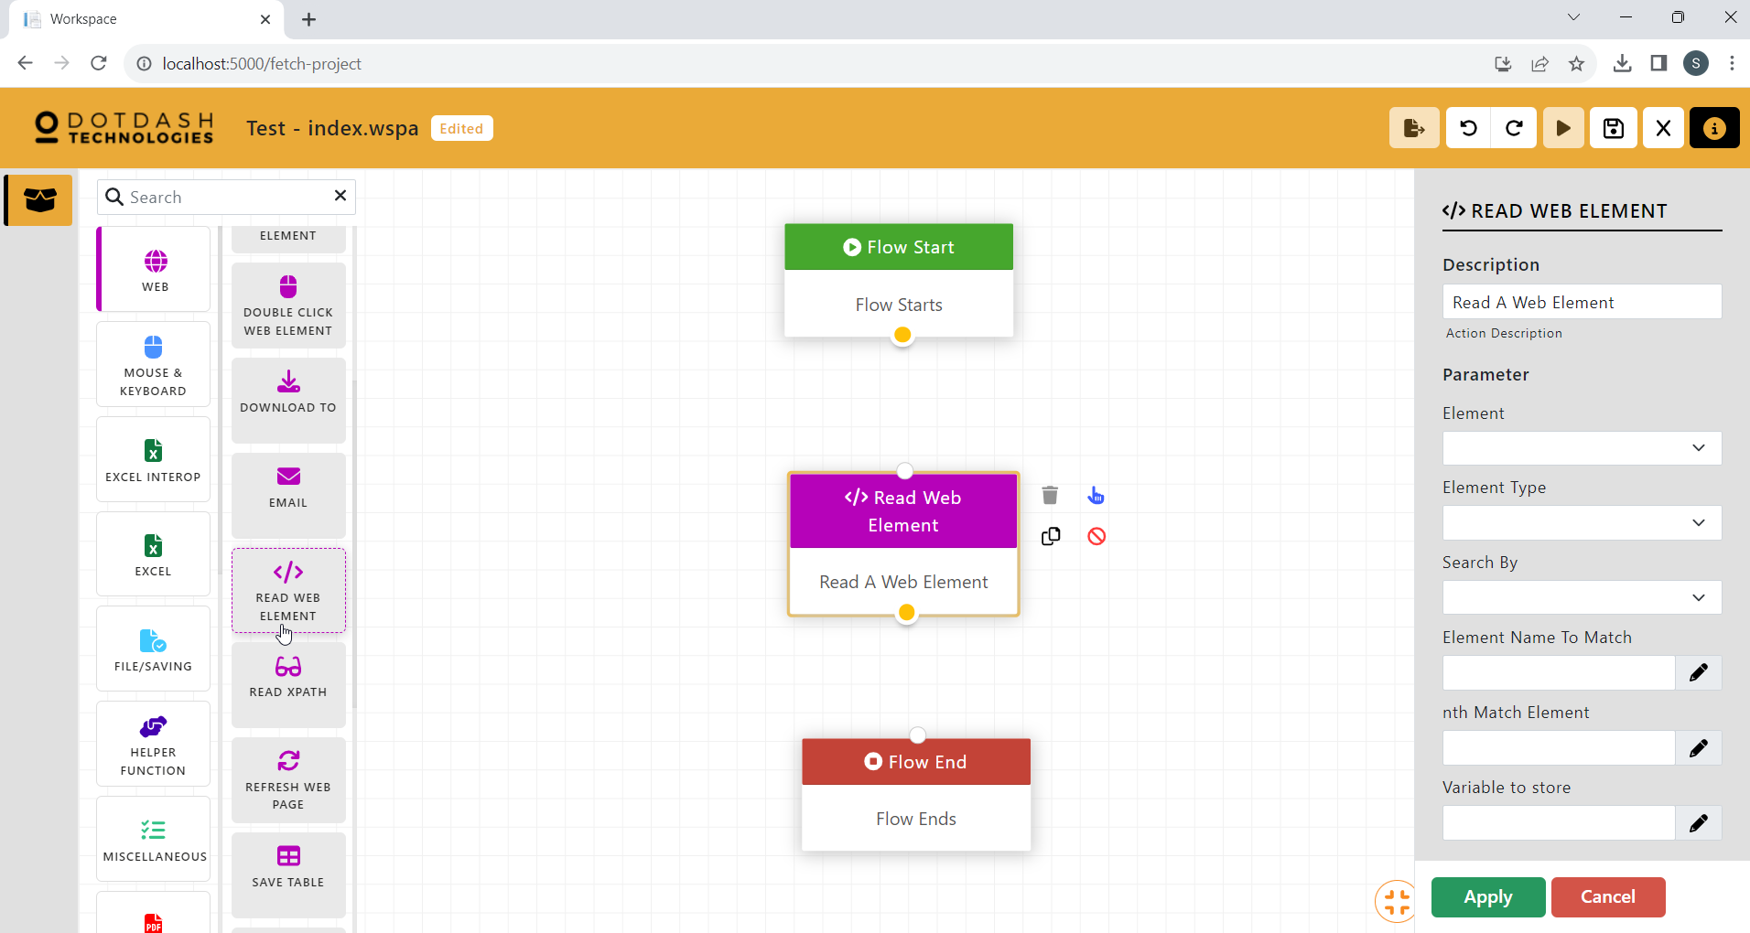

Function: To read the text of the web element.

| Parameter | Description |
| --- | --- |
| Element | Choose the correct Child, Child & Grandchild for the xPath. |
| Element Type | Choose the type of web element. |
| Search By | Choose what xPath you are copying. |
| Element Name To Match | Put the name to match with the “Search By”. |
| Nth Match Element | Put the element after the element name. |
| Variable to store | The variable that will store the text. |

#### Read Xpath

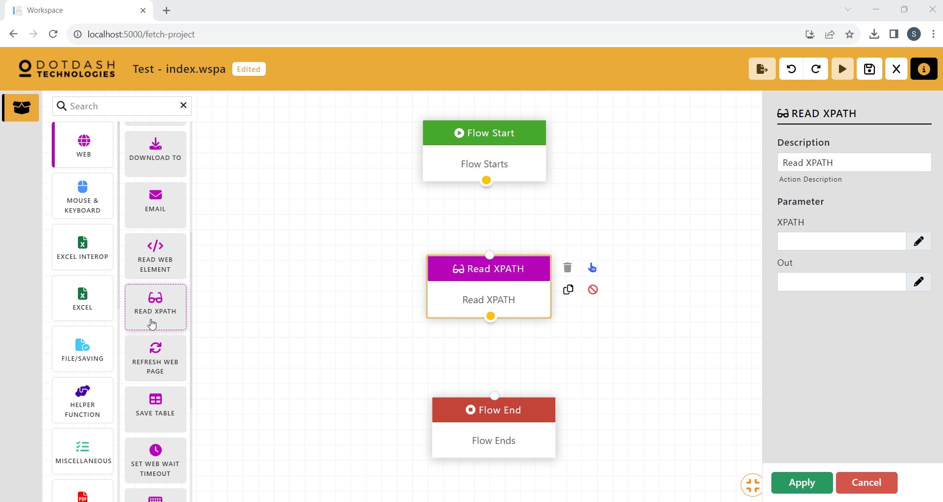

Function: Read the text on specific XPATH

| Parameter | Description |
| --- | --- |
| XPATH | The XPath of the element. |
| Out | The variable to store the text. |

#### Refresh Web Page

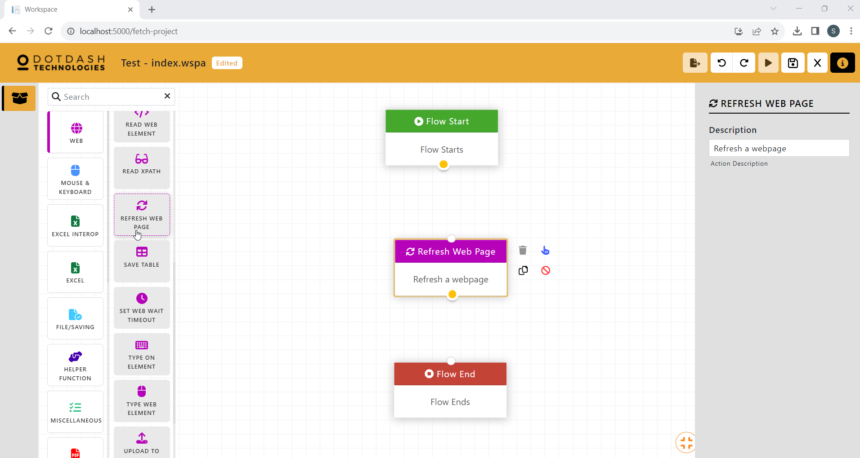

Function: To refresh the website, same as pressing the refresh function (F5)

#### Save Table

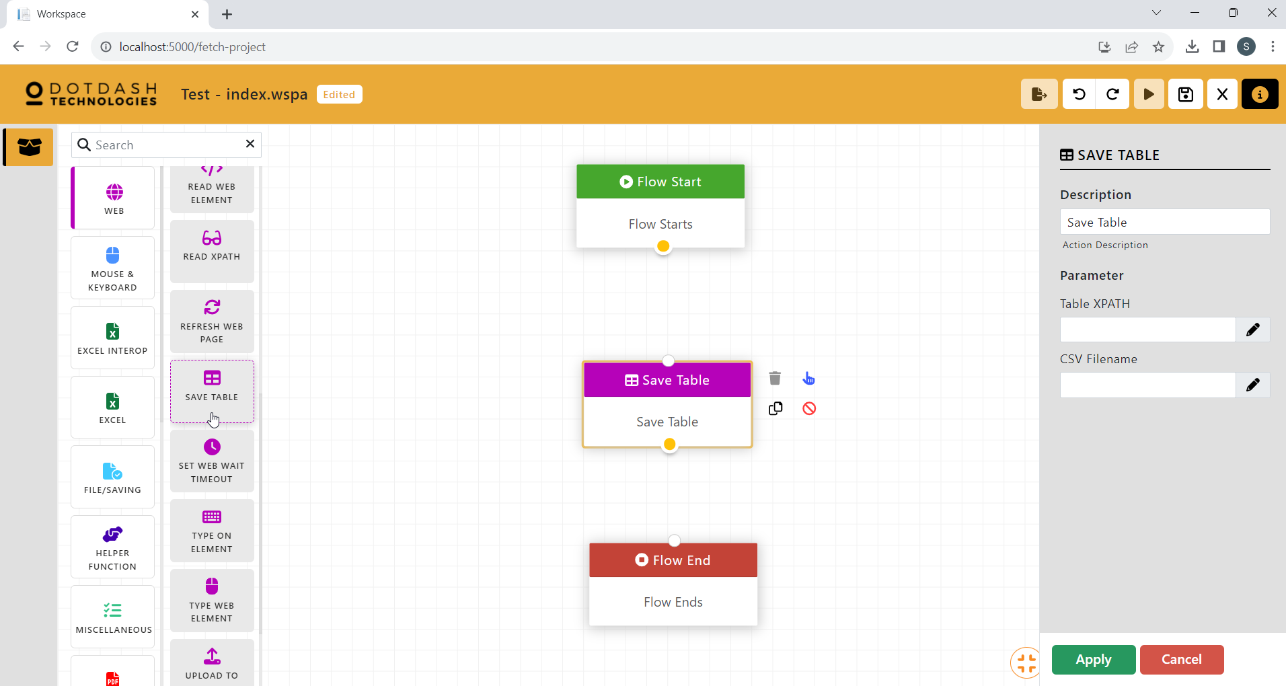

Function: Save the html table data to csv file.

| Parameter | Description |
| --- | --- |
| Table XPATH | The XPath of the html table. |
| CSV Filename | The file path of the csv file. |

#### Set Web Wait Timeout

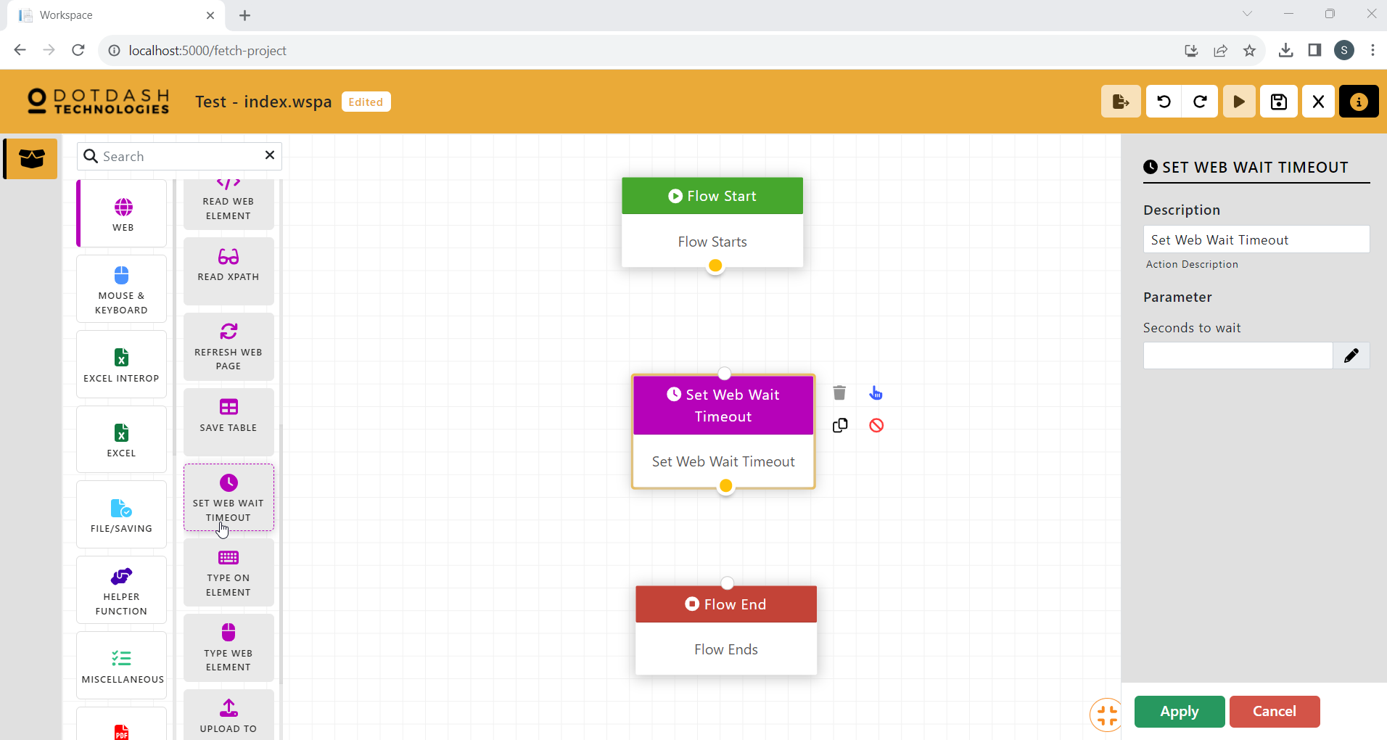

Function: Set the wait timeout for the website

| Parameter | Description |
| --- | --- |
| Second to wait | The number of seconds to wait before timeout. |

#### Type On Element

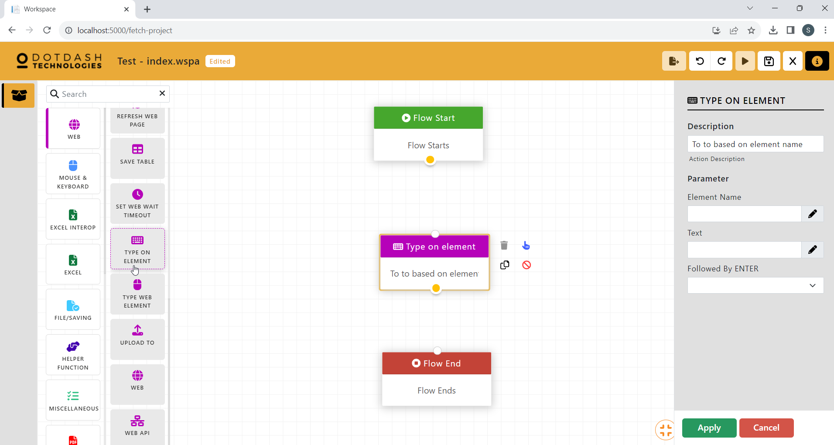

Function: To type text on a web element

| Parameter | Description |
| --- | --- |
| Element Name | The name of the element to be typed on. |
| Text | The text to be typed . |
| Followed by ENTER | Should the text be followed by enter key. |

#### Type Web Element

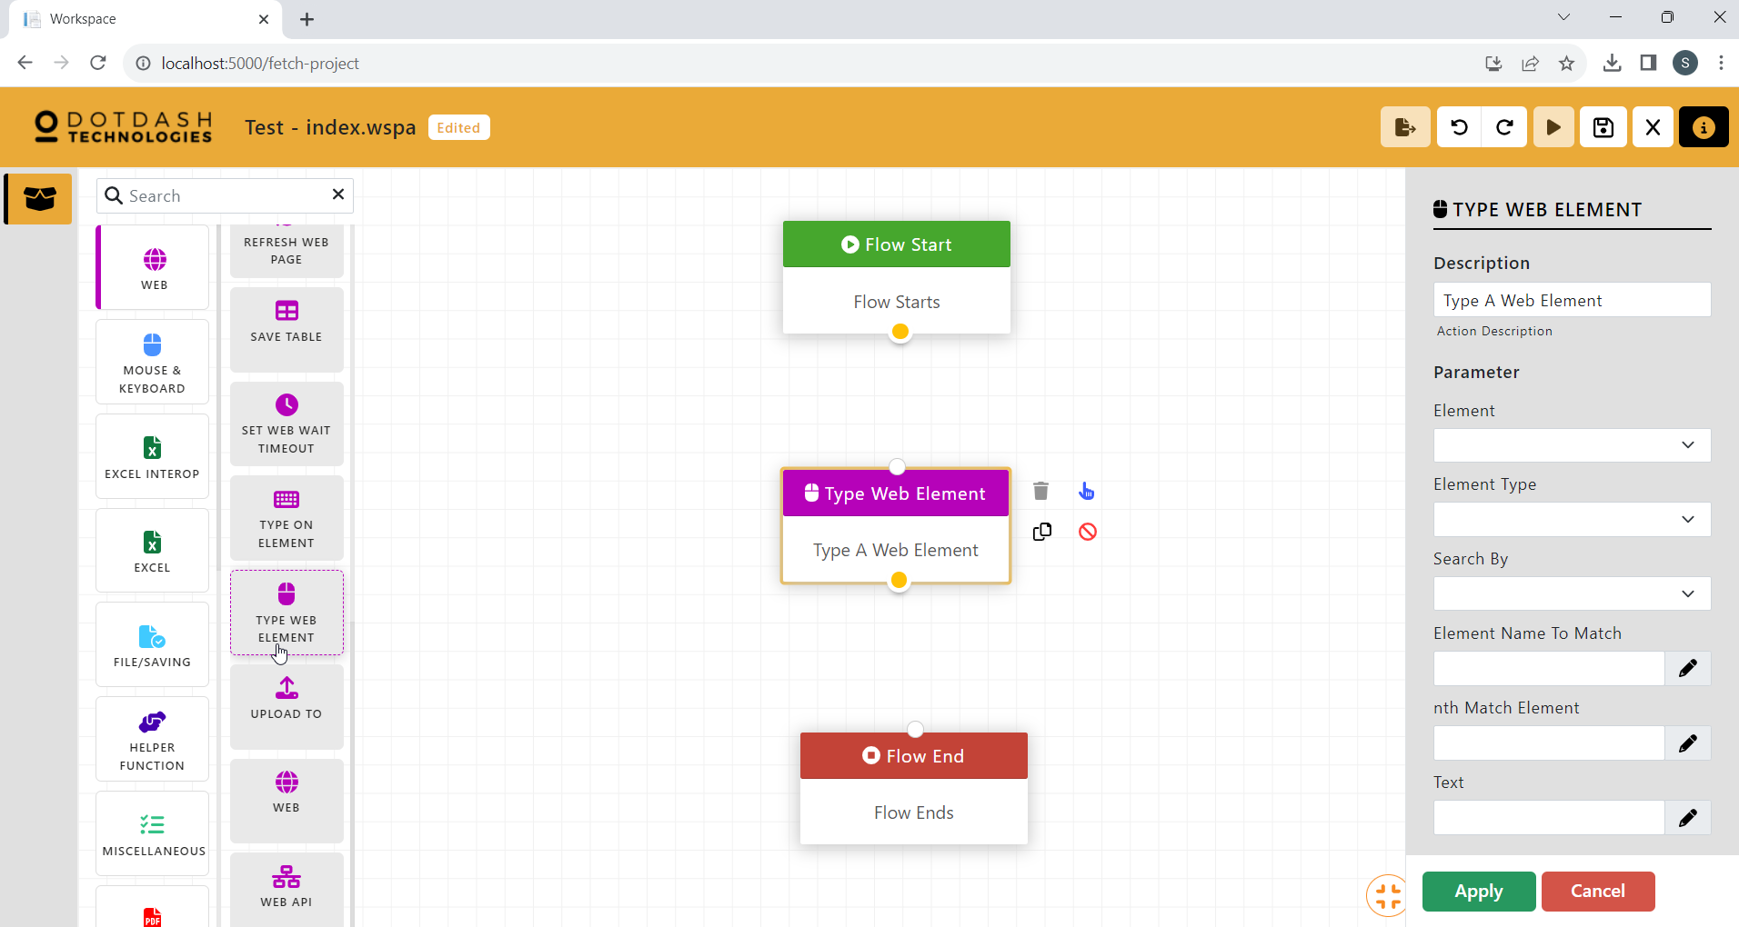

Function: To type text on a web element

| Parameter | Description |
| --- | --- |
| Element | Choose the correct Child, Child & Grandchild for the xPath. |
| Element Type | Choose the type of web element. |
| Search By | Choose what xPath you are copying. |
| Element Name To Match | Put the name to match with the “Search By”. |
| Nth Match Element | Put the element after the element name. |
| Text | The text to be typed. |

#### Upload To

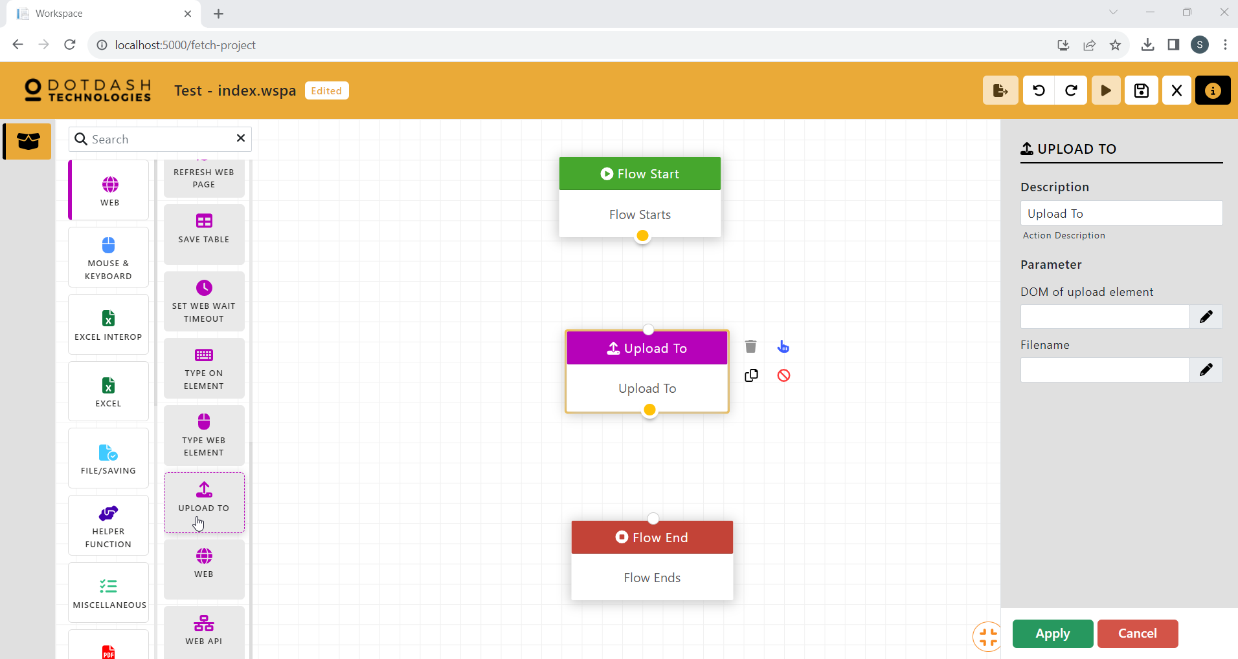

Function: Upload file to the web

| Parameter | Description |
| --- | --- |
| DOM of upload element | The DOM of the upload element in the website. |
| FIlename | The filepath of the file to be uploaded. |

#### Web

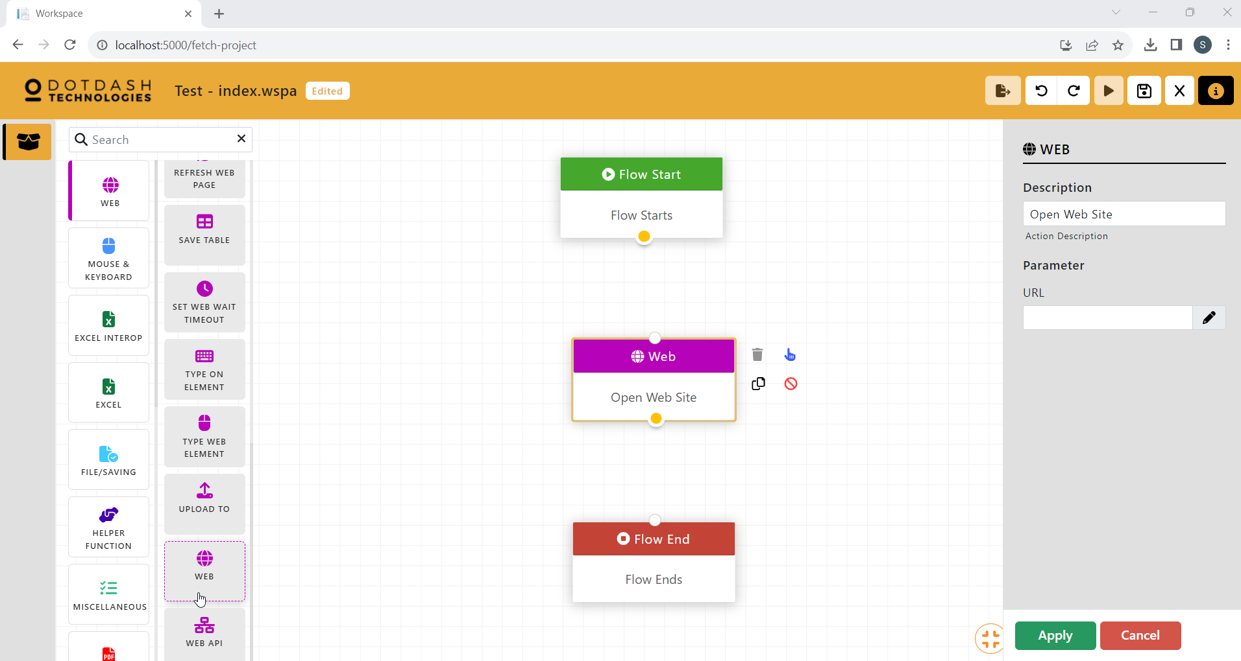

Function: Open a website

| Parameter | Description |
| --- | --- |
| URL | The url of the website to be opened. |

#### Web API

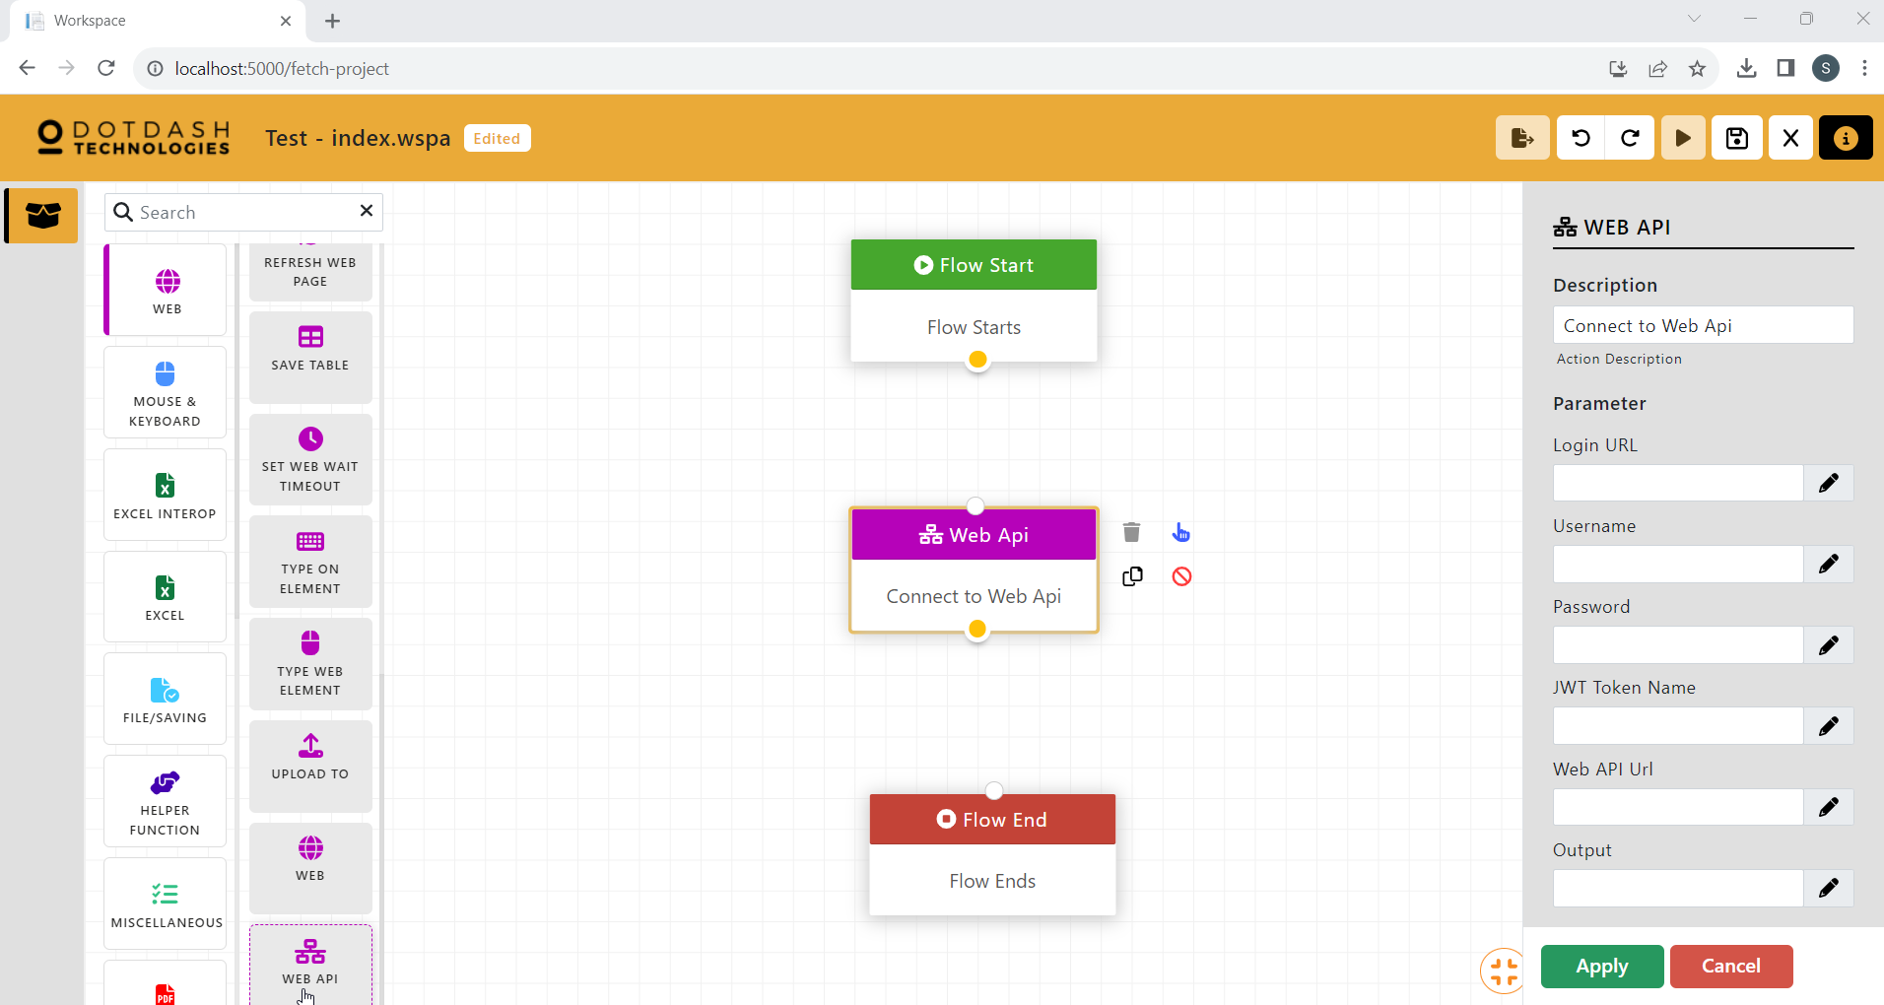

Function:

| Parameter | Description |
| --- | --- |
| Login URL |  |
| Username |  |
| Password |  |
| WT Token Name |  |
| Web API URL |  |
| Output |  |

### Mouse & Keyboard

#### Bring Focus (Not included in the download)

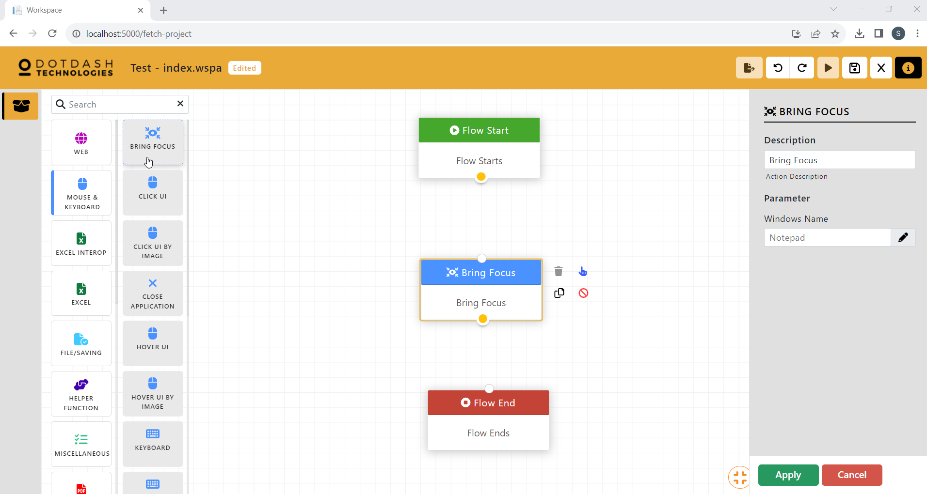

Function: To bring an opened window to the front and set focus on the window

| Parameter | Description |
| --- | --- |
| Window Name | The name of the window to be focused on. |

#### Click UI

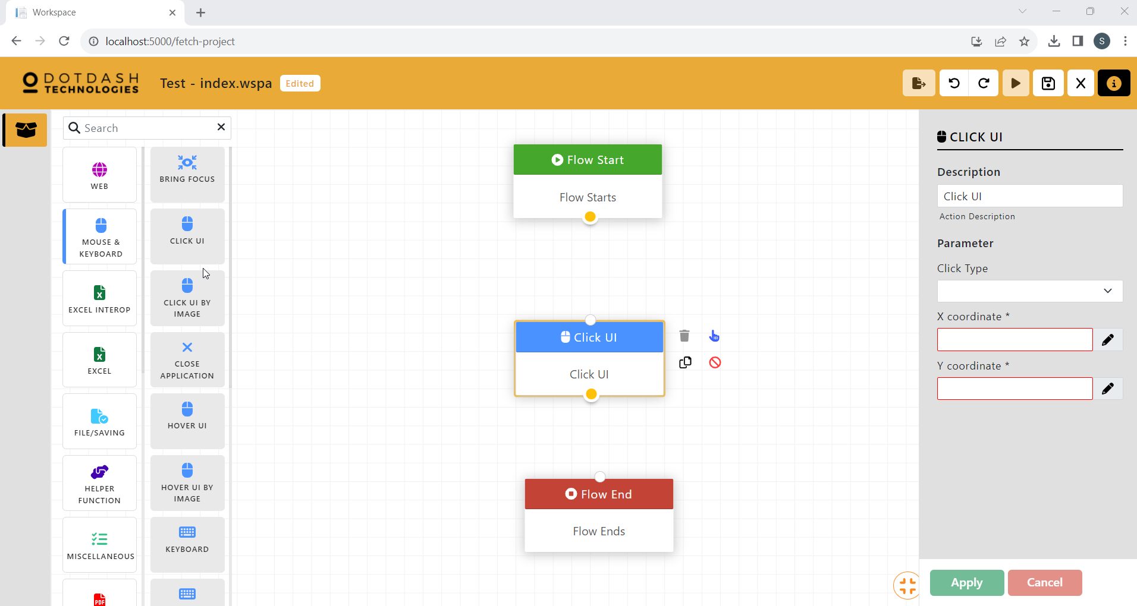

Function: Click the UI at specific location

| Parameter | Description |
| --- | --- |
| Click Type | Select whether to left click, right click or double-click. |
| X coordinate | X coordinate of the target on screen. |
| Y coordinate | Y coordinate of the target on screen. |

#### Click UI By Image

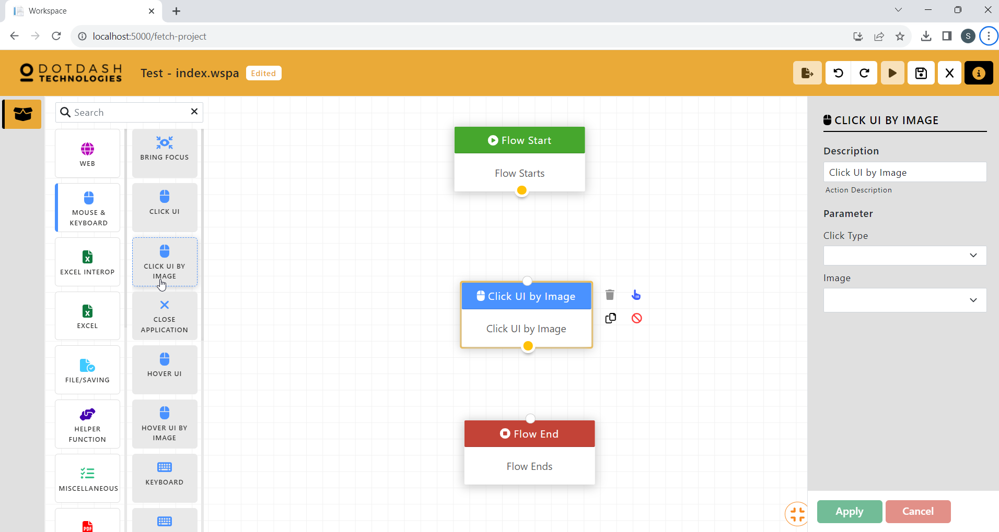

Function: Click the UI based on image

| Parameter | Description |
| --- | --- |
| Click Type | Select whether to left click, right click or double-click. |
| Image | The image of the UI to be clicked. |

#### Close Application

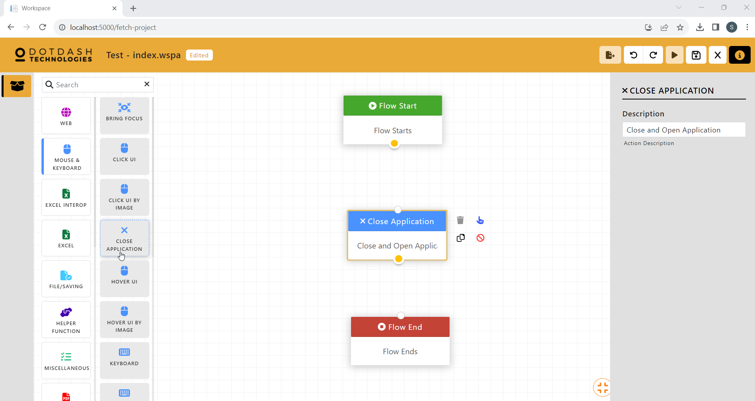

Function: To close the current window

#### Hover UI

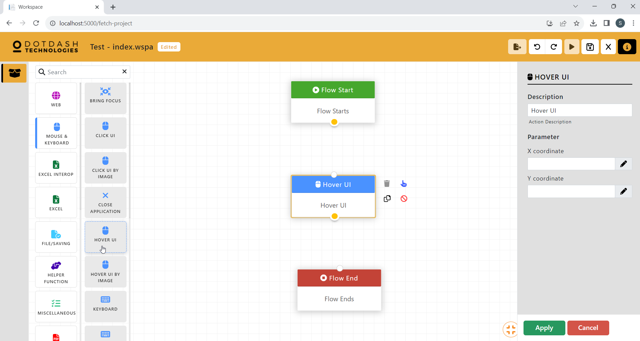

Function: Hover the mouse over the UI at a specific location

| Parameter | Description |
| --- | --- |
| X coordinate | X coordinate of the target on screen. |
| Y coordinate | Y coordinate of the target on screen. |

#### Hover UI By Image

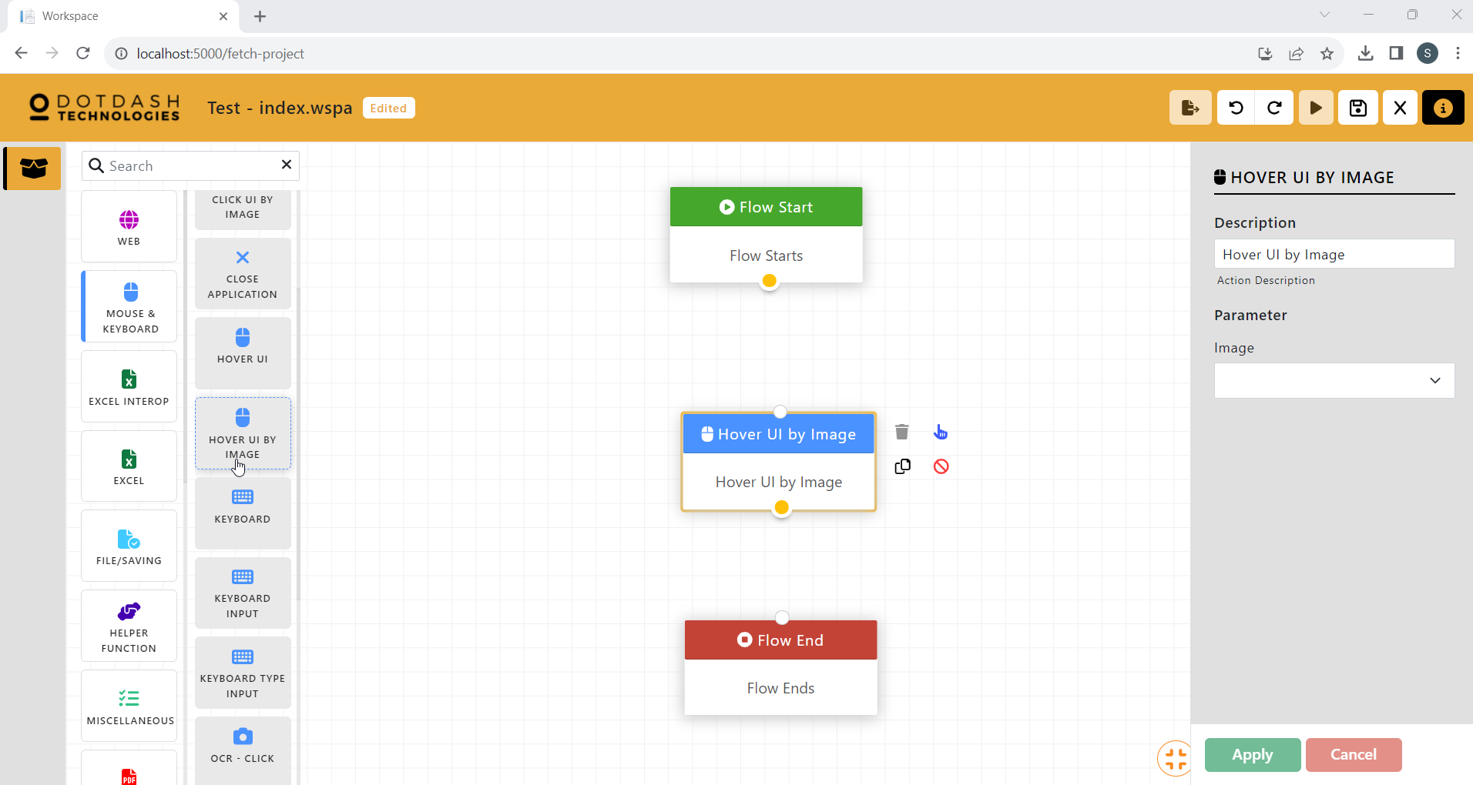

Function: Hover the mouse over the UI based on image

| Parameter | Description |
| --- | --- |
| Image | The image of the UI to be hover over. |

#### Keyboard

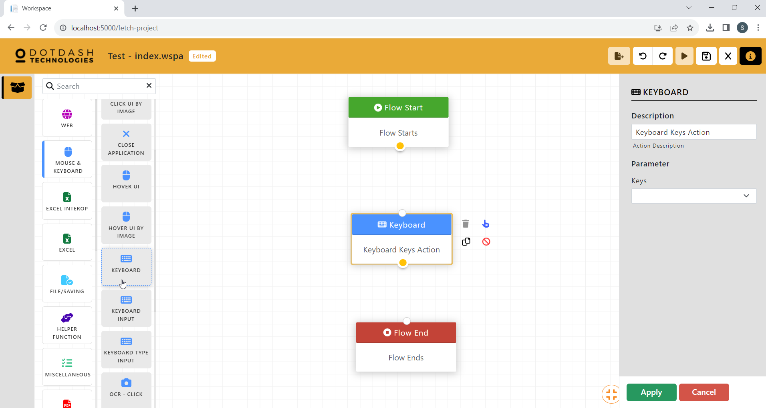

Function: Input of keyboard special key.

| Parameter | Description |
| --- | --- |
| Keys | A selection of special keystroke such as spacebar and alt. |

#### Keyboard Input

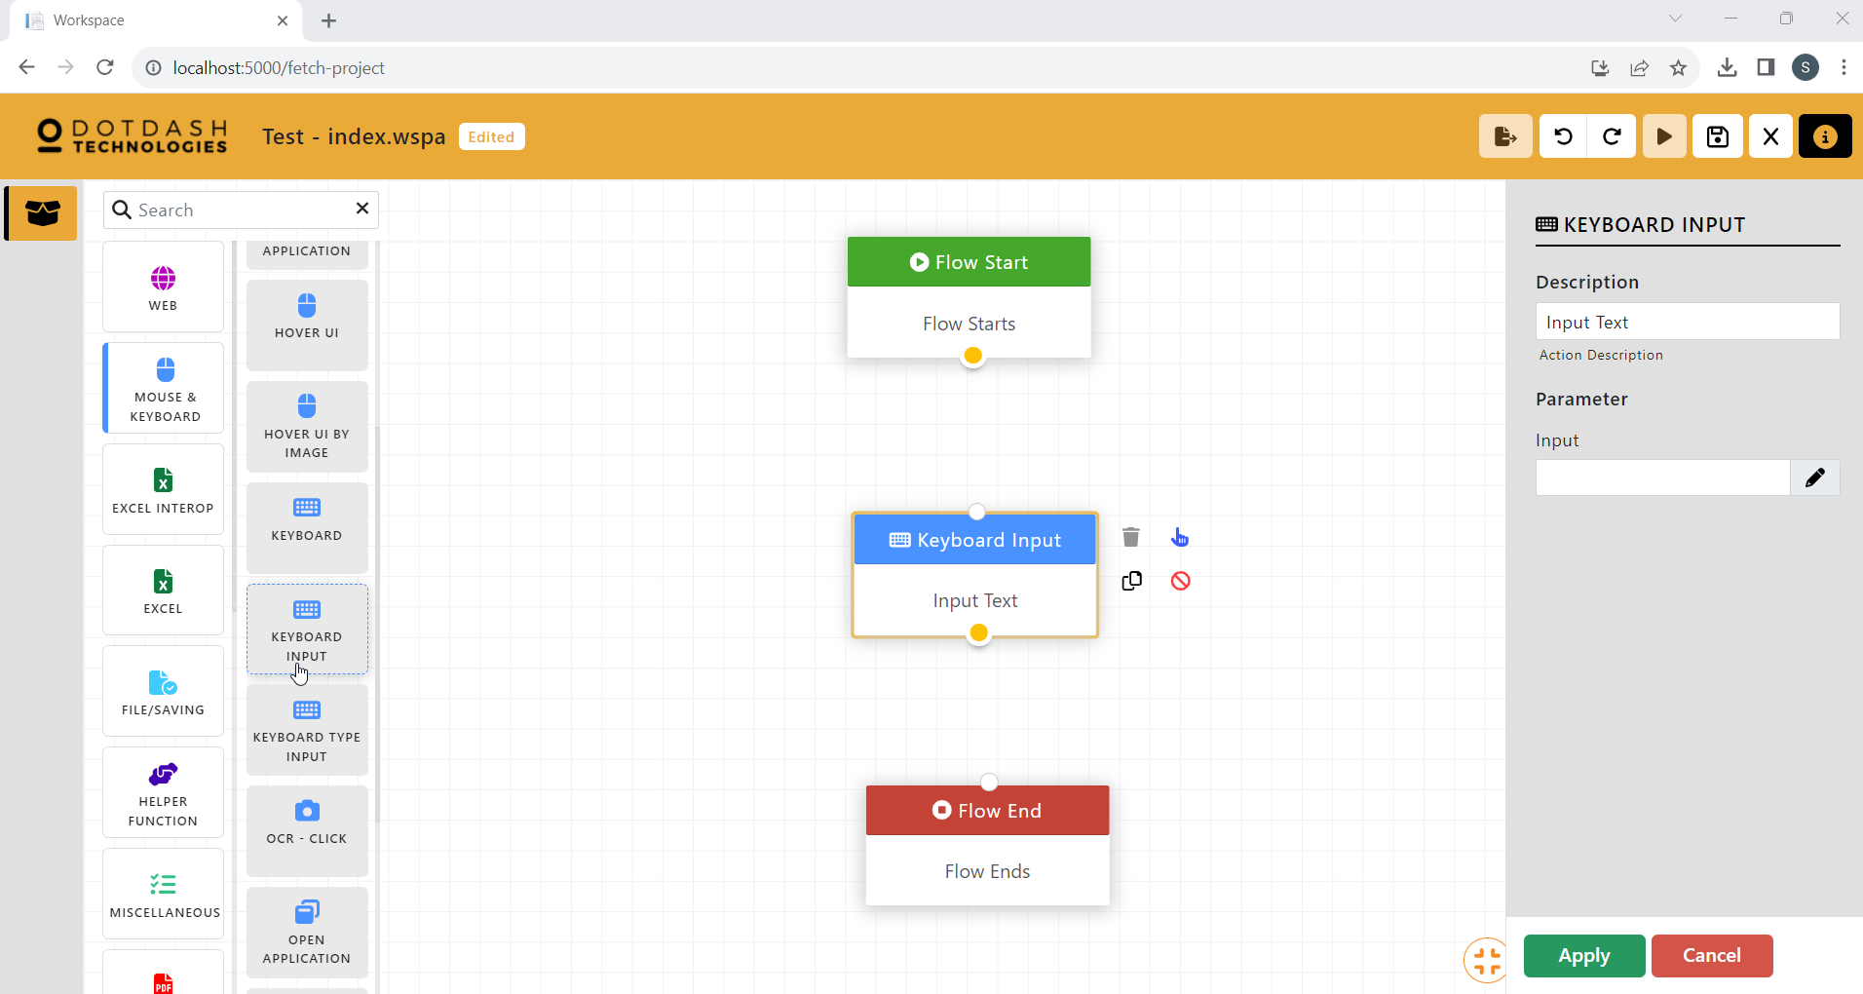

Function: Input of text or combination of keystroke.

| Parameter | Description |
| --- | --- |
| Input | The text that will be typed. |

#### Keyboard Type Input

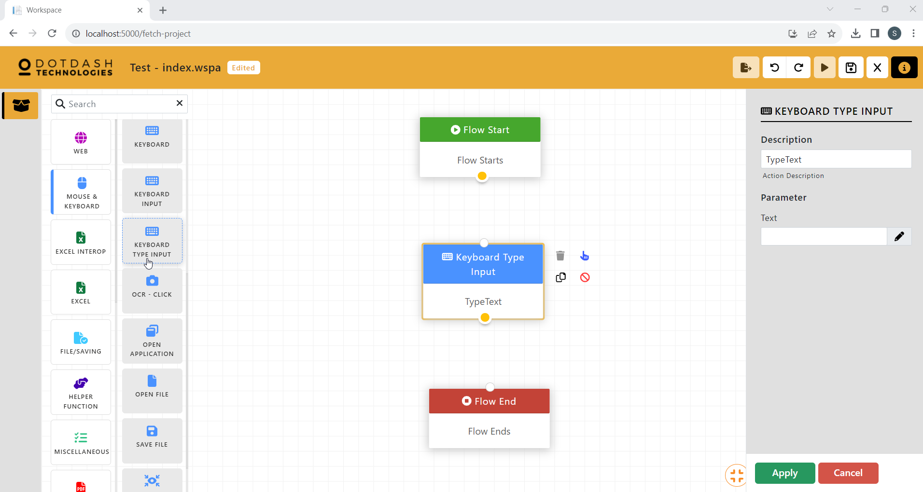

Function: To input a sentence

| Parameter | Description |
| --- | --- |
| Text | The sentences of text to be input. |

#### OCR - Click

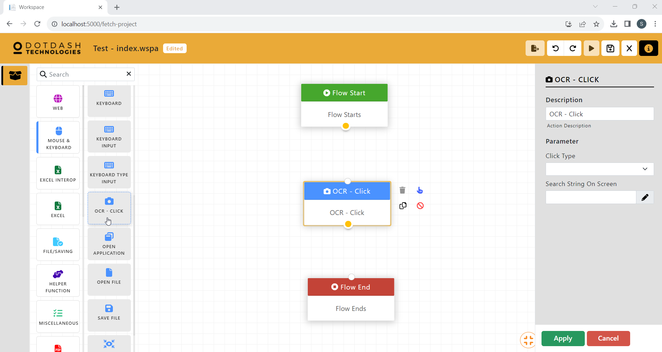

Function: Using OCR to click on a string of text

| Parameter | Description |
| --- | --- |
| Click Type | Select whether to left click, right click or double-click. |
| Search String On Screen | The string of text to be searched for using OCR. |

#### Open Application

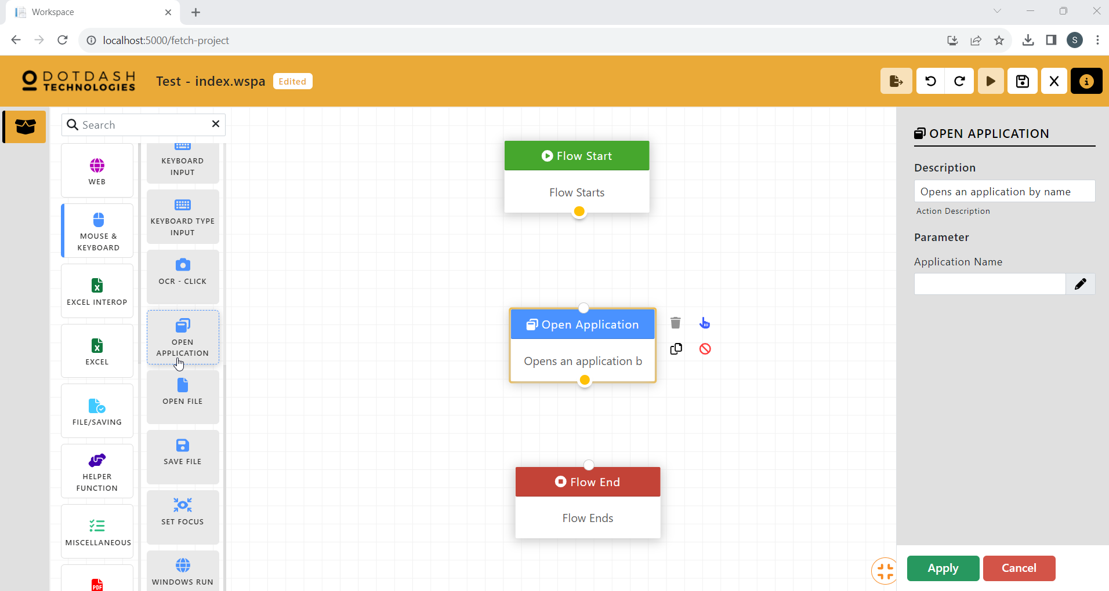

Function: To open an application in the computer

| Parameter | Description |
| --- | --- |
| Application Name | The name of the application to be opened. |

#### Open File

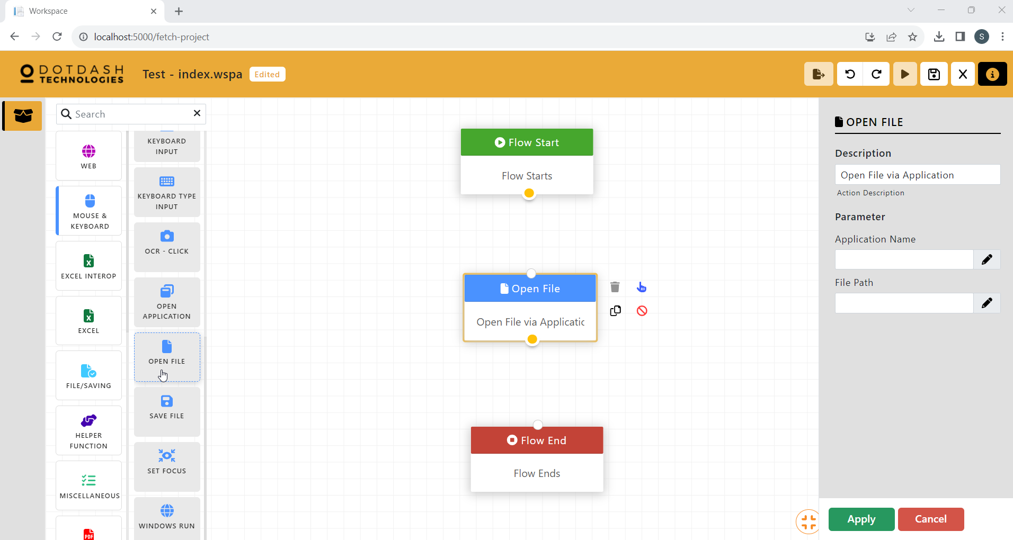

Function: To open a file of an application

| Parameter | Description |
| --- | --- |
| Application Name | The name of the application. |
| File Path | The file path of the file. |

#### Save File

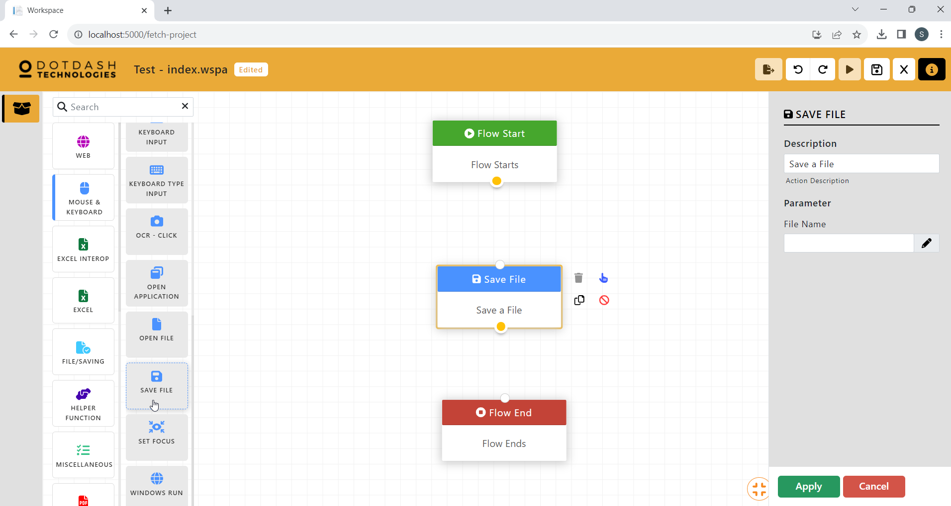

Function: To save the file

| Parameter | Description |
| --- | --- |
| File Name | The name of the saved file. |

#### Set Focus

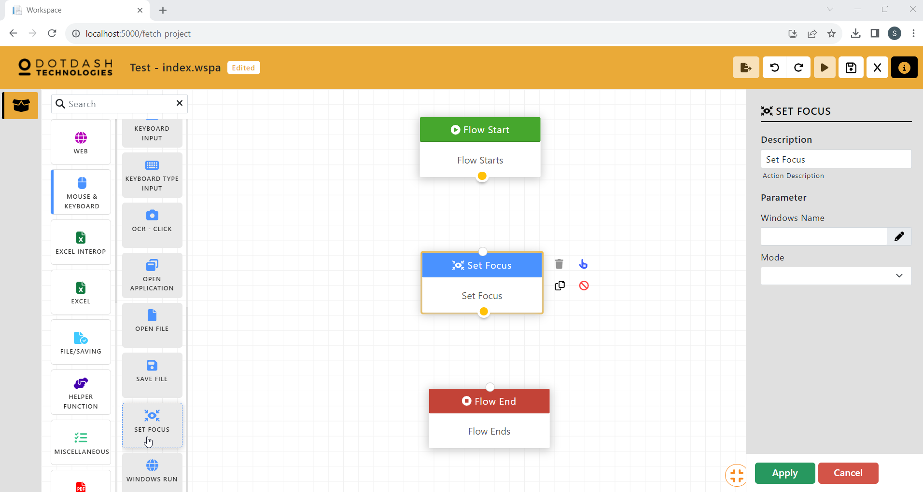

Function: To modify an opened window

| Parameter | Description |
| --- | --- |
| Windows Name | The name of the window. |
| Mode | Choose to restore, maximize or minimize the window. |

#### Windows Run

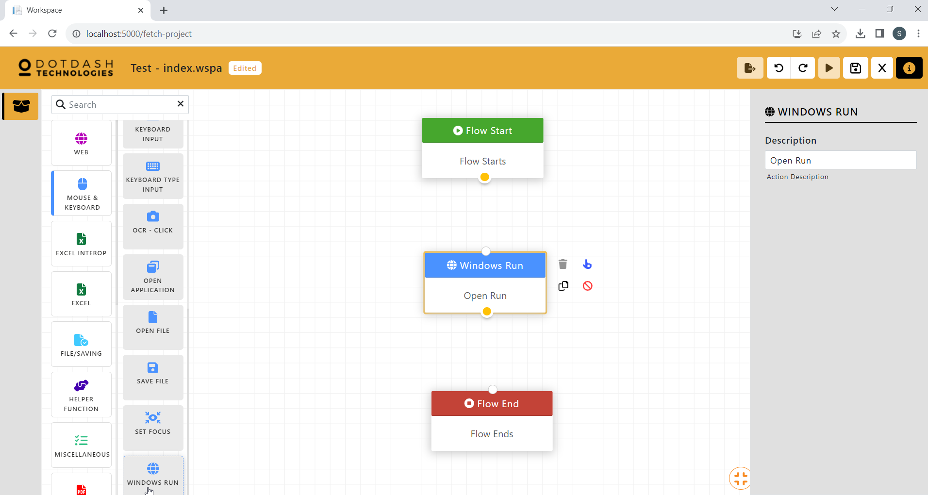

Function: To open the Run Window

### Excel Interop

#### Close Work Sheet

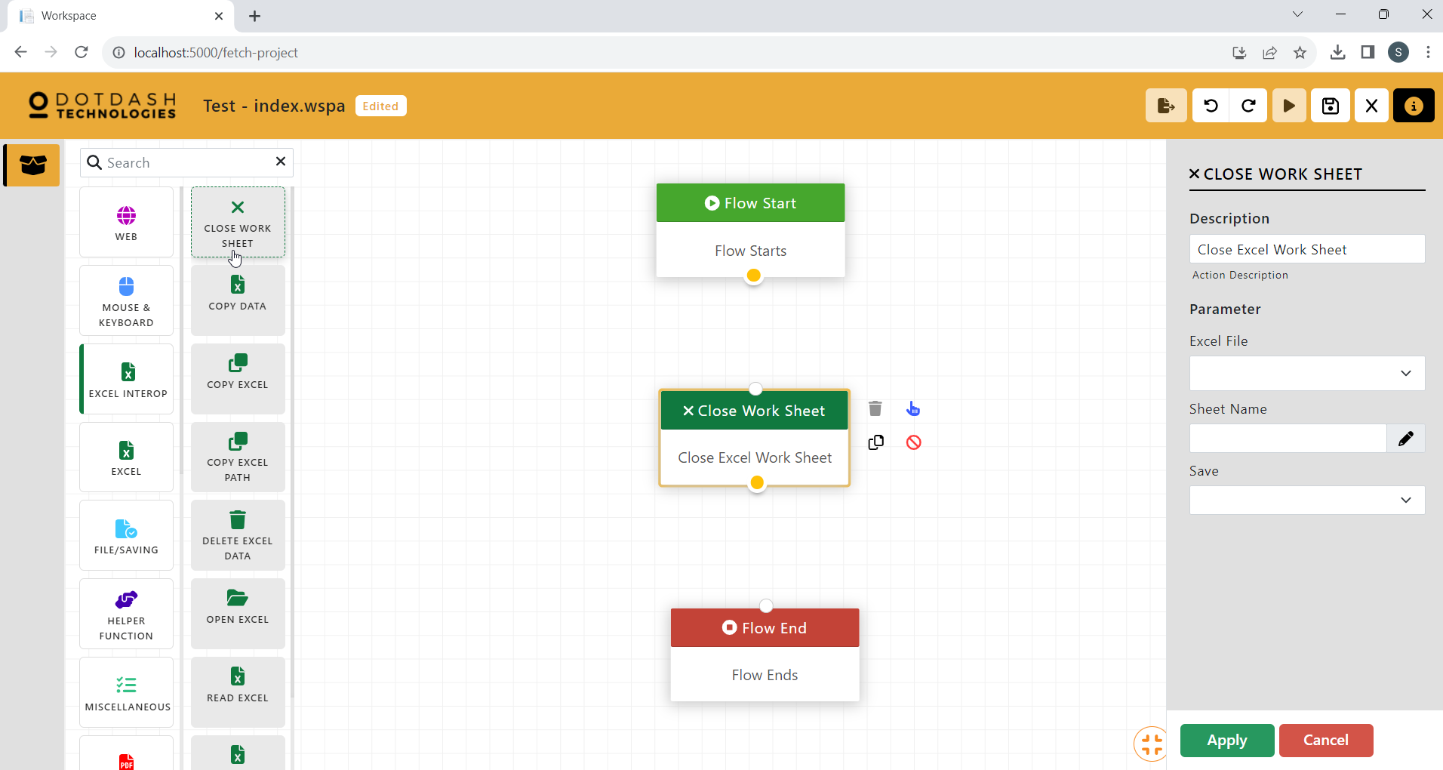

Function: To close an opened worksheet

| Parameter | Description |
| --- | --- |
| Excel File | The name of the excel file. |
| Sheet name | The name of the worksheet. |
| Save | An option to save or not save the worksheet. |

#### Copy Data

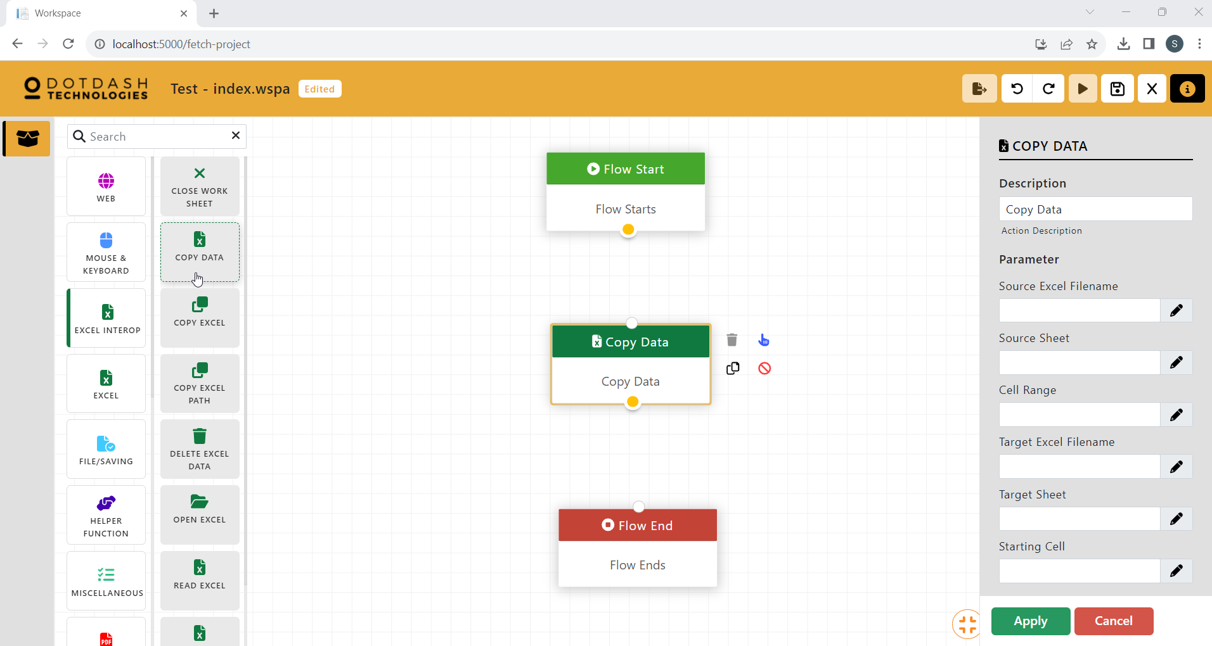

Function: To copy a range of data from one excel sheet to another

| Parameter | Description |
| --- | --- |
| Source Excel Filename | The path of the source excel. |
| Source Sheet | The name of the source excel sheet. |
| Cell Range | The range of data to be copied. |
| Target Excel FIlename | The path of the target excel. |
| Target SHeet | The name of the target excel sheet. |
| Starting Cell | The first cell to start pasting the copied data. |

#### Copy Excel

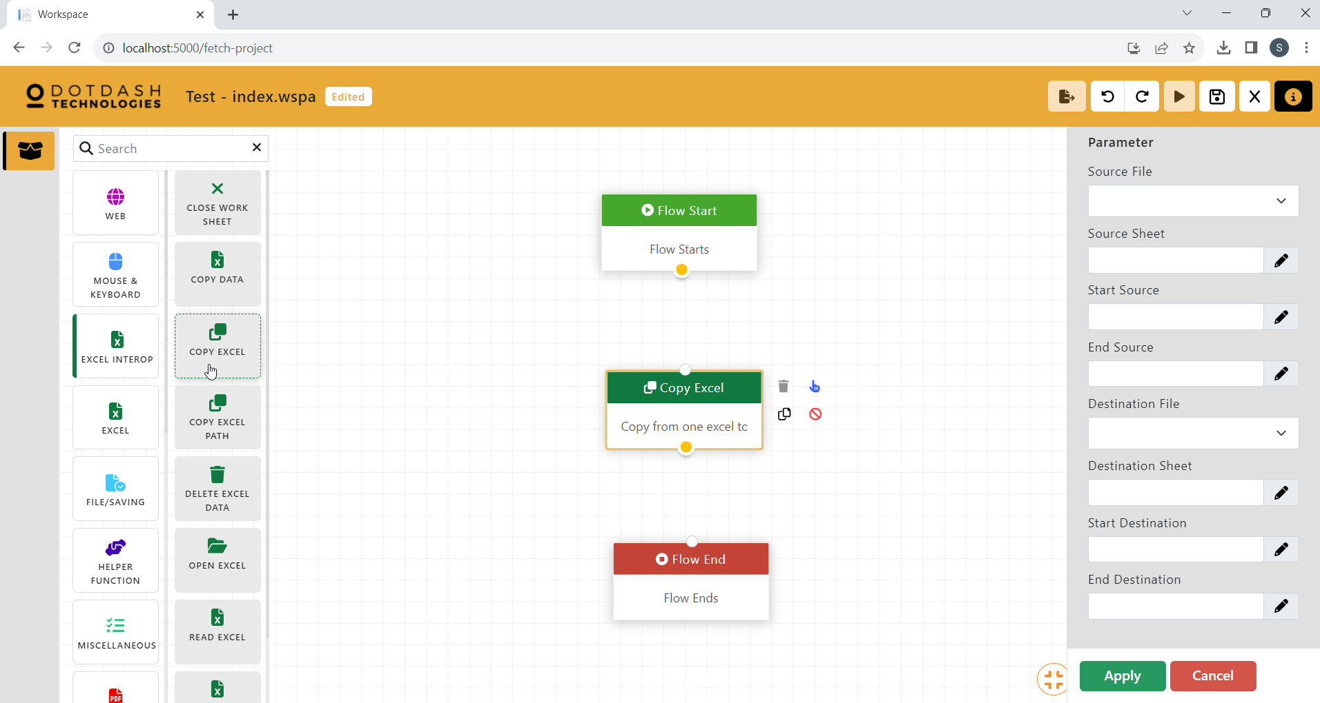

Function: Copy the range of data from one excel sheet to another. (The file needs to be uploaded to the DD RPA workspace)

| Parameter | Description |
| --- | --- |
| Source File | The name of the source file. |
| Source Sheet | The sheet name of the source excel file. |
| Start Source | The starting cell to copy the data. |
| End Source | The ending cell to copy the data. |
| Destination File | The name of the destination file. |
| Destination Sheet | The name of the destination excel file. |
| Start Destination | The starting cell to paste the data. |
| End Destination | The ending cell to paste the data. |

#### Copy Excel Path

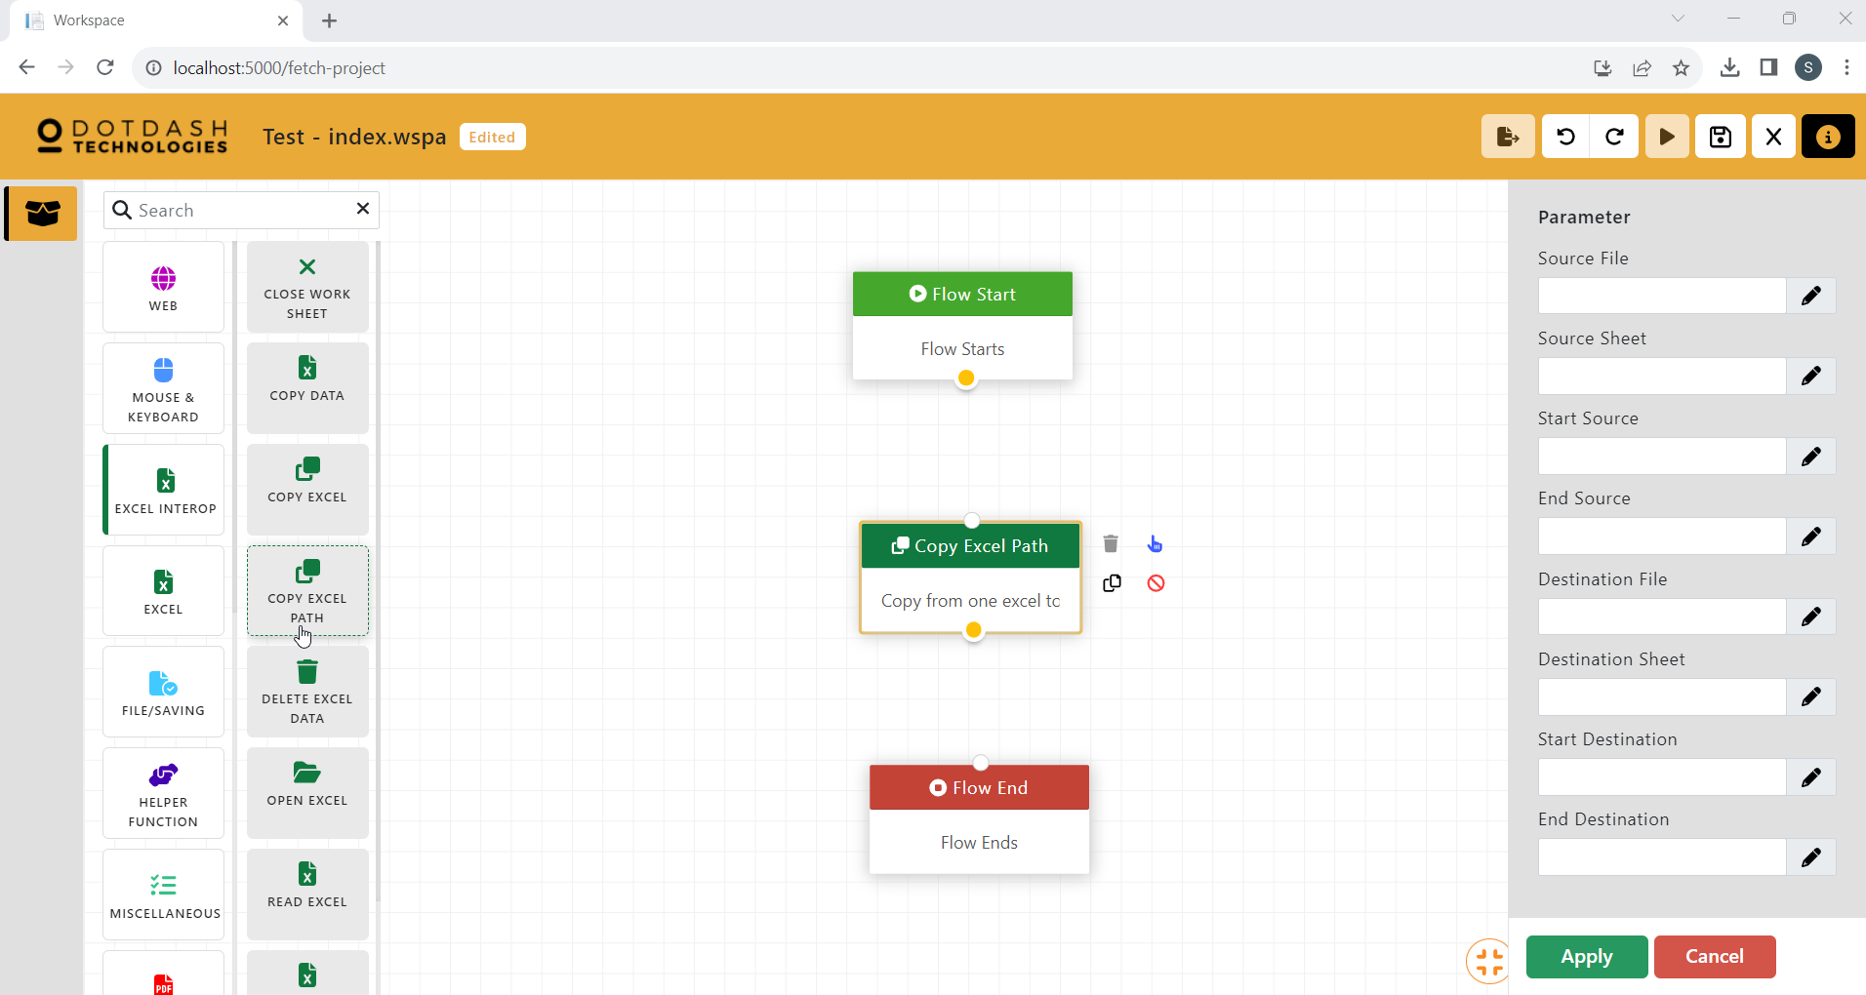

Function: Copy a range of data from one excel sheet to another. (Using the file path of the excel file that is located in the device)

| Parameter | Description |
| --- | --- |
| Source File | The name of the source file . |
| Source Sheet | The sheet name of the source excel file. |
| Start Source | The starting cell to copy the data. |
| End Source | The ending cell to copy the data. |
| Destination File | The name of the destination file. |
| Destination Sheet | The name of the destination excel file. |
| Start Destination | The starting cell to paste the data. |
| End Destination | The ending cell to paste the data. |

#### Delete Excel Data

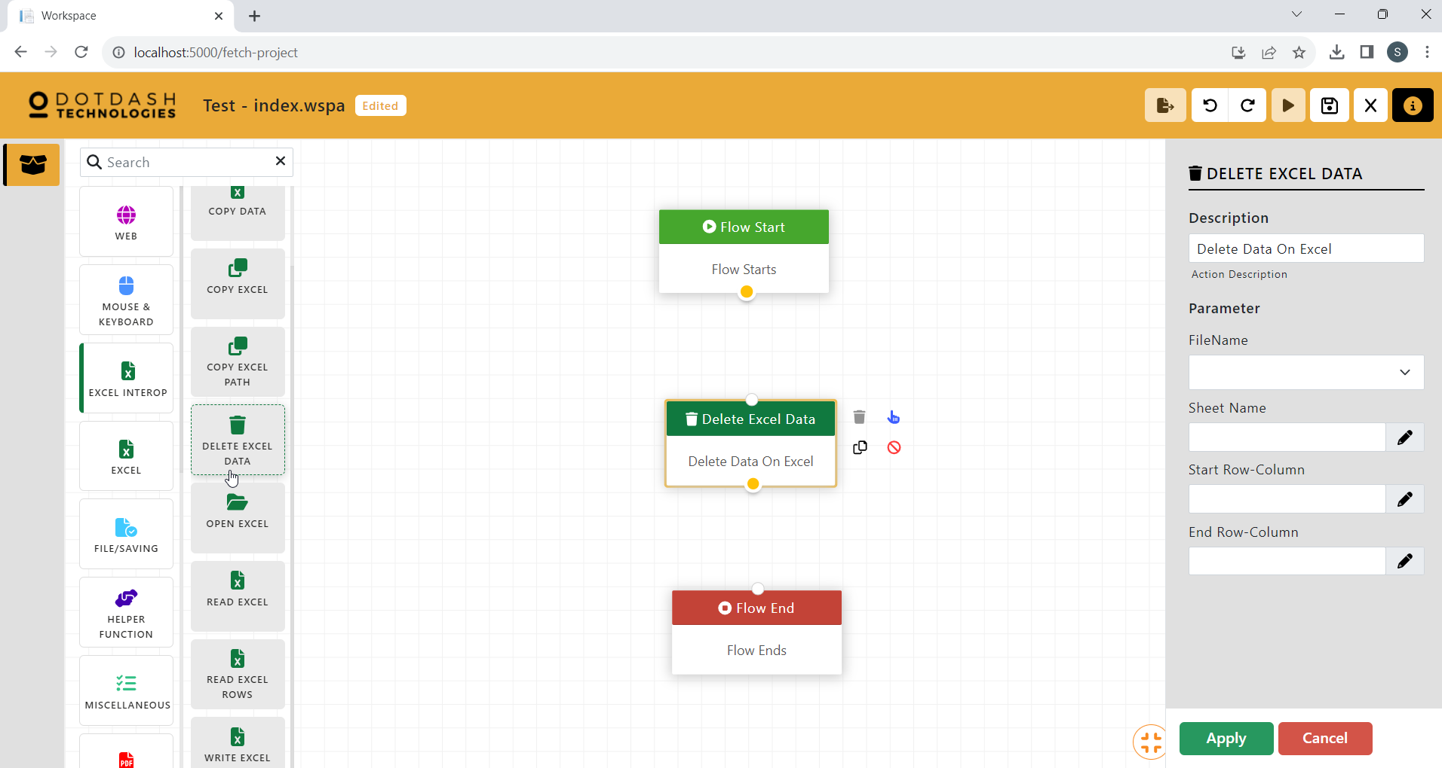

Function: Delete data in an excel sheet

| Parameter | Description |
| --- | --- |
| FileName | The name of the excel file. |
| SHeet Name | The name of the excel sheet. |
| Start Row-Column | The first cell of data. |
| End Row-Column | The last cell of data. |

#### Open Excel

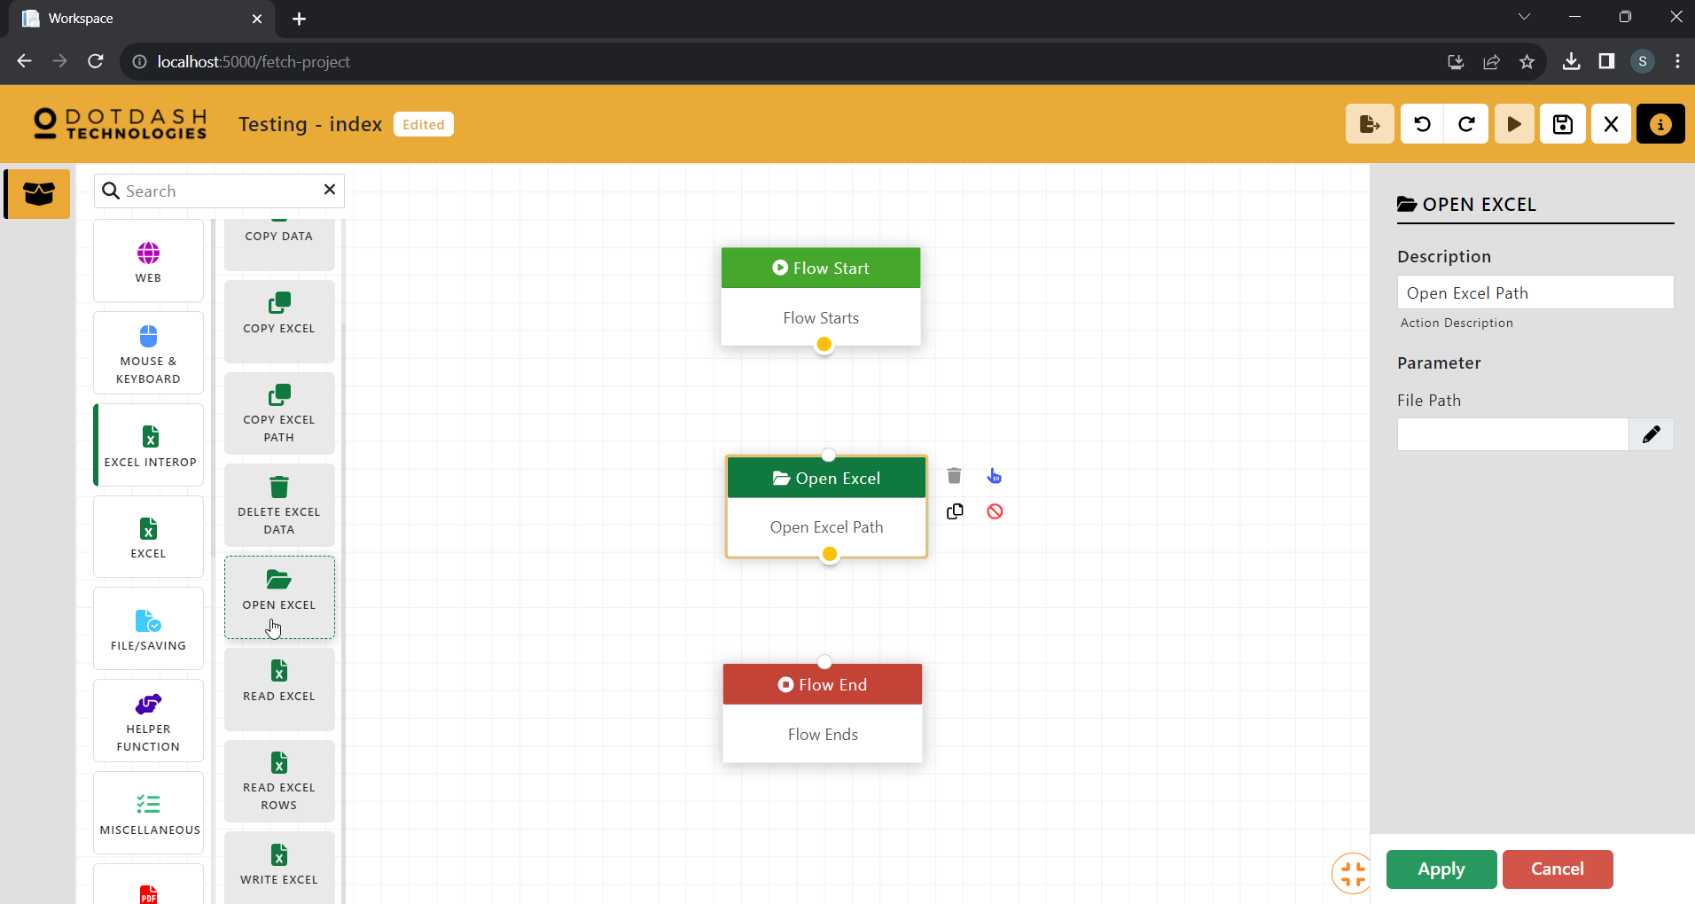

Function: Open an excel file

| Parameter | Description |
| --- | --- |
| File Path | The file path of the excel file to be opened. |

#### Read Excel

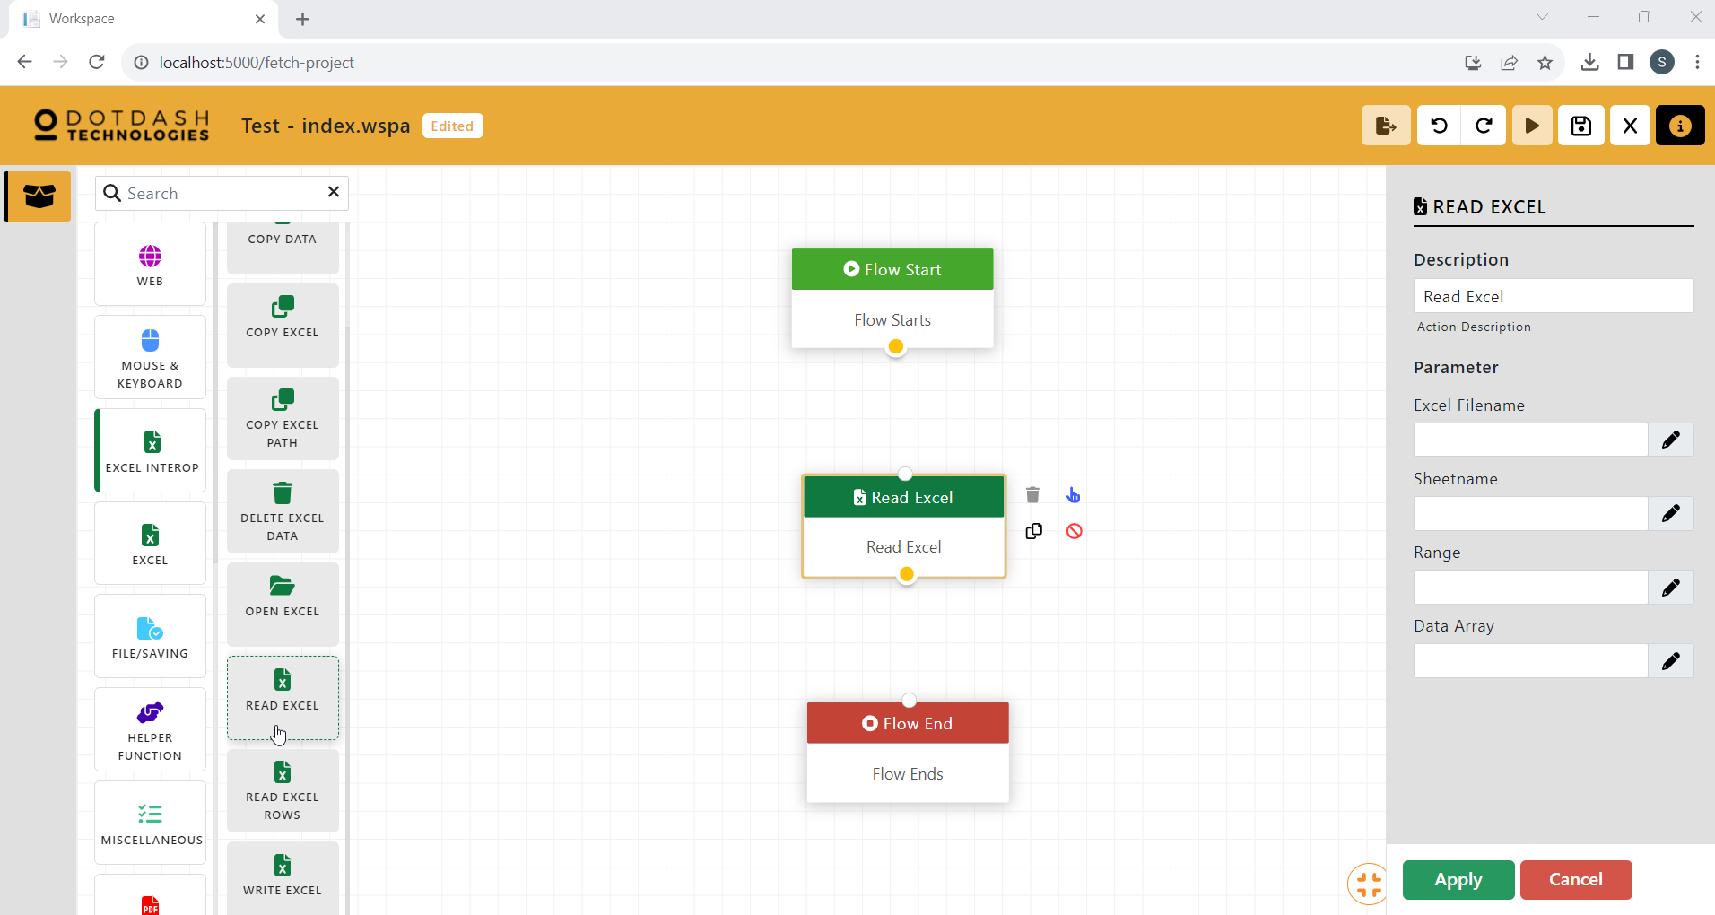

Function: To read a range of data into a data array

| Parameter | Description |
| --- | --- |
| Excel Filename | The file path of the excel file. |
| Sheetname | The name of the excel sheet. |
| Range | The range of data to be read. |
| Data Array | The data array variable to store the data. |

#### Read Excel Rows

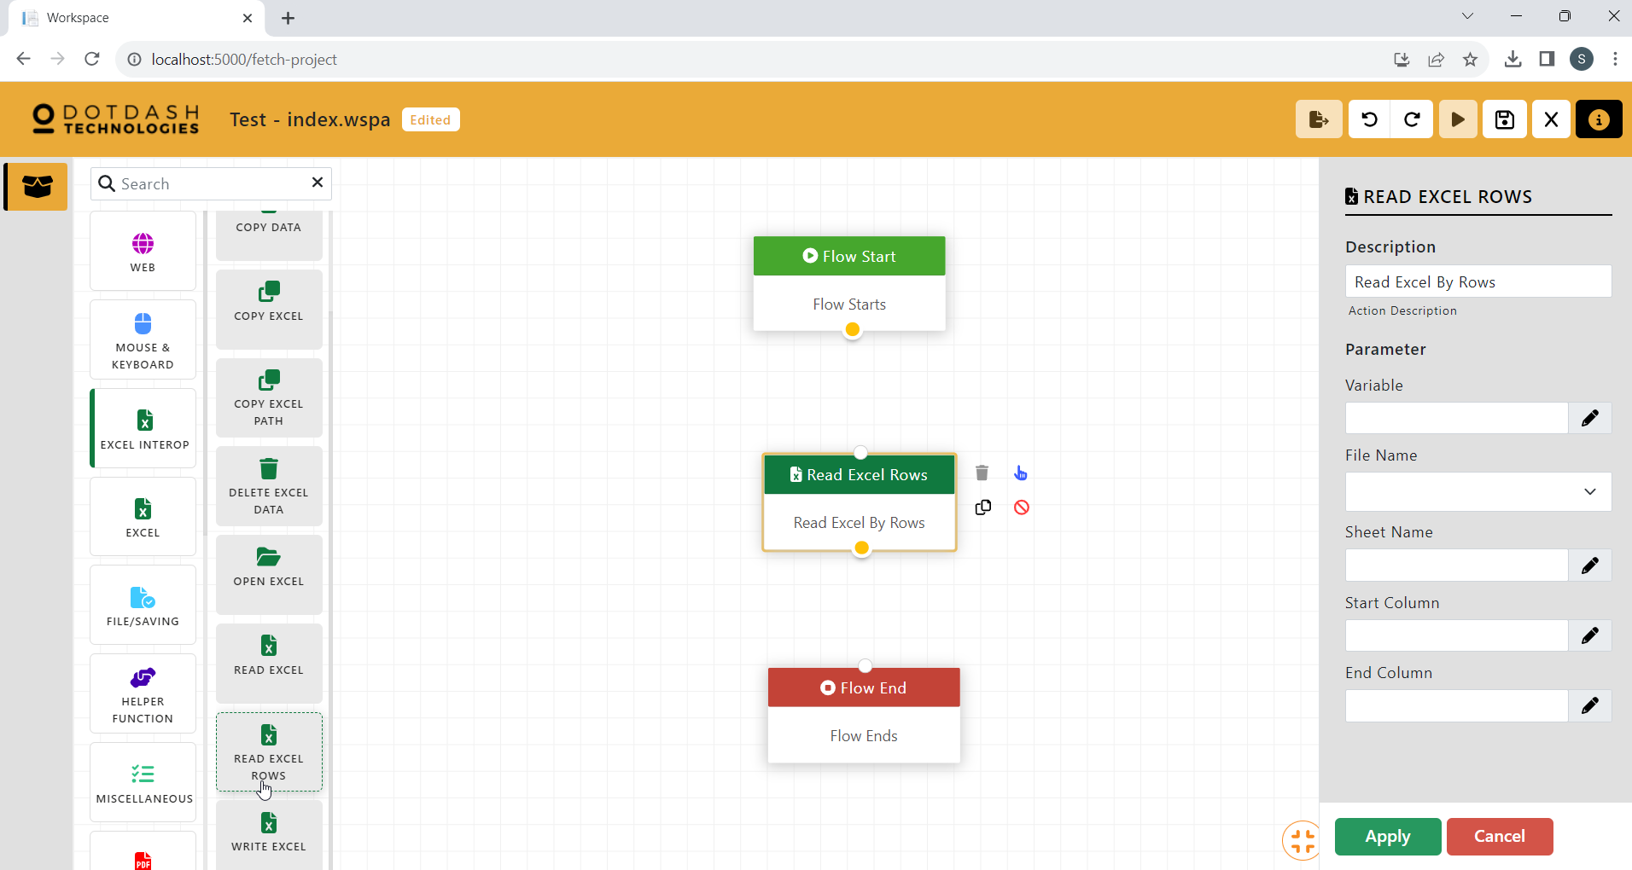

Function: Read a row of data into a variable

| Parameter | Description |
| --- | --- |
| Variable | THe variable to store the data. |
| File Name | The name of the excel file. |
| Sheet Name | The name of the excel sheet. |
| Start Column | The first column of the data range. |
| End Column | The last column of the data range. |

#### Write Excel

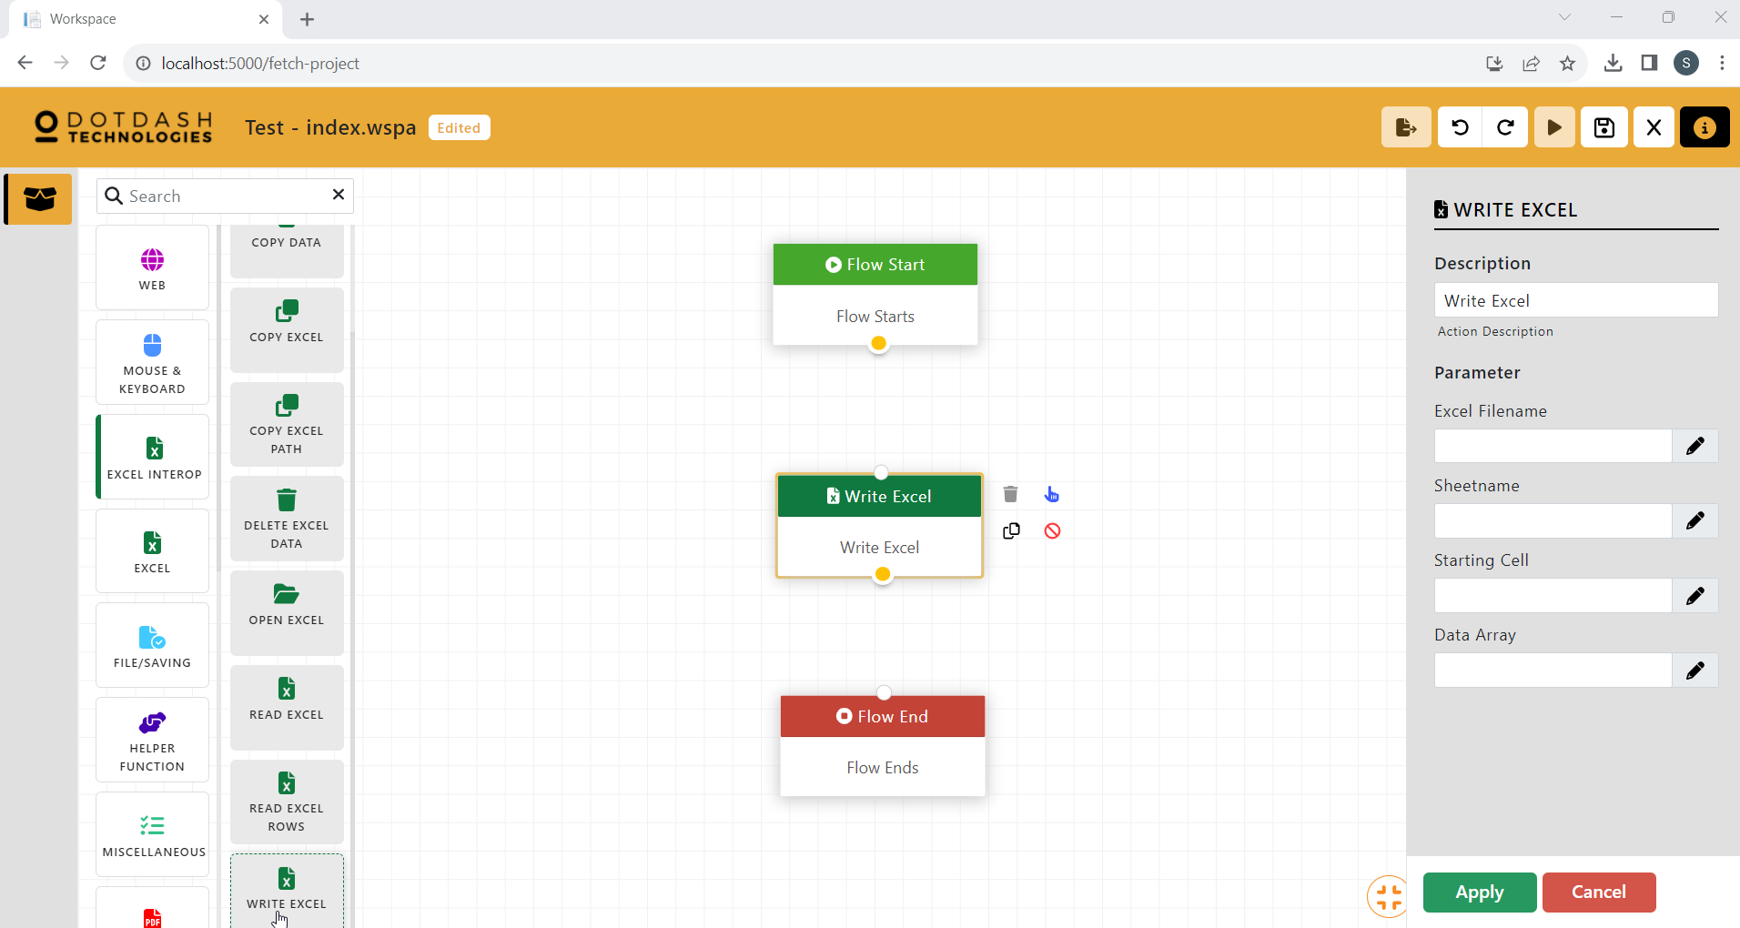

Function: To write a data array into an excel sheet

| Parameter | Description |
| --- | --- |
| Excel FIlename | The file path of the excel file. |
| Sheetname | The name of the excel sheet. |
| Starting Cell | The first cell to start writing the data. |
| Data Array | The data array that will be used to write into the excel. |

### Excel

#### Add Column

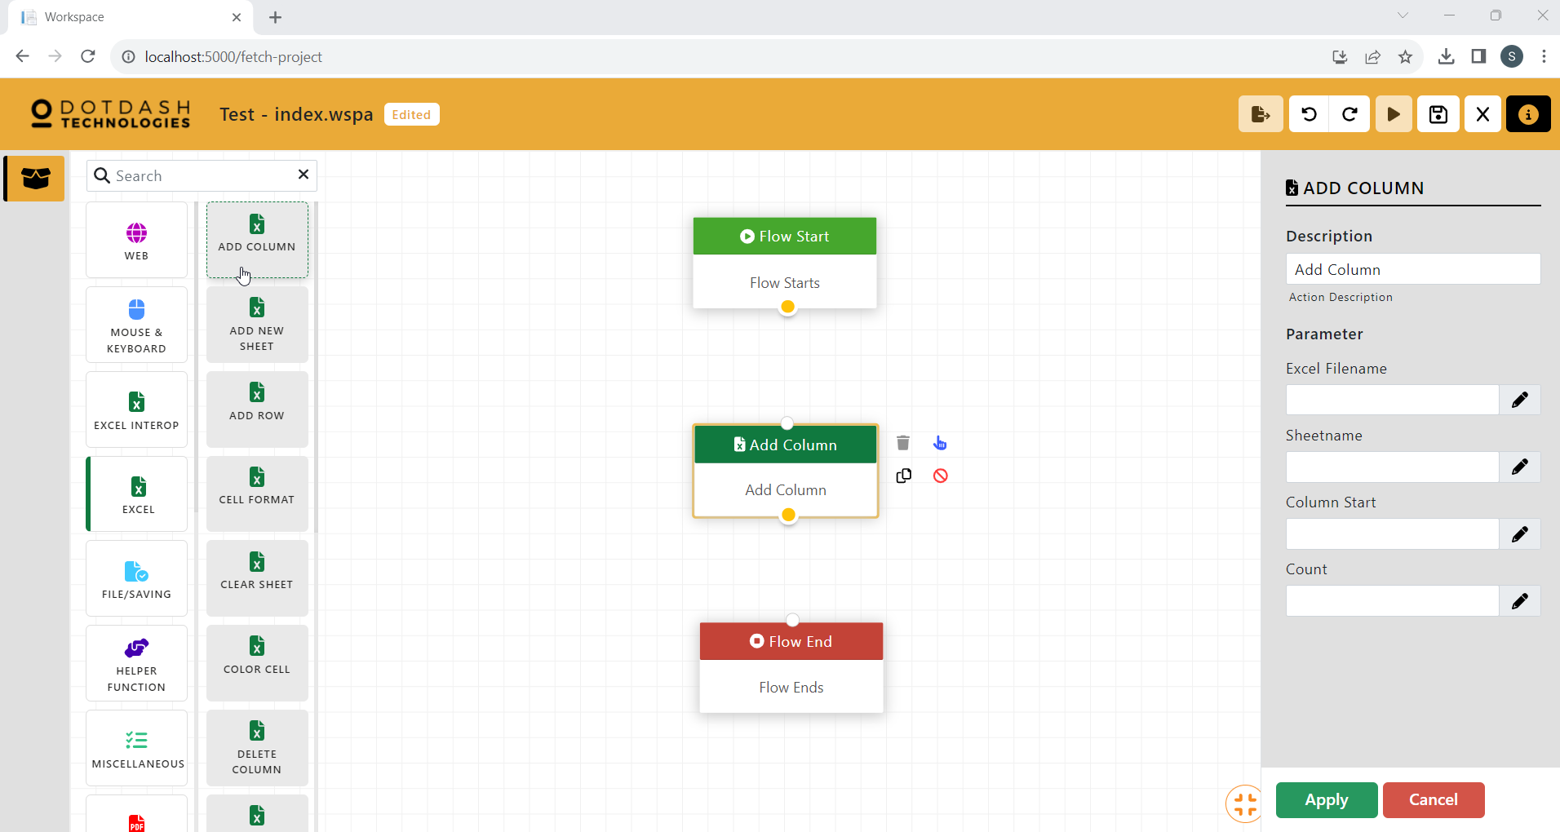

Function: This function is to add columns in the excel file. It will use the insert column function of excel.

| Parameter | Description |
| --- | --- |
| Excel Filename | The file path of the excel file. |
| Sheetname | The name of the excel sheet. |
| Column Start | The starting column to add new columns. |
| Count | The number of columns to be added. |

#### Add New Sheet

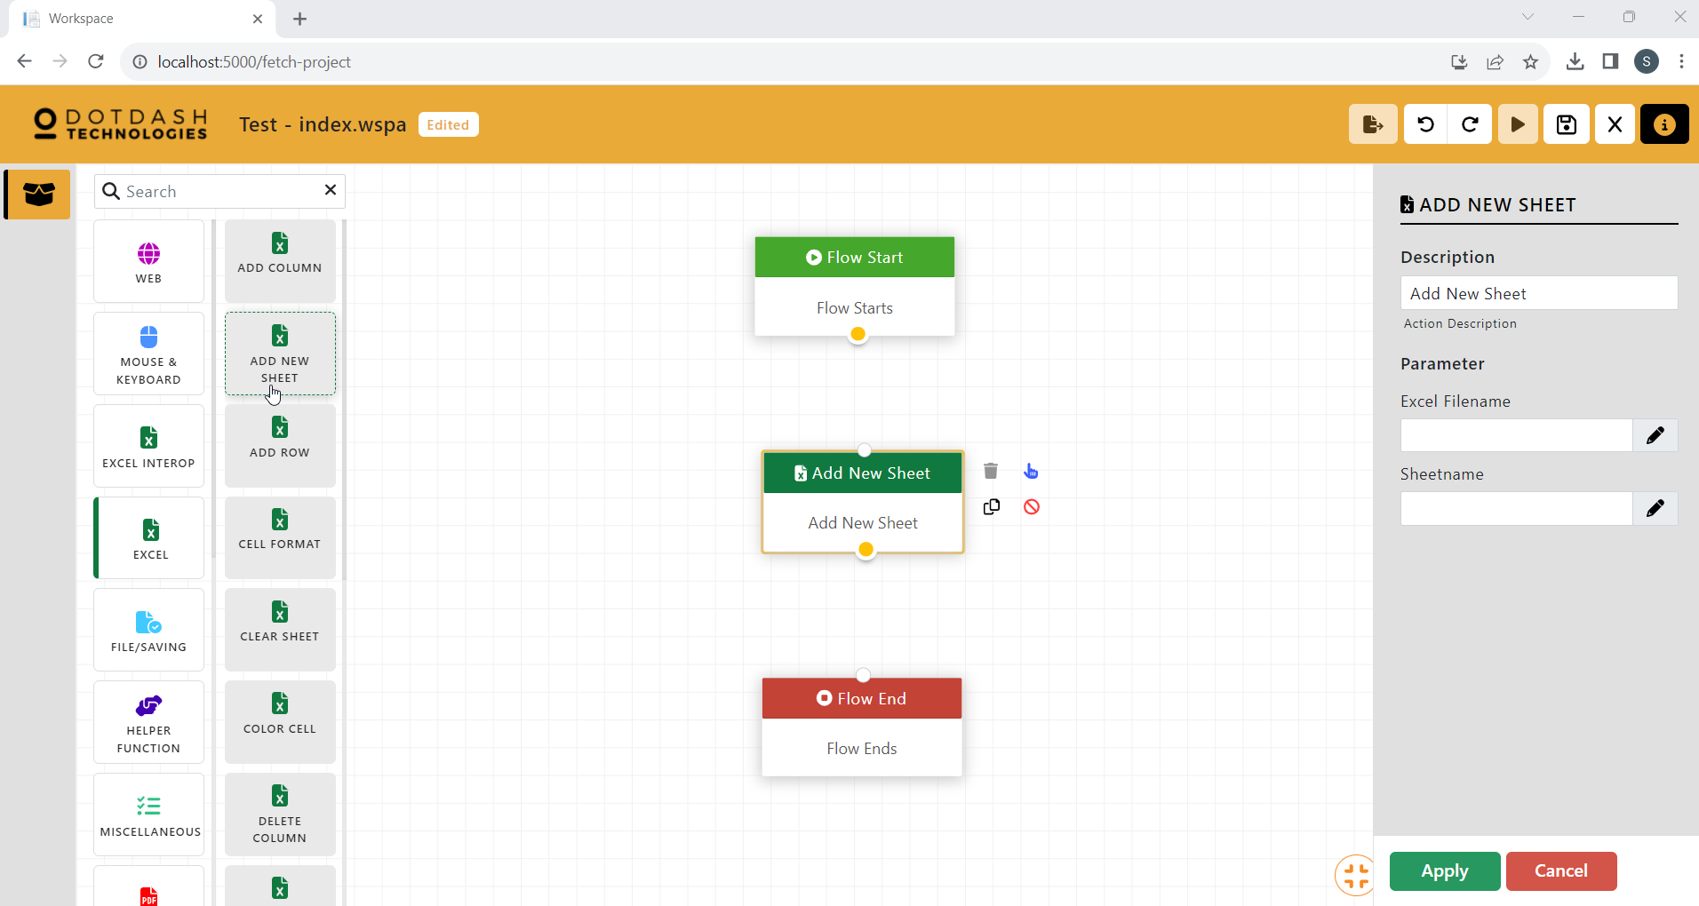

Function: This function is to add a new sheet to an excel file.

| Parameter | Description |
| --- | --- |
| Excel Filename | The file path of the excel file. |
| Sheetname | The name of the new sheet to be added. |

#### Add Row

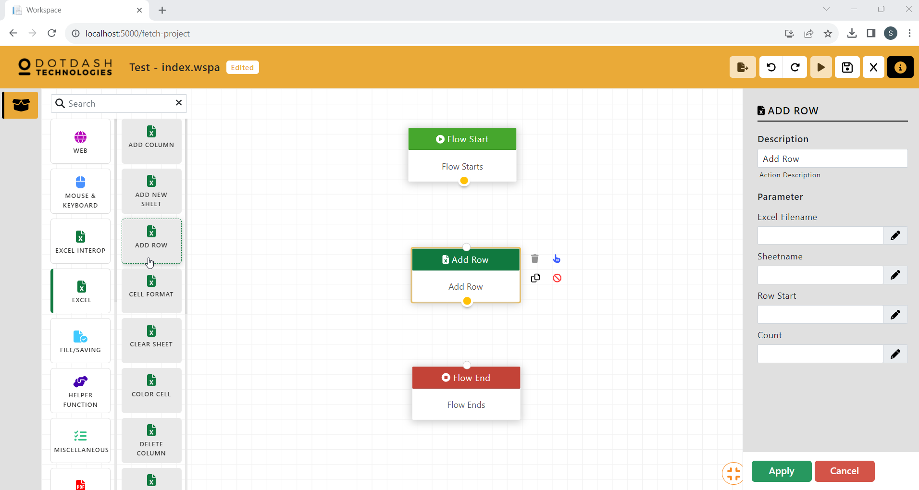

Function: This function is to add rows in the excel file. It will use the insert row function of excel.

| Parameter | Description |
| --- | --- |
| Excel Filename | The file path of the excel file. |
| Sheetname | The name of the excel sheet. |
| Row Start | The starting row to add new rows. |
| Count | The number of rows to be added. |

#### Cell Format

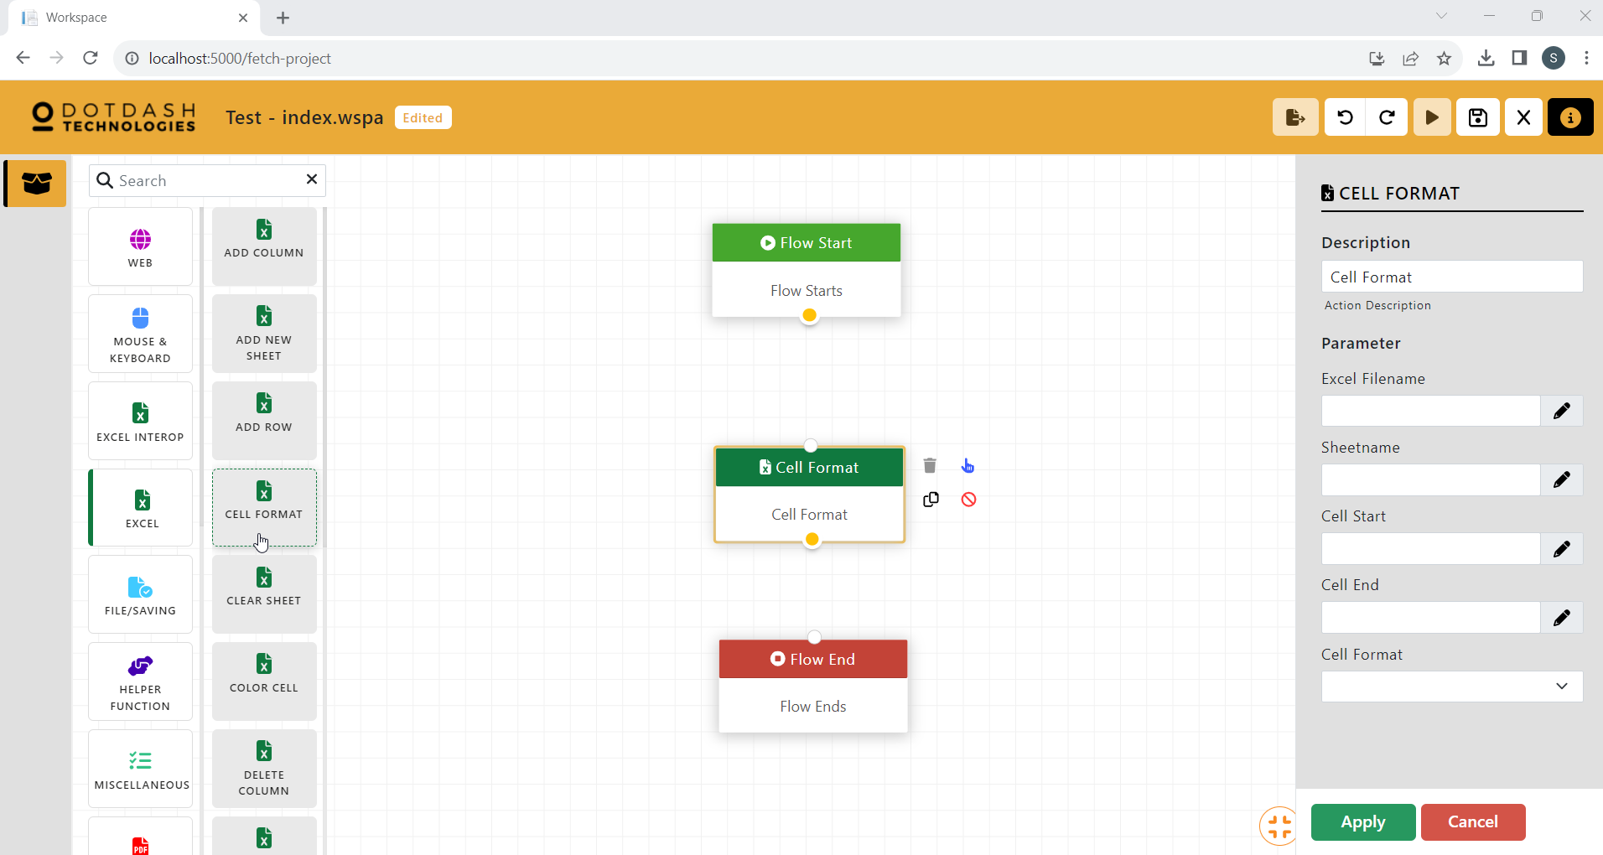

Function: This function is to set the format for a range of cells in an excel file.

| Parameter | Description |
| --- | --- |
| Excel FIlename | The file path of the excel file. |
| Sheetname | The name of the excel sheet. |
| Cell Start | The first cell of the cell range. |
| Cell End | THe last cell of the cell range. |
| Cell Format | The format to be set for the cell range. |

#### Clear Sheet

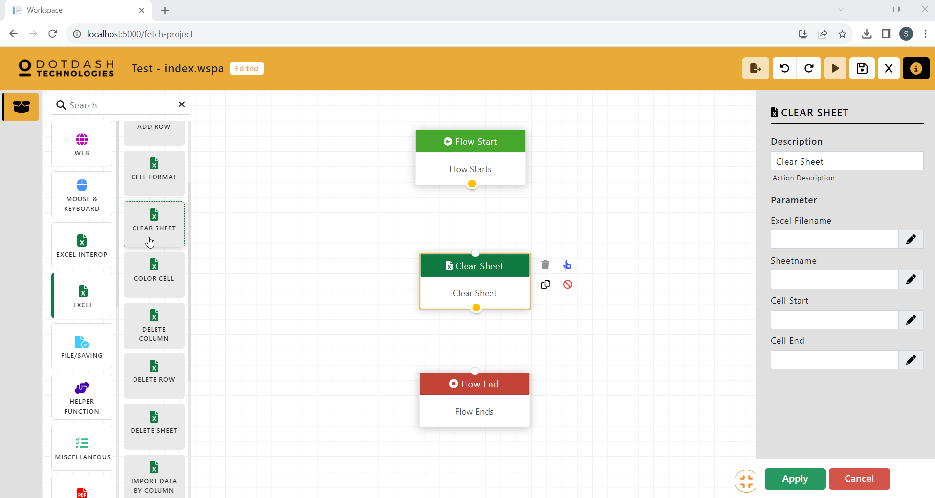

Function: This function is to clear the cell in an excel sheet.

| Parameter | Description |
| --- | --- |
| Excel Filename | The file path of the excel file. |
| Sheetname | The name of the excel sheet. |
| Cell Start | The first cell of the cell range. |
| Cell End | The last cell of the cell range. |

#### Color Cell

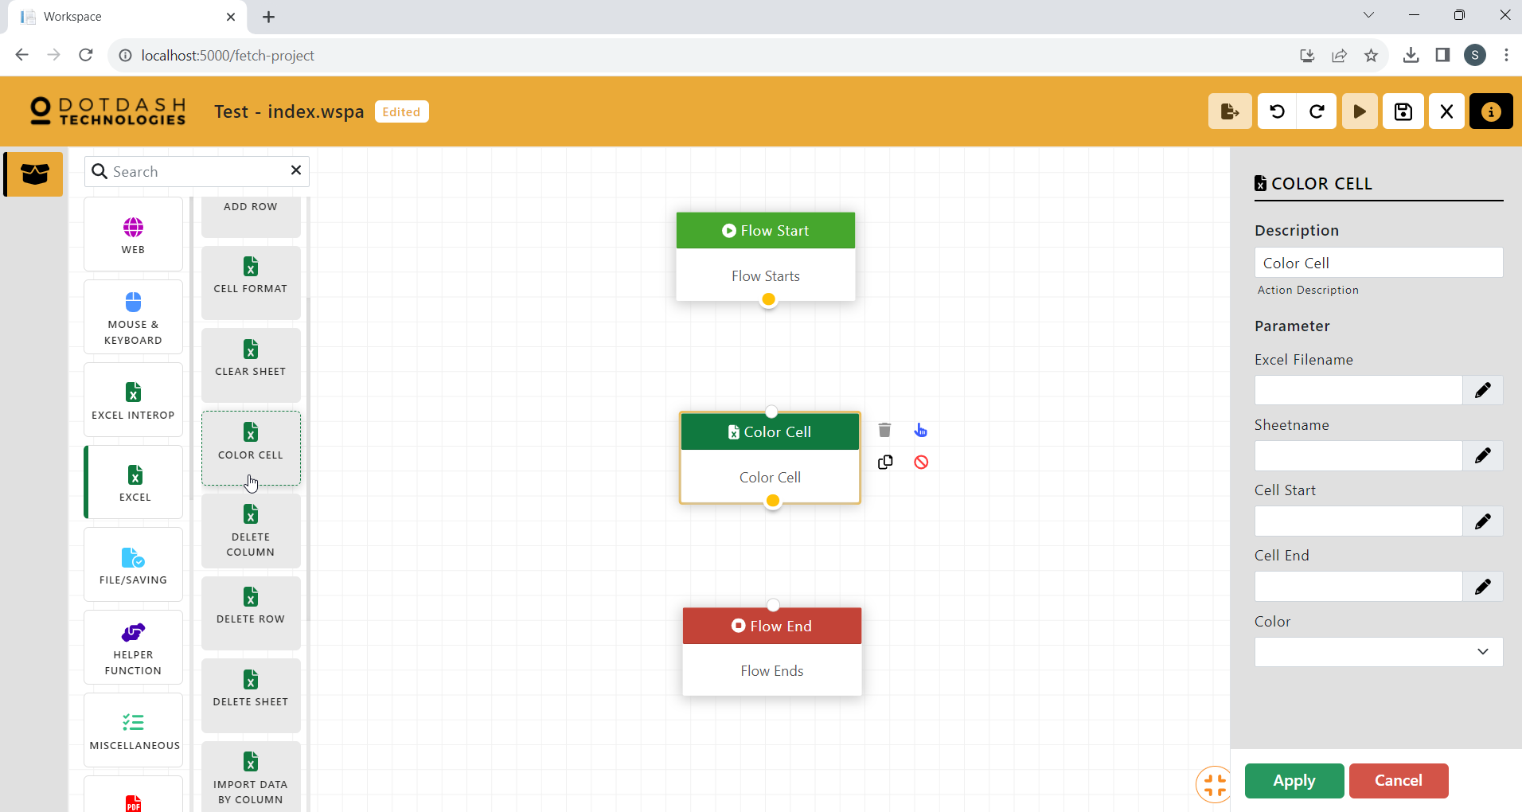

Function: This function is to color the cell in an excel file.

| Parameter | Description |
| --- | --- |
| Excel Filename | The file path of the excel file. |
| Sheetname | The name of the excel sheet. |
| Cell Start | The first cell of the cell range. |
| Cell End | The last cell of the cell range. |
| Color | The color to be set for the cell range. |

#### Delete Column

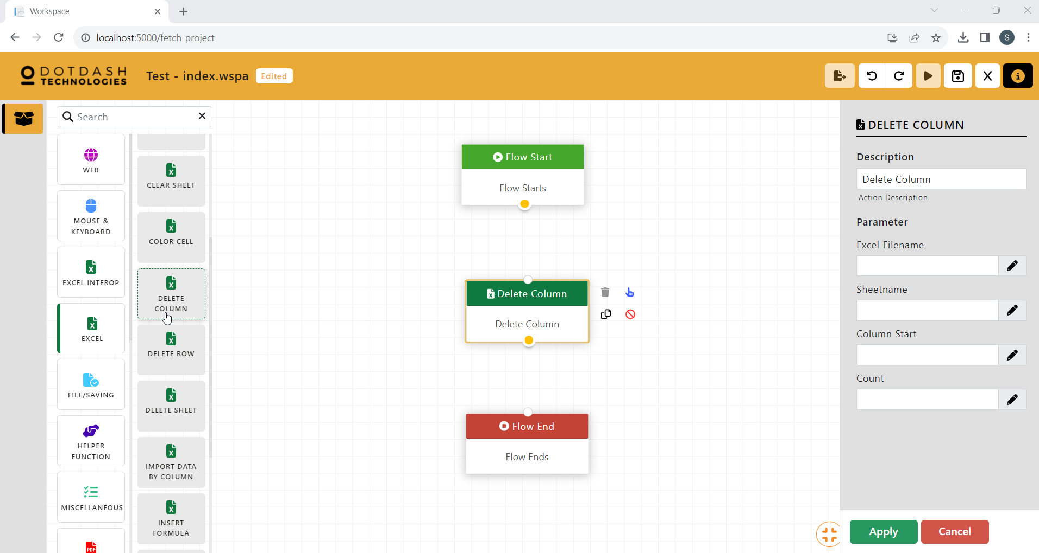

Function: This function is to delete columns in the excel file.

| Parameter | Description |
| --- | --- |
| Excel Filename | The file path of the excel file. |
| Sheetname | The name of the excel sheet. |
| Column Start | The first column to be deleted. |
| Count | The number of columns to be deleted. |

#### Delete Row

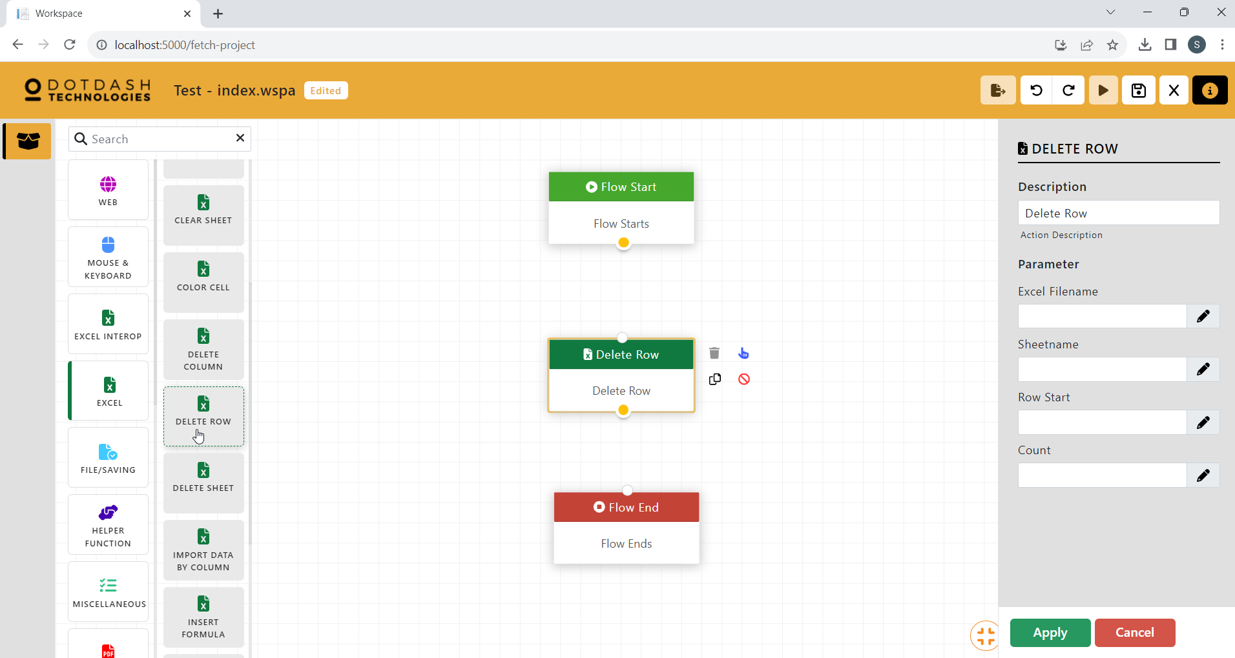

Function: This function is to delete rows in the excel file.

| Parameter | Description |
| --- | --- |
| Excel Filename | The file path of the excel file. |
| Sheetname | The name of the excel sheet. |
| Row Start | The first row to be deleted. |
| Count | The number of rows to be deleted. |

#### Delete Sheet

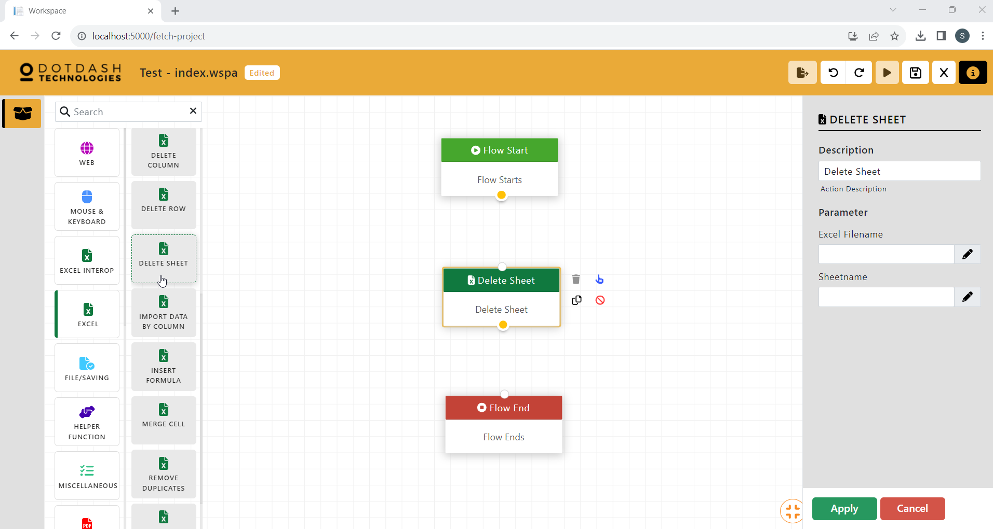

Function: This function is to delete a sheet of an excel file.

| Parameter | Description |
| --- | --- |
| Excel Filename | The file path of the excel file. |
| Sheetname | The name of the excel sheet. |

#### Import Data By Column

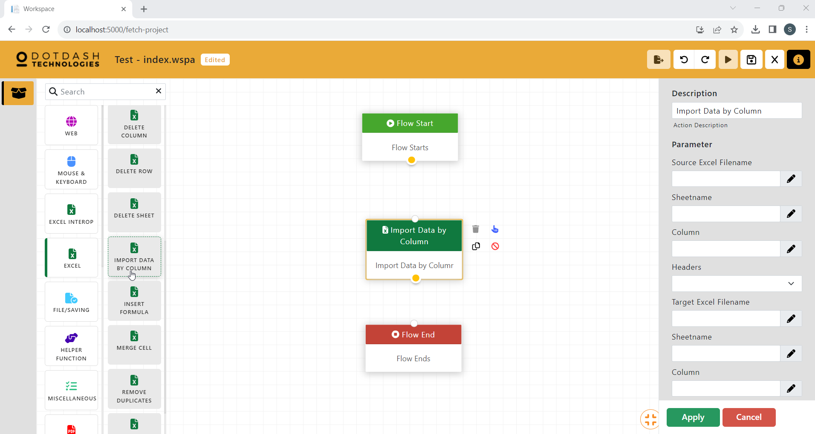

Function: Import entire column from one excel sheet to another

| Parameter | Description |
| --- | --- |
| Source Excel Filename | The file path of the source excel file. |
| Sheetname | THe name of the source excel sheet. |
| Column | The column to be copied. |
| Headers | An option to import the headers or not. |
| Target Excel Filename | The file path of the target excel file. |
| Sheetname | The name of the target excel sheet. |
| Column | The column to import the data. |

#### Insert Formula

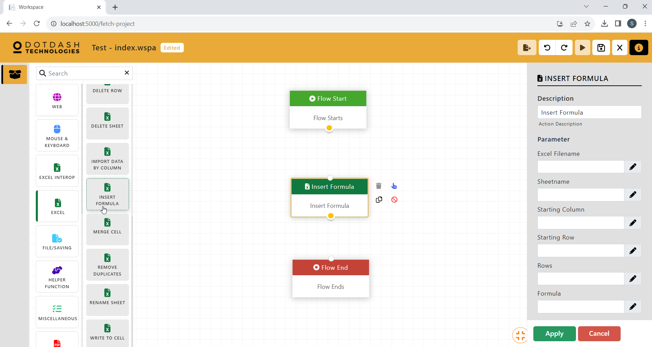

Function: To insert formula to a row of cells

| Parameter | Description |
| --- | --- |
| Excel Filename | The file path of the excel file. |
| Sheetname | The name of the excel sheet. |
| Starting Column | The column of the first cell. |
| Starting Row | The row of the first cell. |
| Rows | The number of rows after the first cell. |
| Formula | The formula to be inserted into the cell range. |

#### Merge Cell

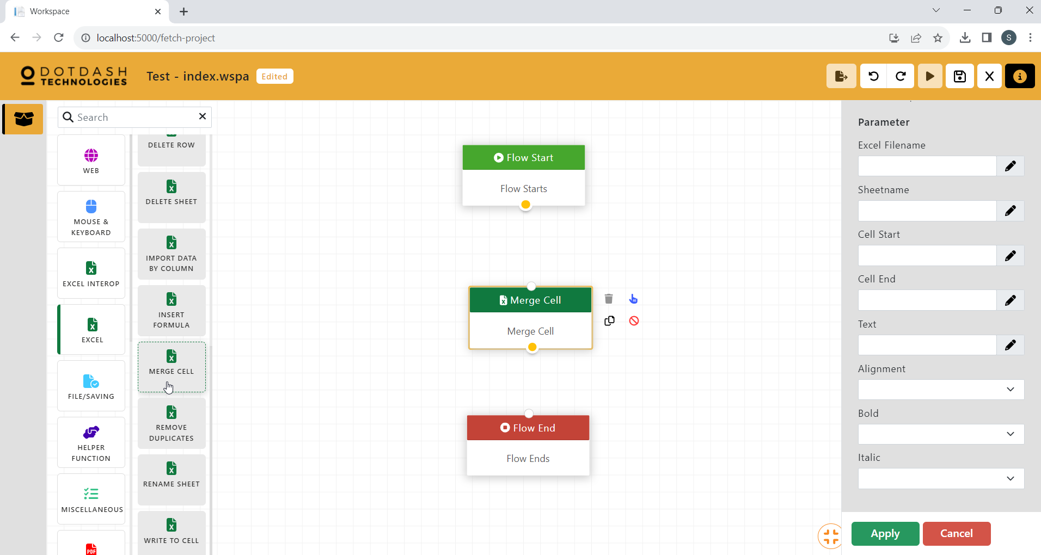

Function: To merge two or more cells together

| Parameter | Description |
| --- | --- |
| Excel FIlename | The file path of the excel file. |
| Sheetname | The name of the excel sheet. |
| Cell Start | The first cell of the cell range. |
| Cell End | The last cell of the cell range. |
| Text | Th text to be written into the merged cell. |
| Alignment | The text alignment of the merged cell. |
| Bold | An option to make the text bold. |
| Italic | An option to make the text italic. |

#### Remove Duplicates

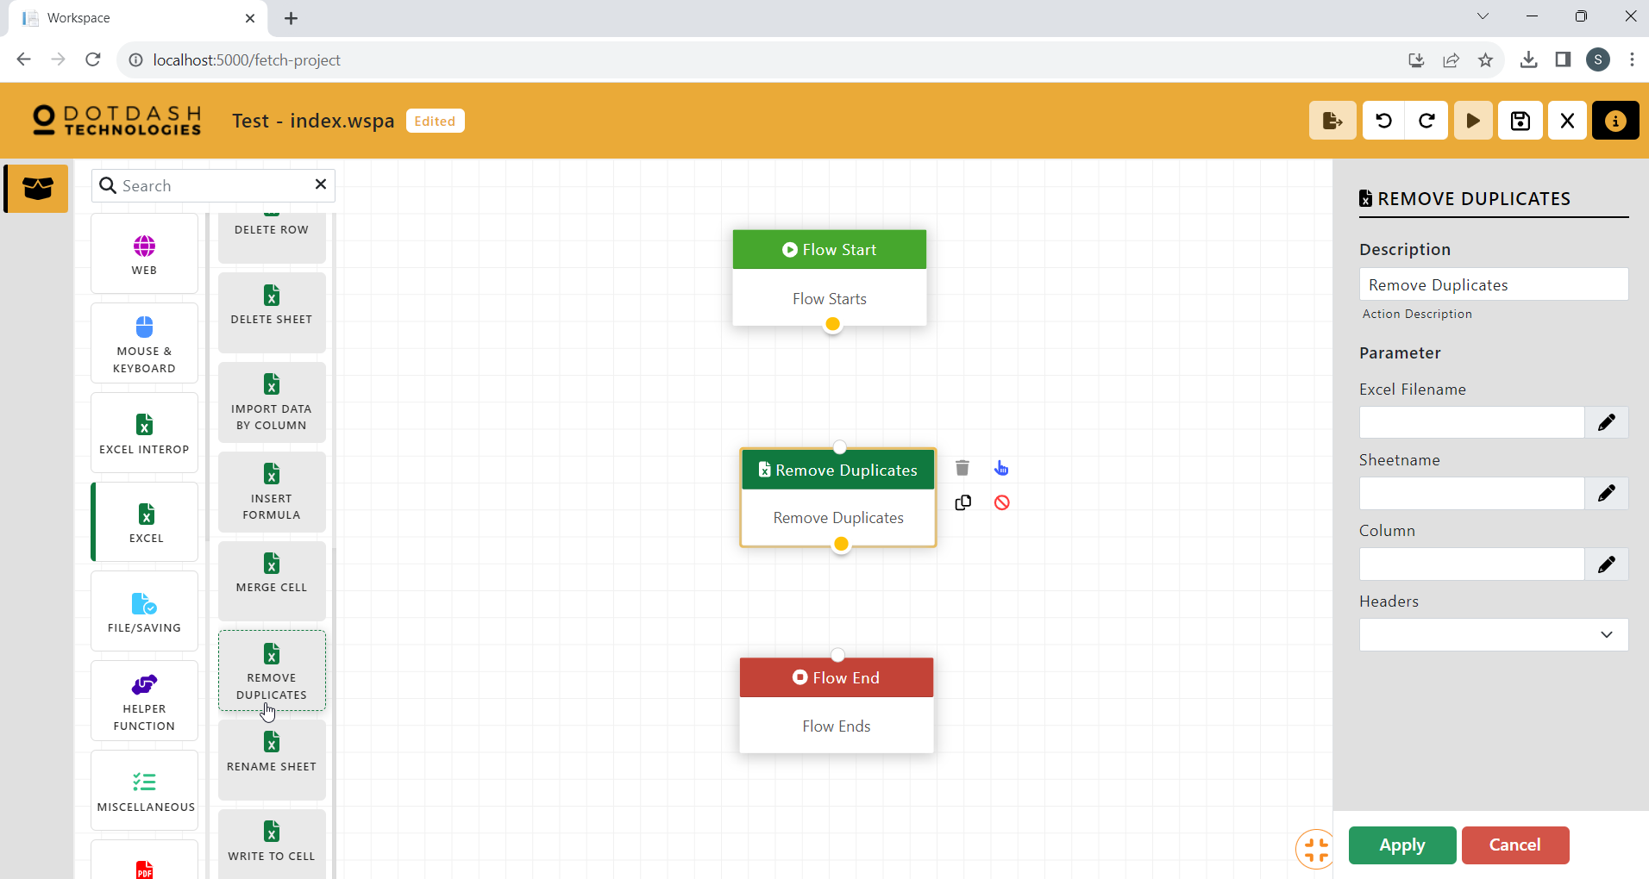

Function: To remove all duplicates in the same column

| Parameter | Description |
| --- | --- |
| Excel Filename | The file path of the excel file. |
| Sheetname | The name of the excel sheet. |
| Column | THe column to remove duplicates. |
| Headers | An option for if there is a header or not. |

#### Rename Sheet

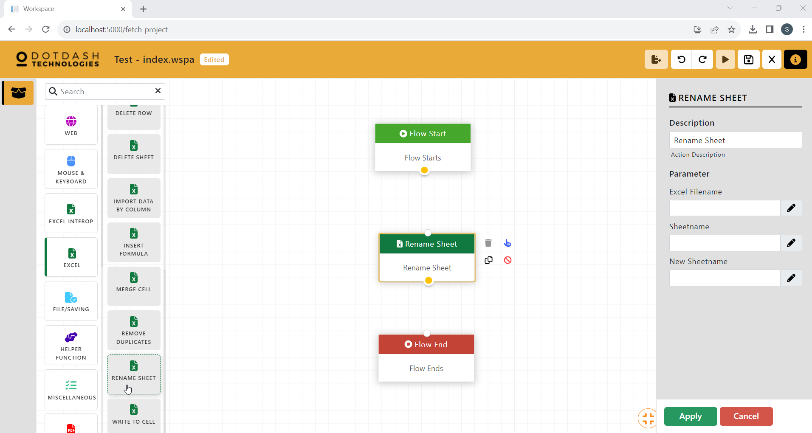

Function: To rename an existing sheet

| Parameter | Description |
| --- | --- |
| Excel FIlename | The file path of the excel file. |
| Sheetname | The name of the excel sheet. |
| New Sheetname | The new name of the excel sheet. |

#### Write To Cell

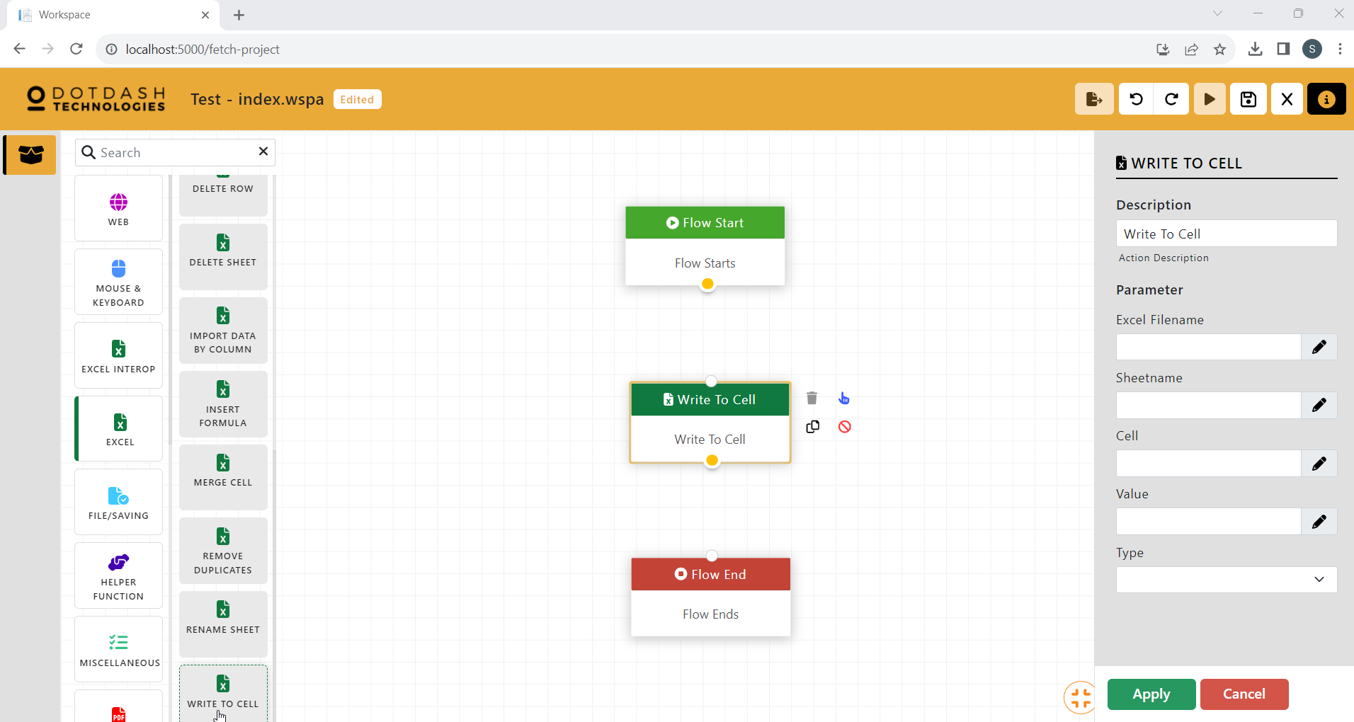

Function: To write data to a cell

| Parameter | Description |
| --- | --- |
| Excel FIlename | The file path of the excel file. |
| Sheetname | The name of the excel sheet. |
| Cell | The cell to write the data. |
| Value | The value to be written to the cell. |
| Type | The type of the value. |

### File/Saving

#### Copy Move File

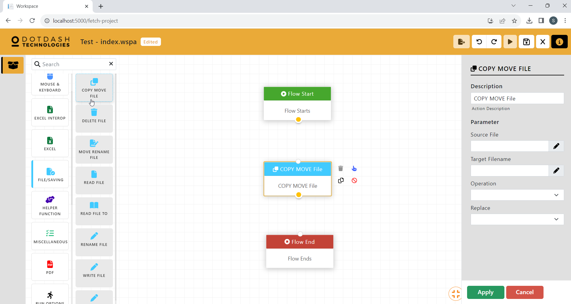

Function: To copy or move a file

| Parameter | Description |
| --- | --- |
| Source File | The file path of the source file. |
| Target File | The file path of the target file. |
| Operation | An option to copy or move the source file. |
| Replace | An option to replace the existing file in the destination path. |

#### Delete File

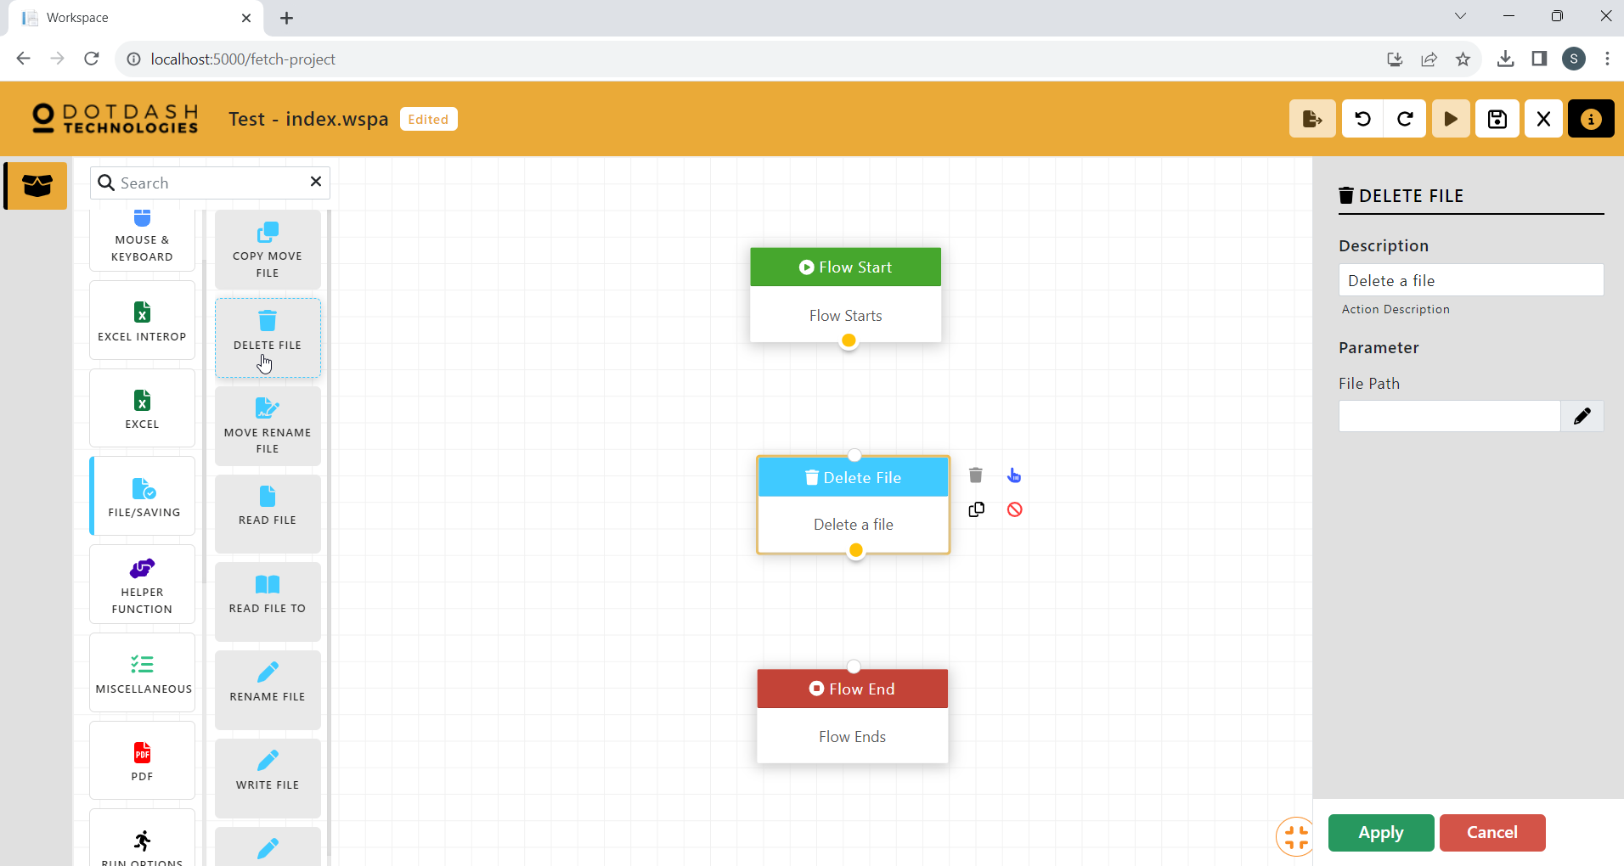

Function: To delete an existing file.

| Parameter | Description |
| --- | --- |
| File Path | The file path of the file to be deleted. |

#### Move Rename File

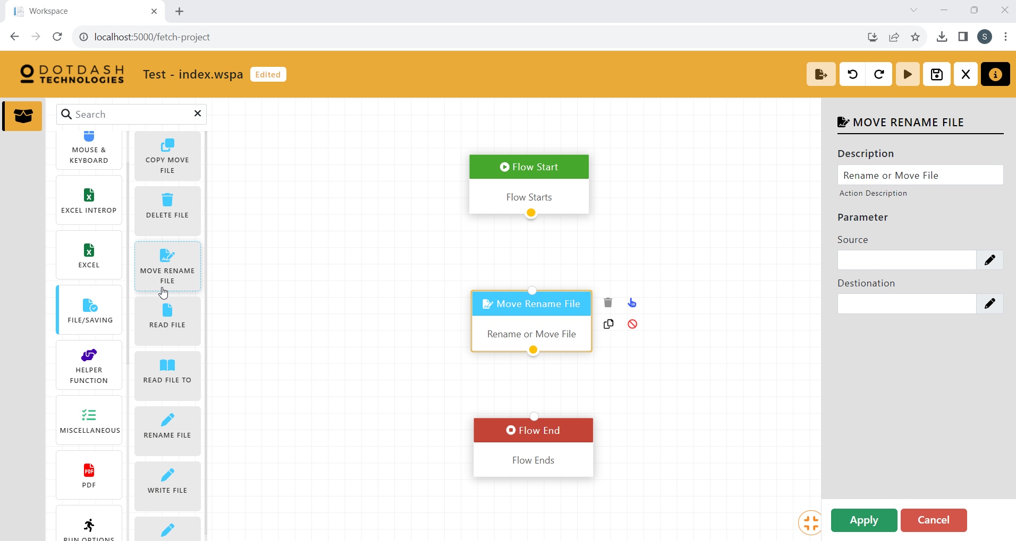

Function: To rename or move the file.

| Parameter | Description |
| --- | --- |
| Source | The file path of the source file. |
| Destination | The file path of the destination. |

#### Read File

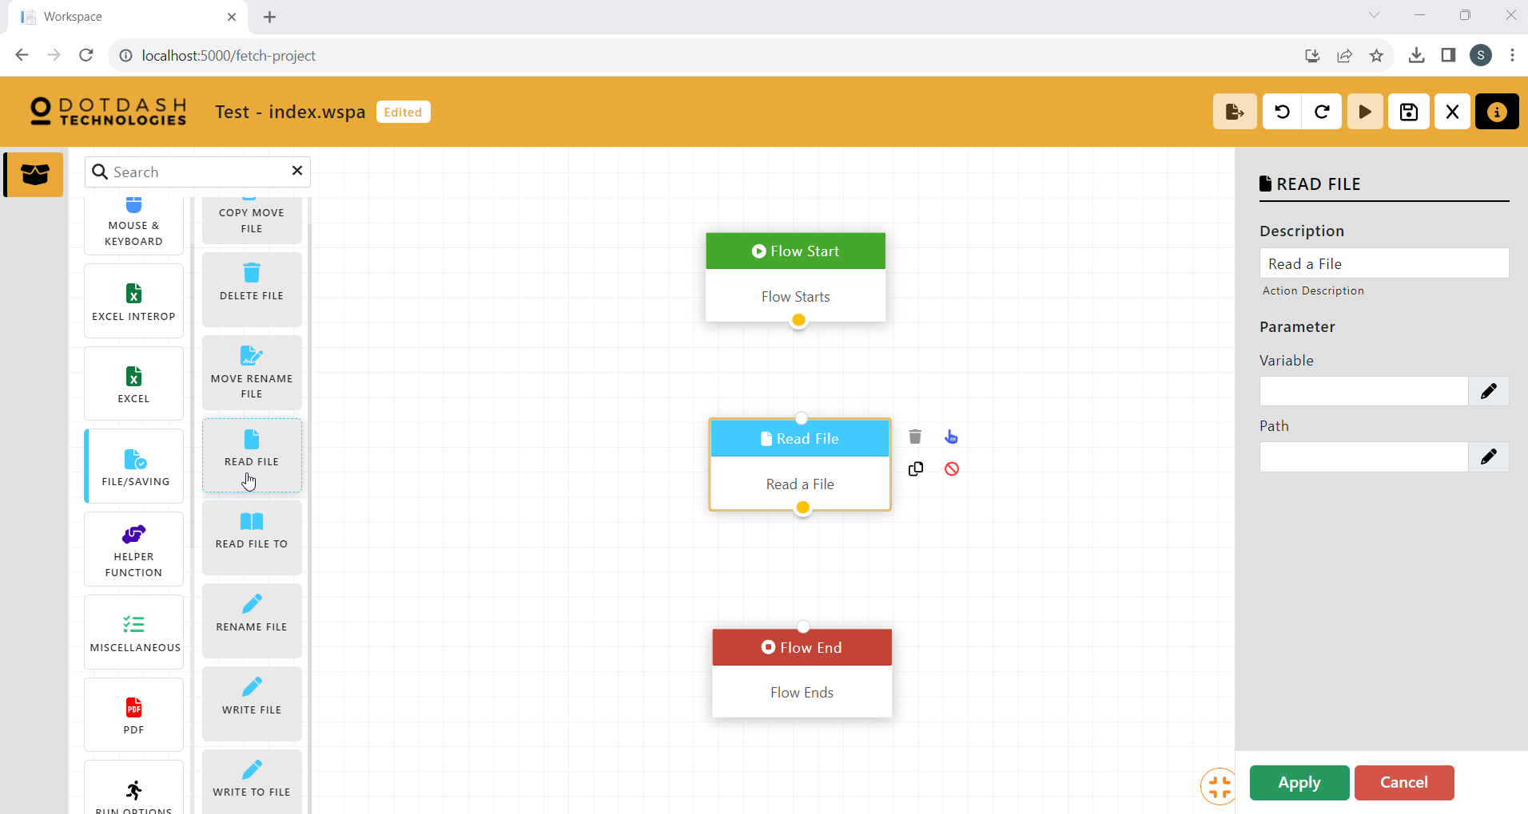

Function: To read a file and store it in a variable

| Parameter | Description |
| --- | --- |
| Variable | The variable to store the data. |
| Path | The file path of the file to be read. |

#### Read FIle To

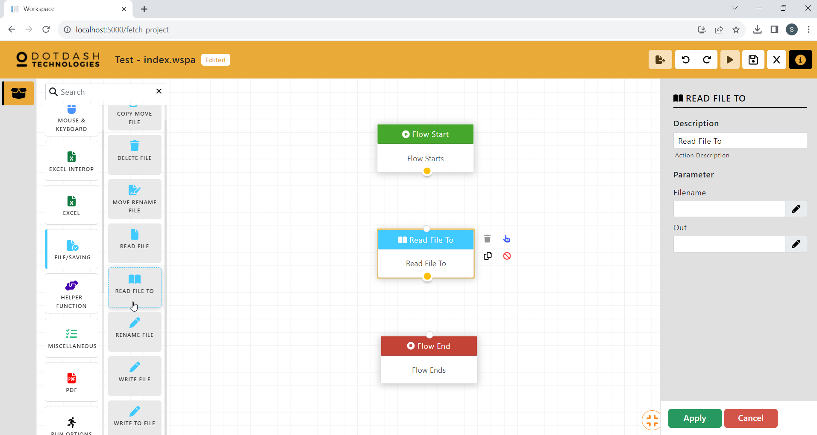

Function: To read a file and store it in a variable

| Parameter | Description |
| --- | --- |
| Filename | The file path of the file to be read. |
| Out | The variable to store the data. |

#### Rename FIle

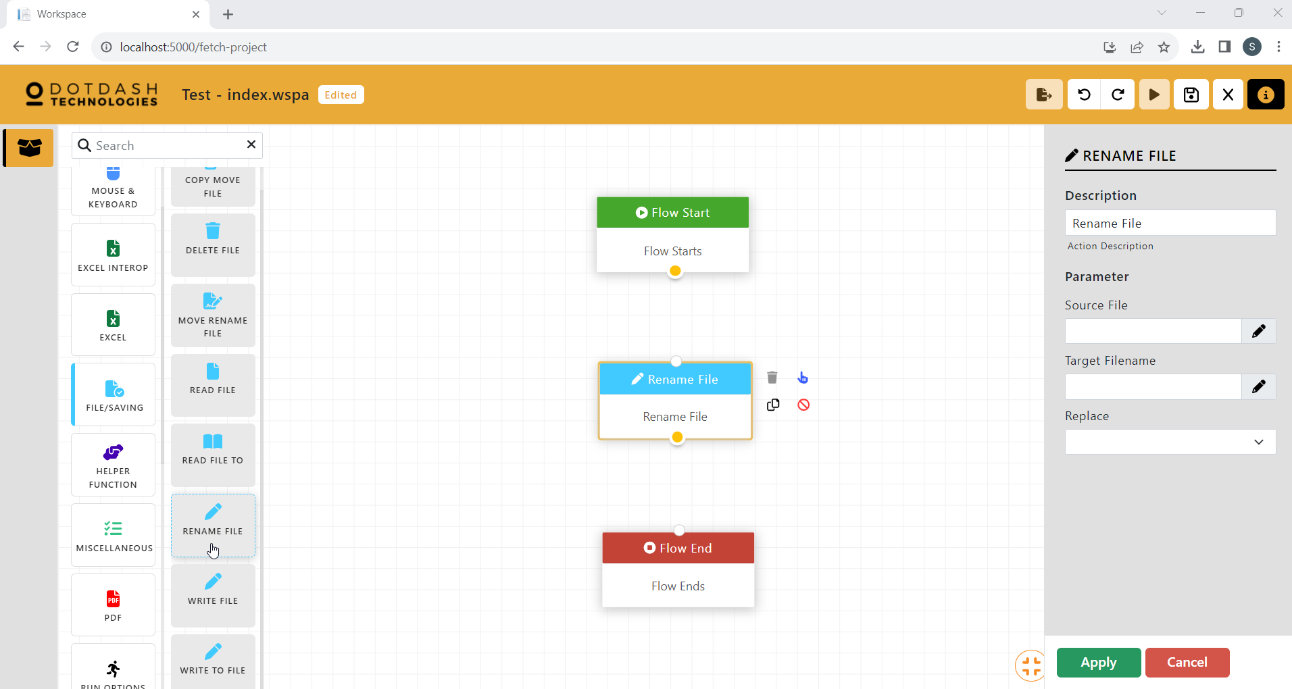

Function: To rename a file

| Parameter | Description |
| --- | --- |
| Source File | The file path of the source file. |
| Target Filename | The new file name. |
| Replace | An option to replace if another file with the same name exists. |

#### Write FIle

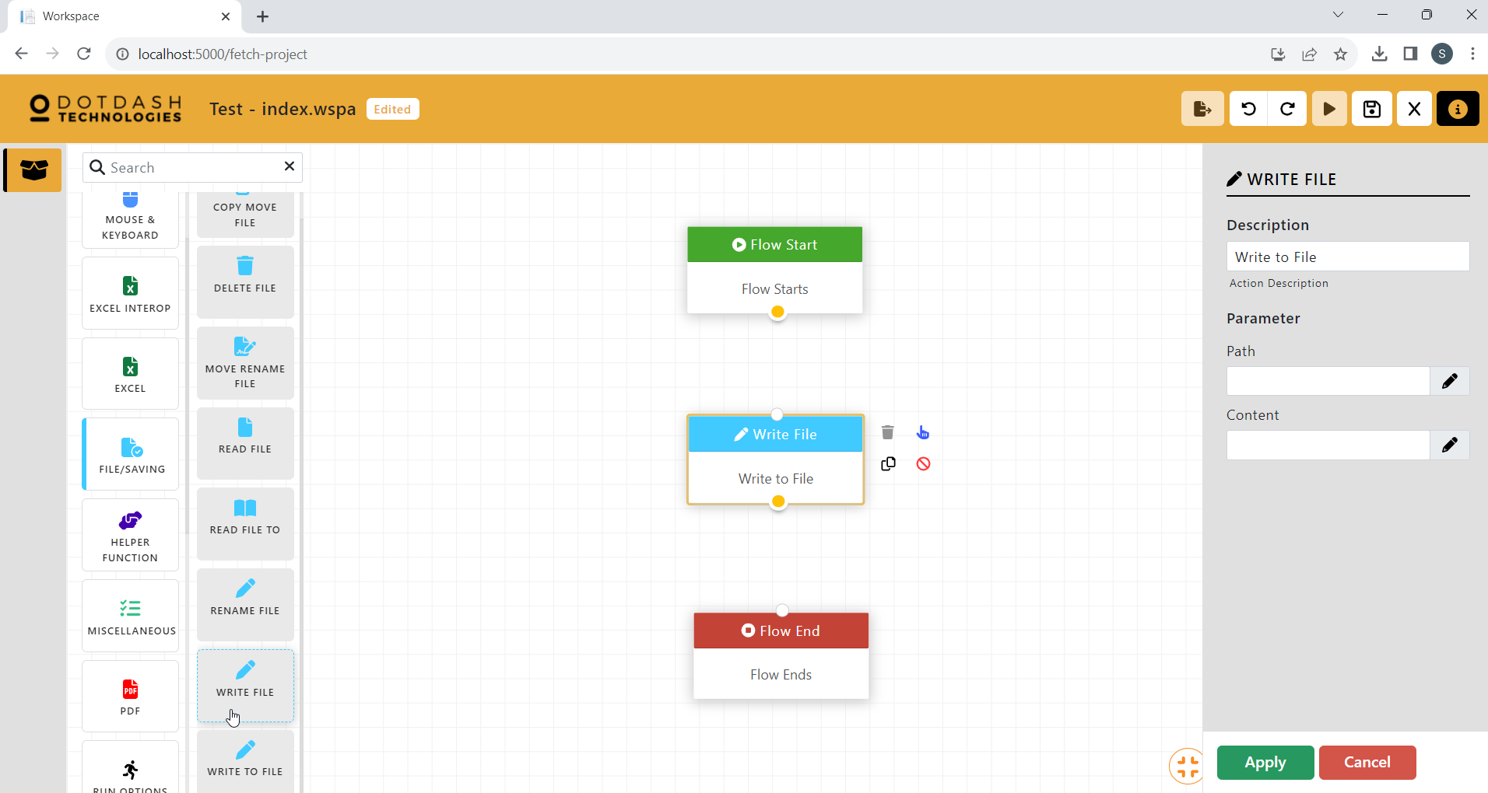

Function: To write data to a file

| Parameter | Description |
| --- | --- |
| Path | The file path of the file. |
| Content | The data to be written to the file. |

#### Write To File

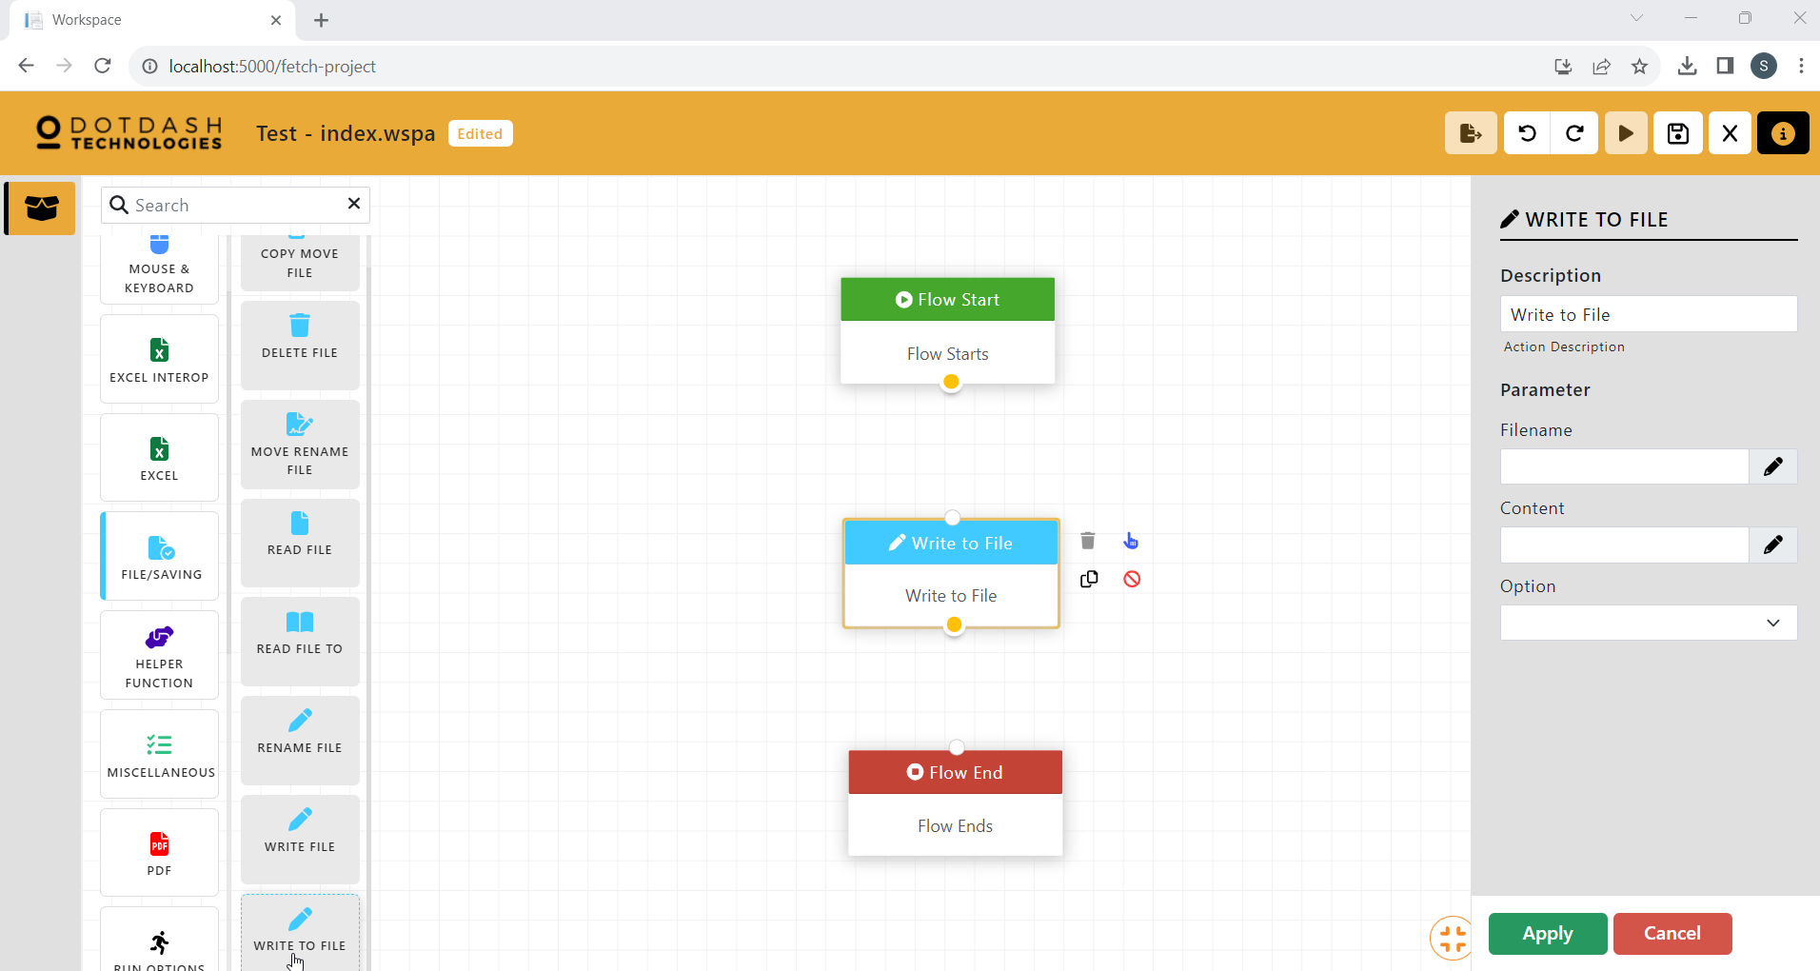

Function: To write data to a file

| Parameter | Description |
| --- | --- |
| Filename | The file path of the file. |
| Content | The data to be written to the file. |
| Option | An option to append or replace the data inside the file. |

### Helper Function

#### Close Window

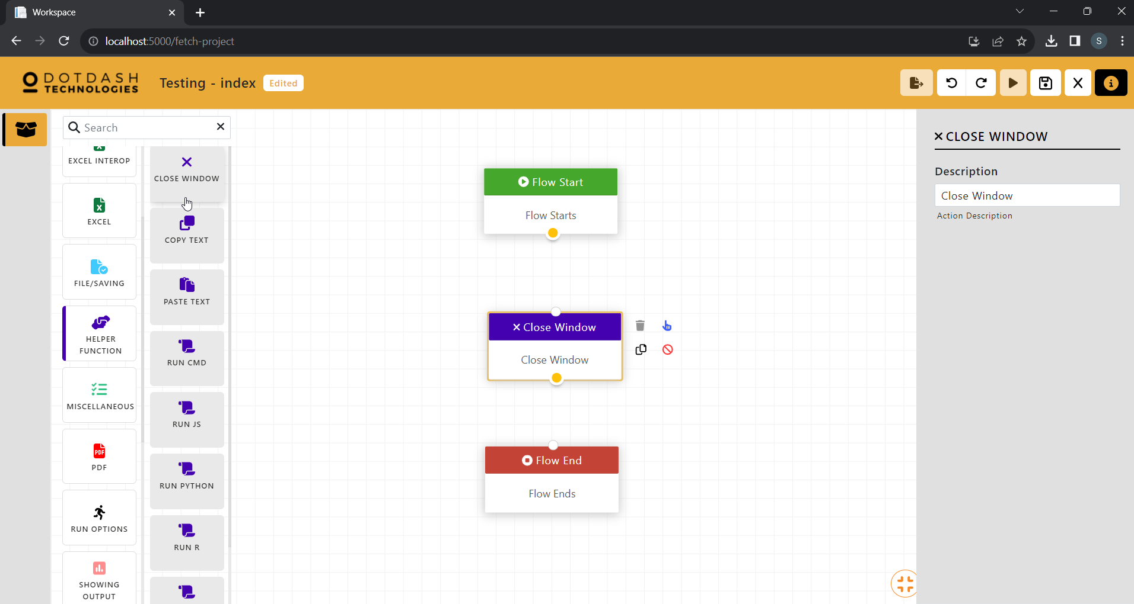

Function: To close the currently opened window

#### Copy Text

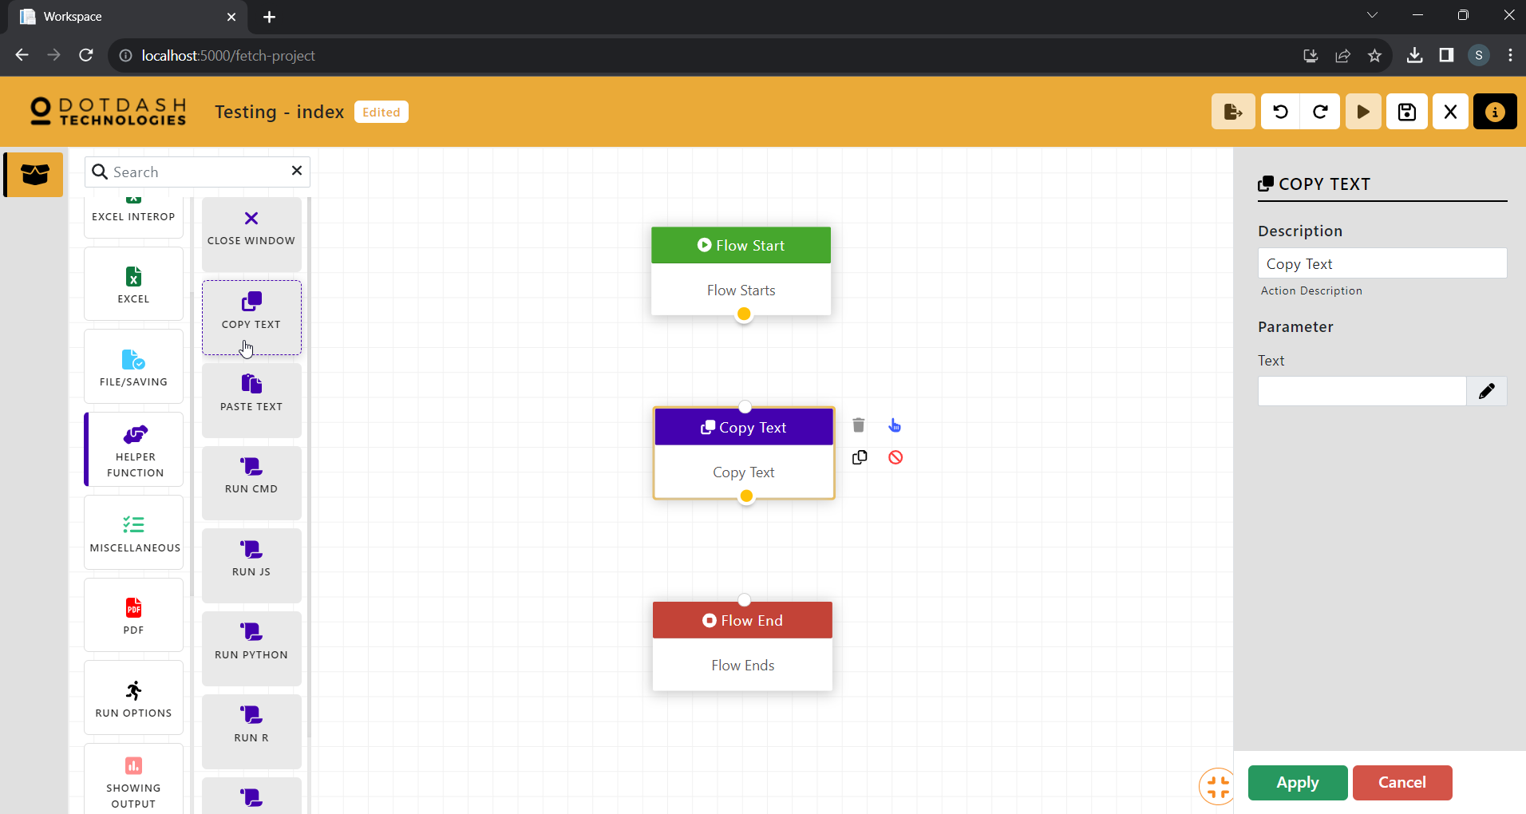

Function: To copy text to the clipboard

| Parameter | Description |
| --- | --- |
| Text | The text to be copied. |

#### Paste Text

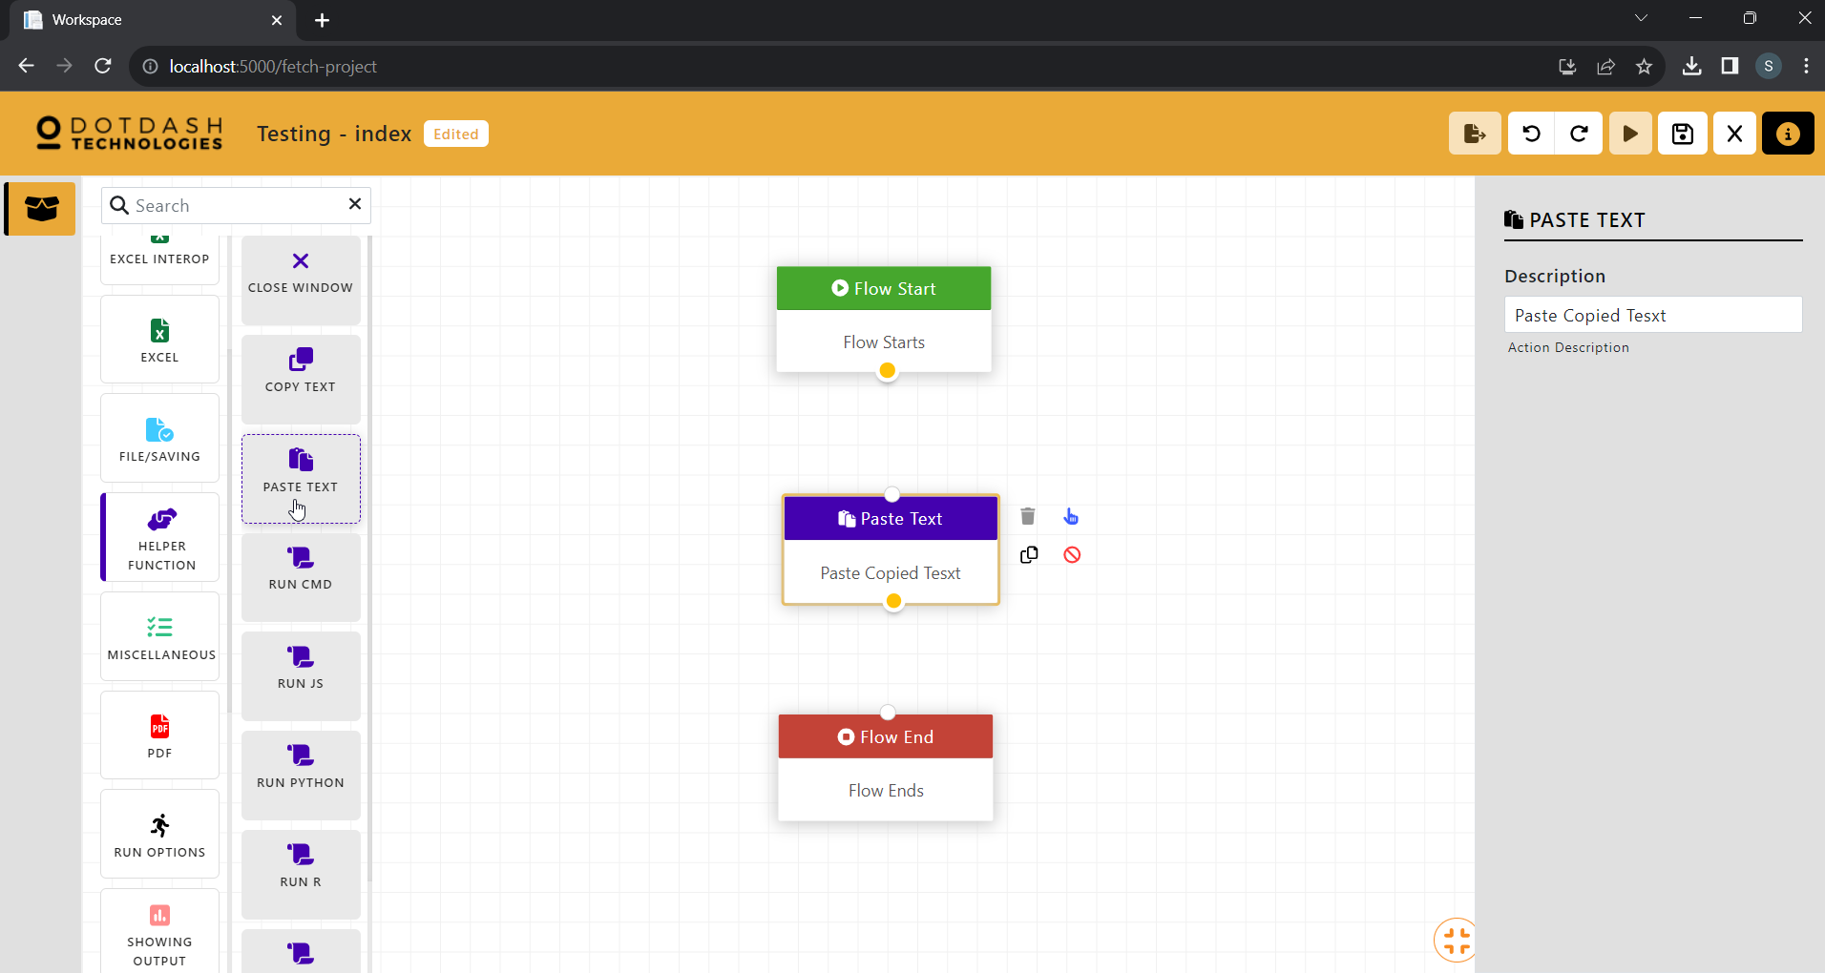

Function: To paste the text in the clipboard

#### Run CMD

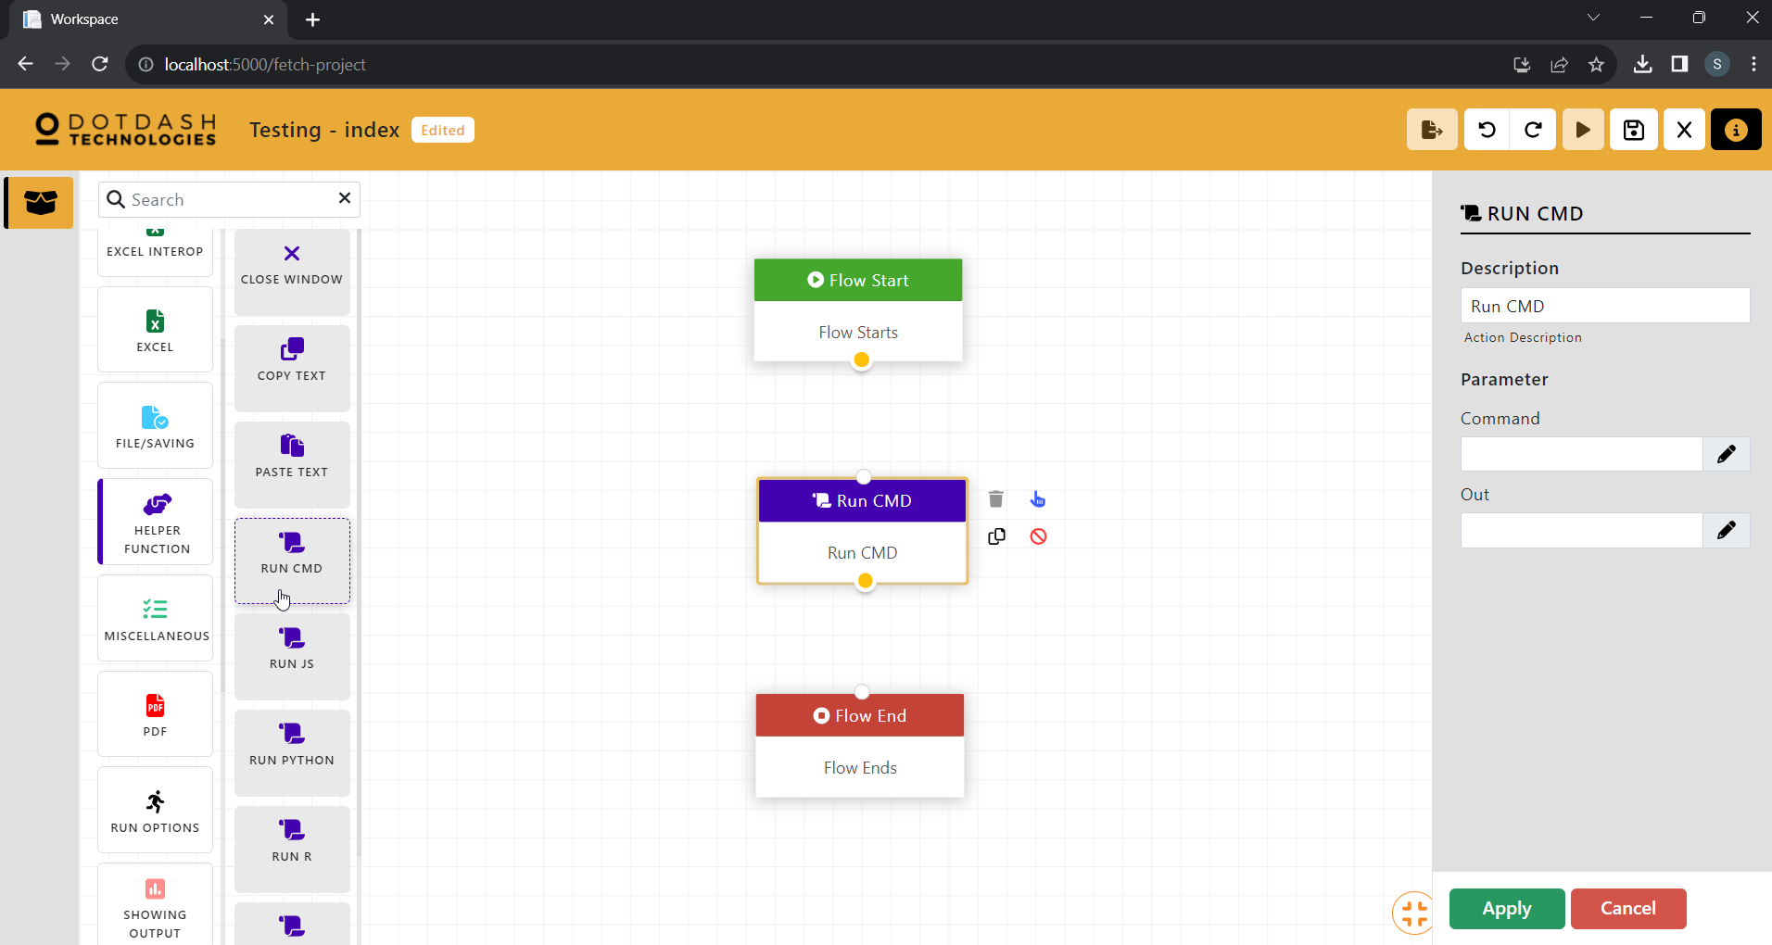

Function: To run a cmd command

| Parameter | Description |
| --- | --- |
| Command | The cmd command to be run. |
| Out | The variable to store the output. |

#### Run JS

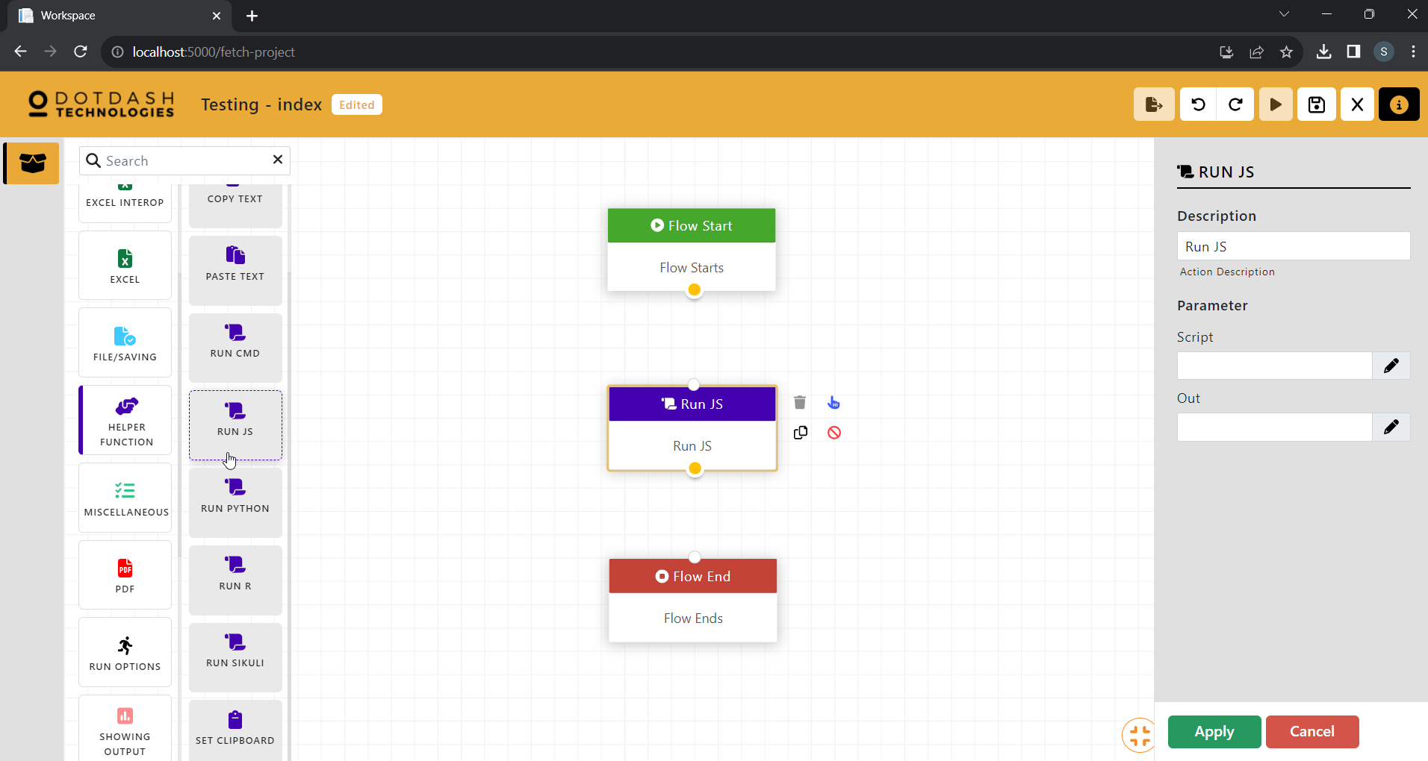

Function: To run a JavaScript code

| Parameter | Description |
| --- | --- |
| Script | The JavaScript code to be run. |
| Out | The variable to store the output. |

#### Run Python

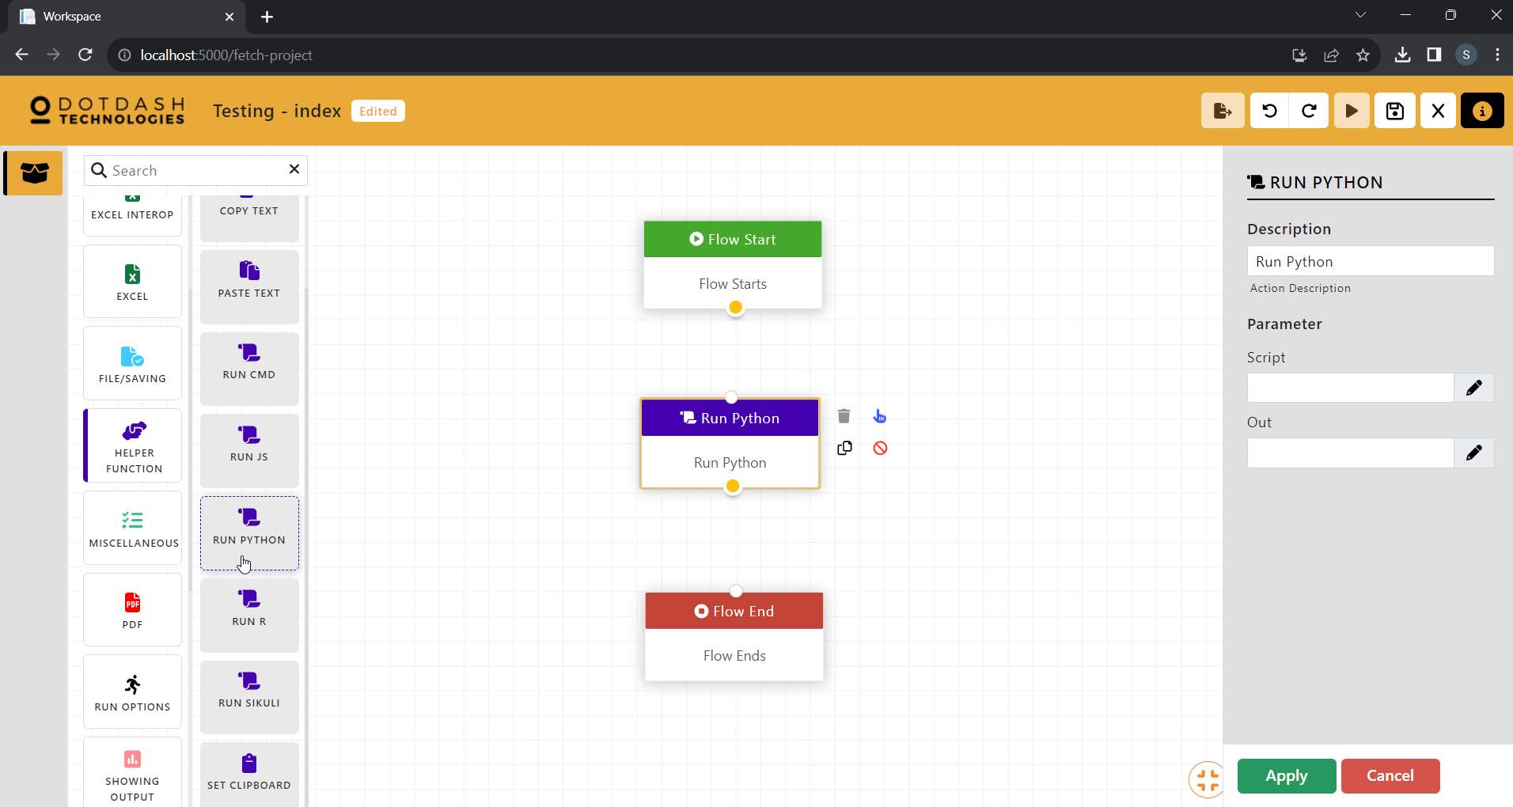

Function: To run a Python code

| Parameter | Description |
| --- | --- |
| Script | The Python code to be run. |
| Out | The variable to store the output. |

#### Run R

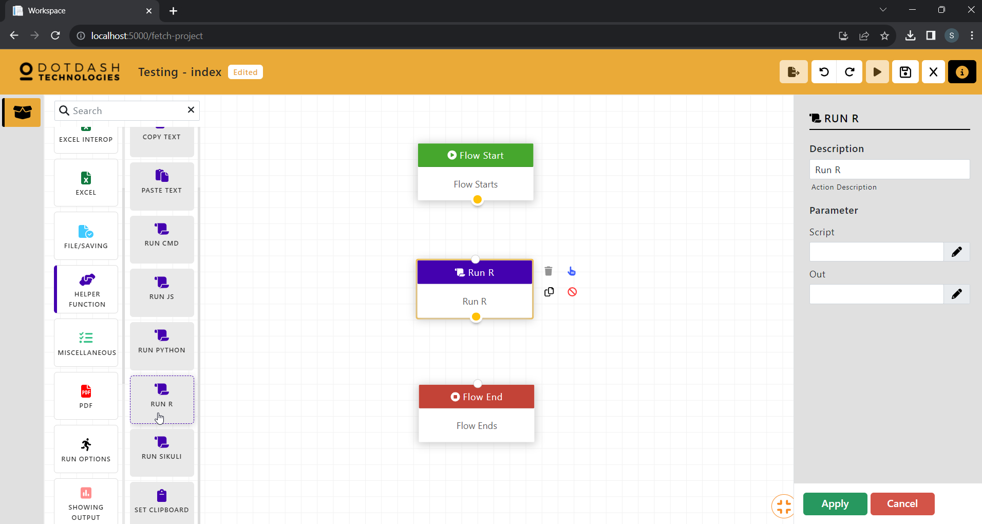

Function: To run a R code

| Parameter | Description |
| --- | --- |
| Script | The R code to be run. |
| Out | The variable to store the output. |

#### Run Sikuli

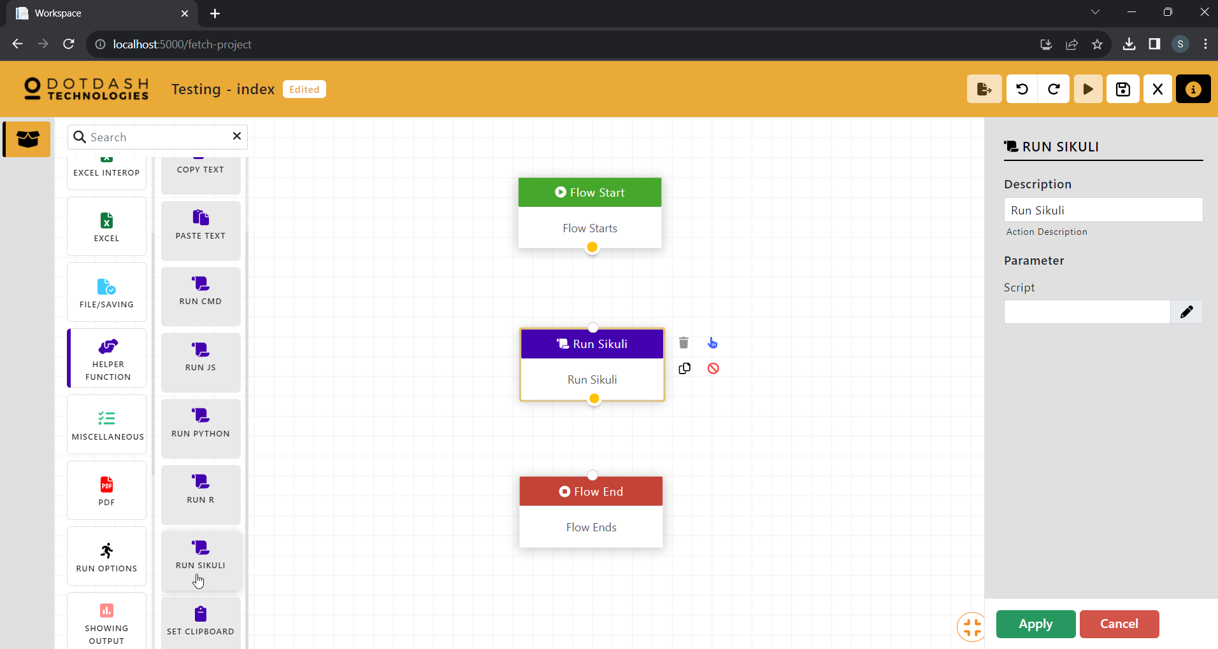

Function: To run a Sikuli code

| Parameter | Description |
| --- | --- |
| Script | The Sikuli code to be run. |

#### Set Clipboard

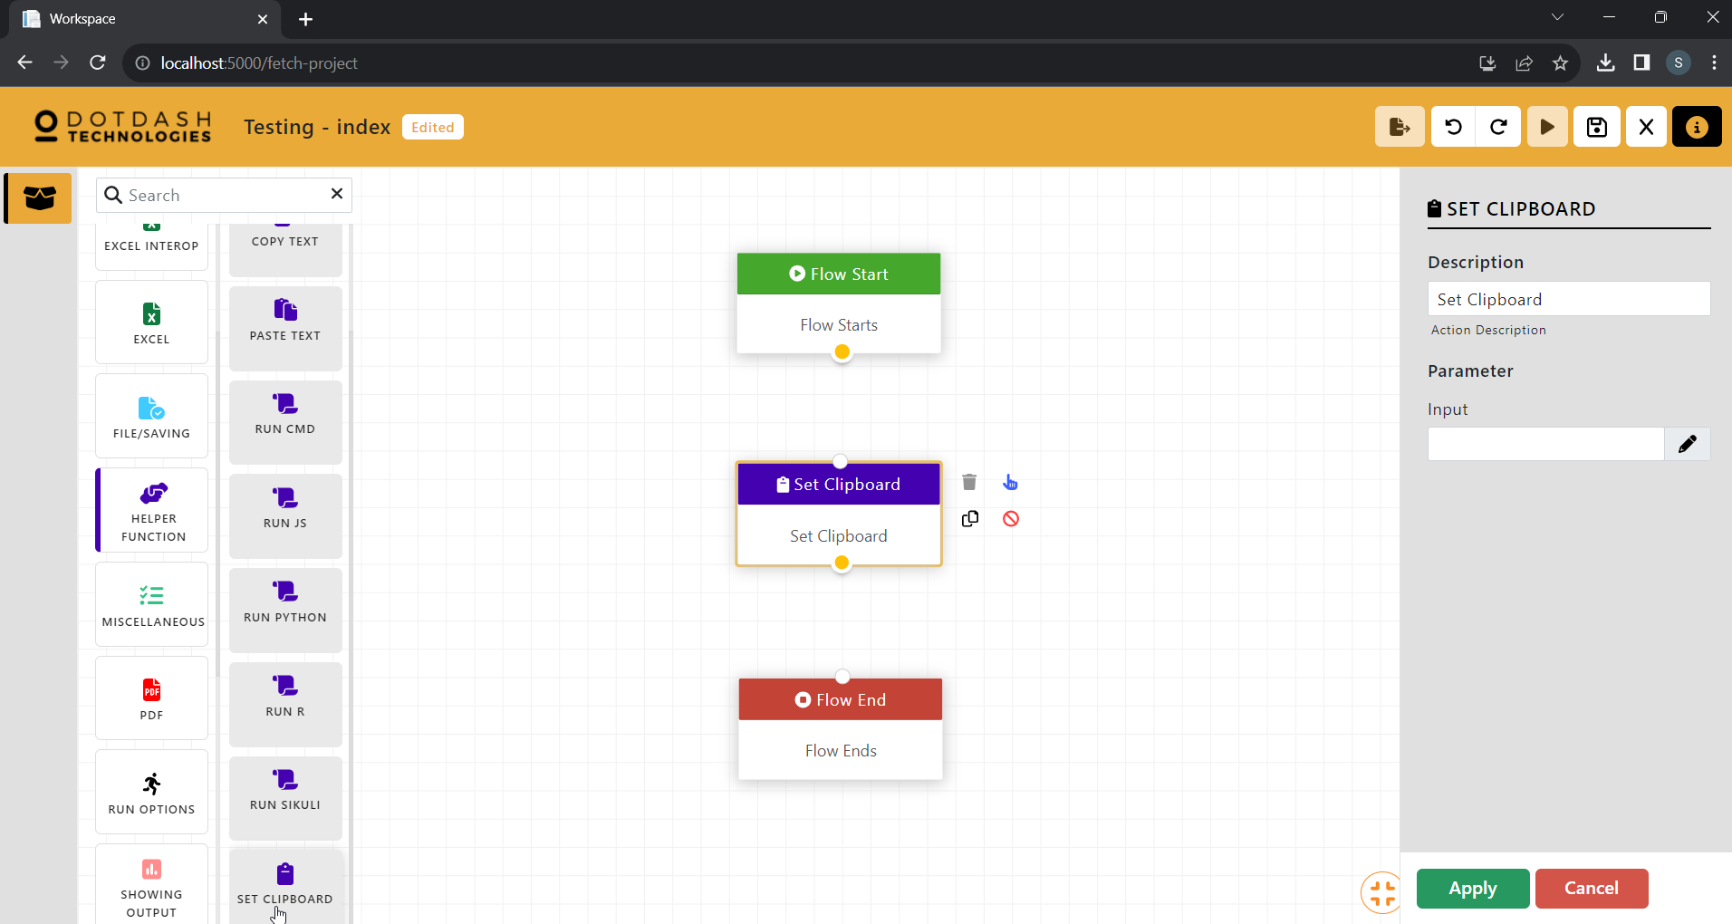

Function: To set a value to the clipboard

| Parameter | Description |
| --- | --- |
| Input | The value to be set to clipboard |

### Miscellaneous

#### API Basic

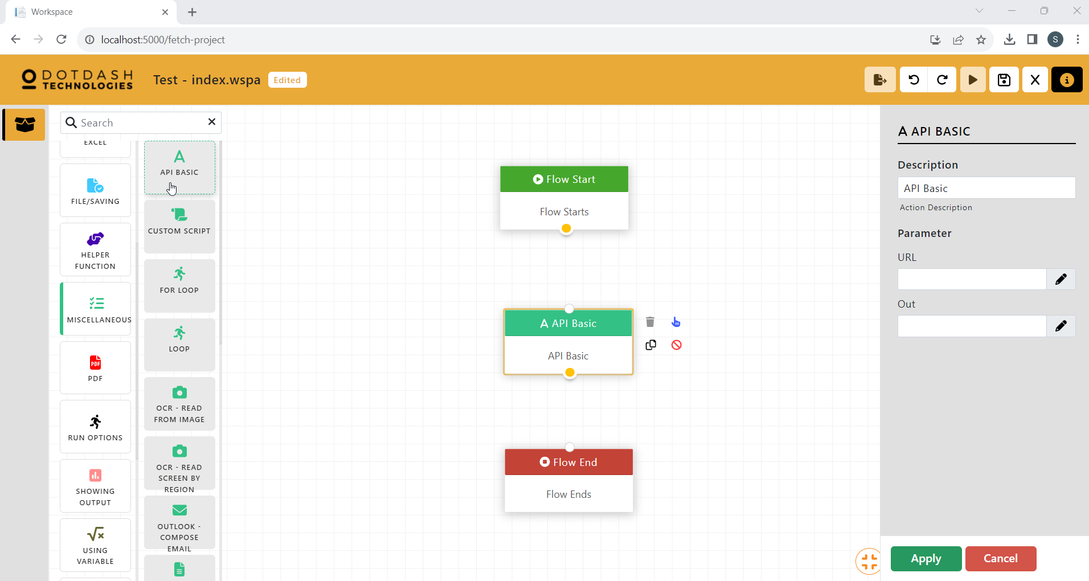

Function: Call a web API and save the raw response.

| Parameter | Description |
| --- | --- |
| URL | URL of the API. |
| Out | The variable to store the output. |

#### Custom Script

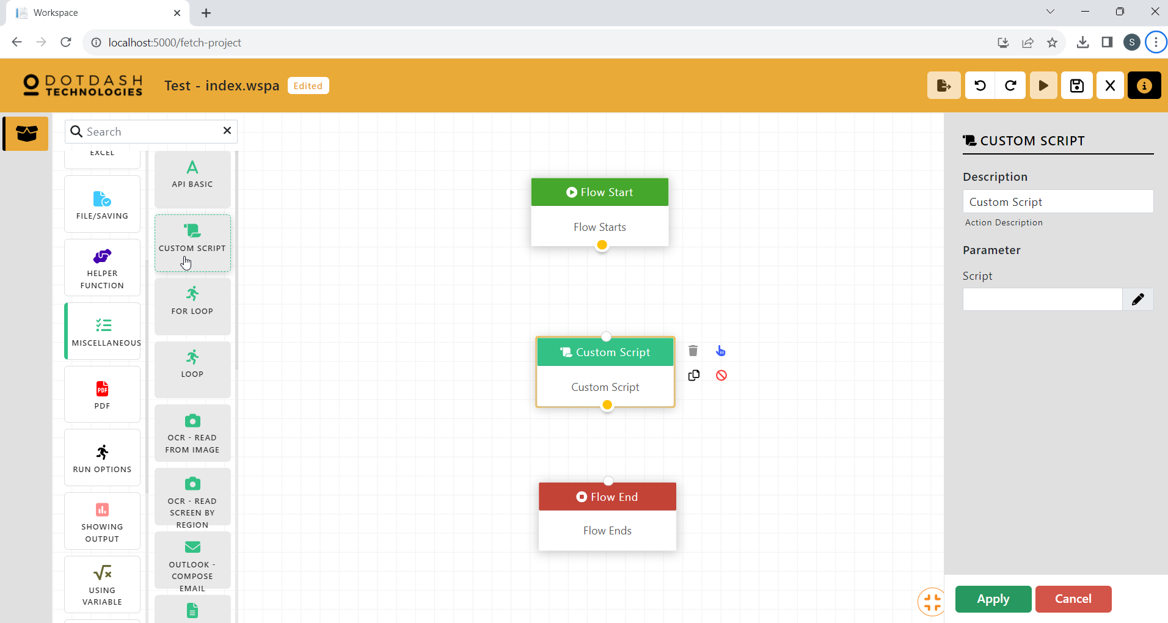

Function: To make some custom script to run in the flow.

| Parameter | Description |
| --- | --- |
| Script | The custom script to be run. |

#### For Loop

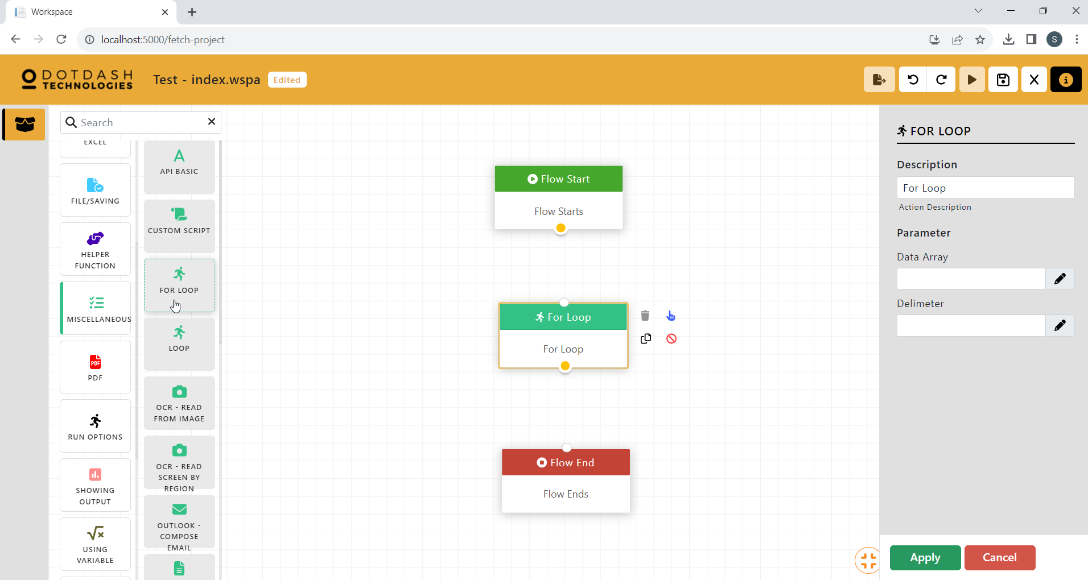

Function: Used to repeat a specific action multiple times.

| Parameter | Description |
| --- | --- |
| Data Array | The data array to determine the loop count. |
| Delimiter | The delimiter that is used in the data array. |

#### Loop

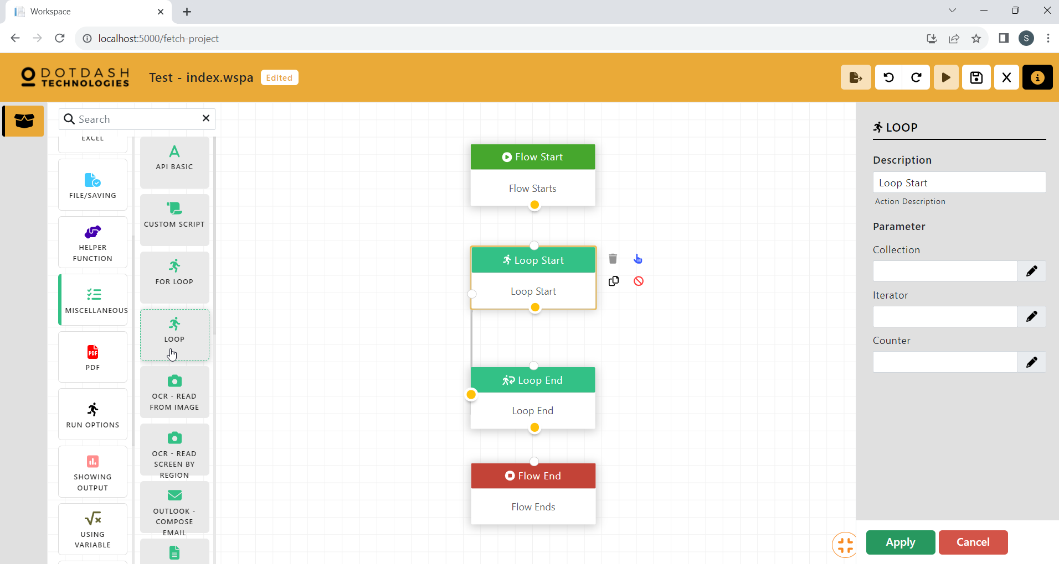

Function: To create a loop in the workflow

| Parameter | Description |
| --- | --- |
| Collection | The number of loops. |
| Iterator | The iterator for the loop. |
| Counter | The counter to be used in the loop. |

#### OCR - Read From Image

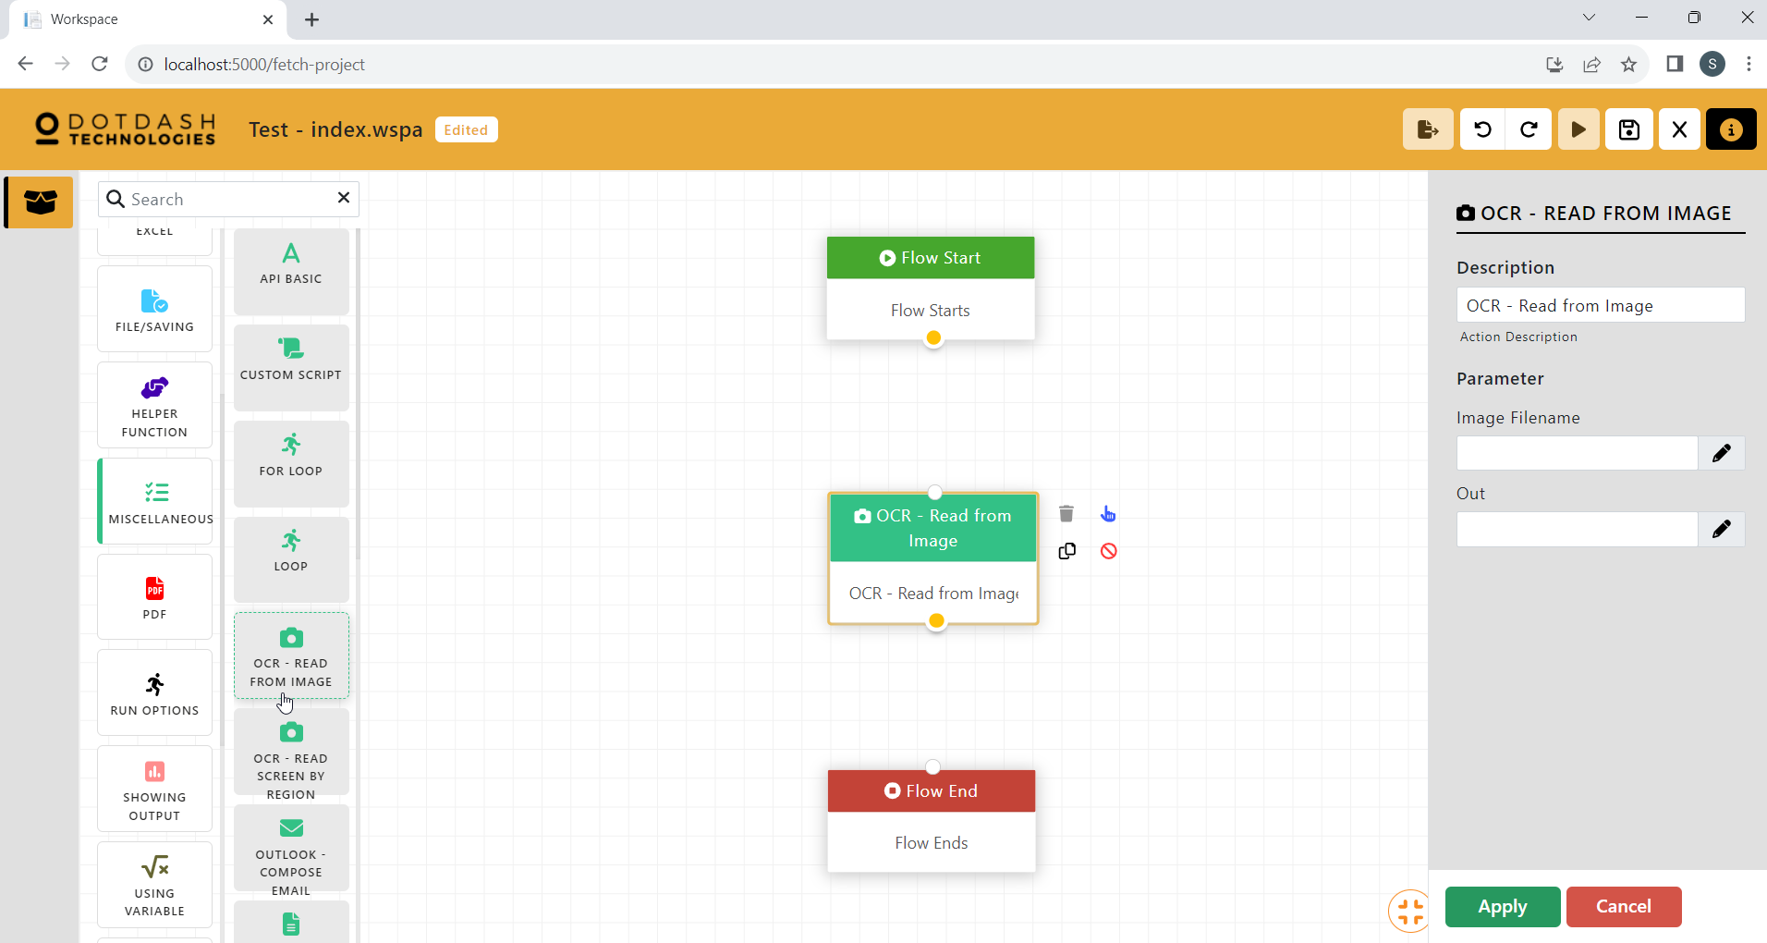

Function: This action allows text extraction with the use of OCR. (Hand-written words would not be read by OCR)

| Parameter | Description |
| --- | --- |
| Image Filename | The file path of the image. |
| Out | The variable to store the output. |

#### OCR - Read Screen By Region

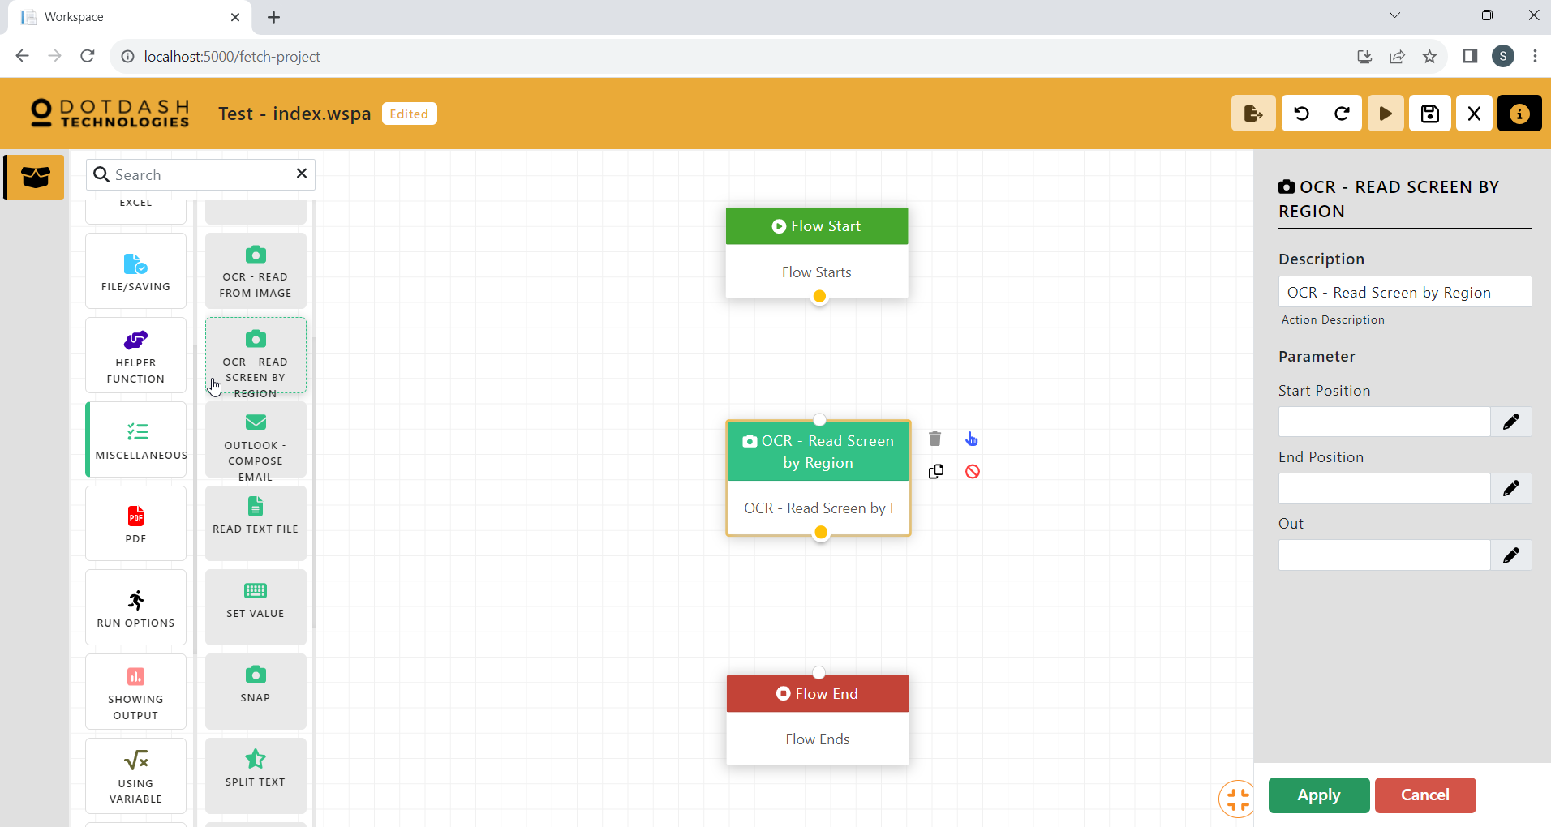

Function:This action allows the user to read the screen content of a region

| Parameter | Description |
| --- | --- |
| Start Position | The first coordinate on the screen. |
| End Position | The second coordinate on the screen. |
| Out | The variable to store the output. |

#### Outlook - Compose Email

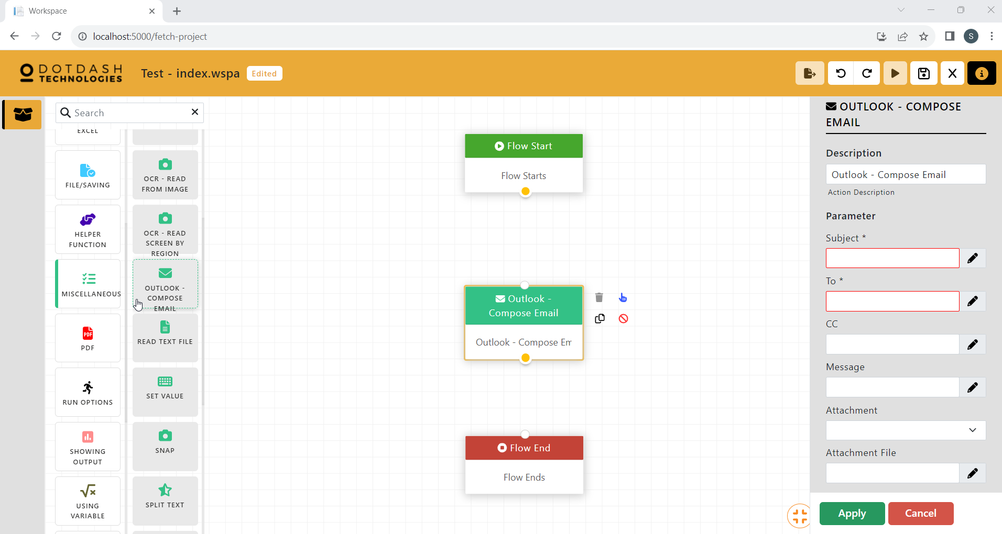

Function: To send an email using the outlook application

| Parameter | Description |
| --- | --- |
| Subject | The subject of the email. |
| To | The receiver of the email. |
| CC | The receiver of a CC of the email. |
| Message | The body of the email. |
| Attachment | An option to choose if there is an attachment for the email. |
| Attachment File | The file path of the attachment file. |

#### Read Text File

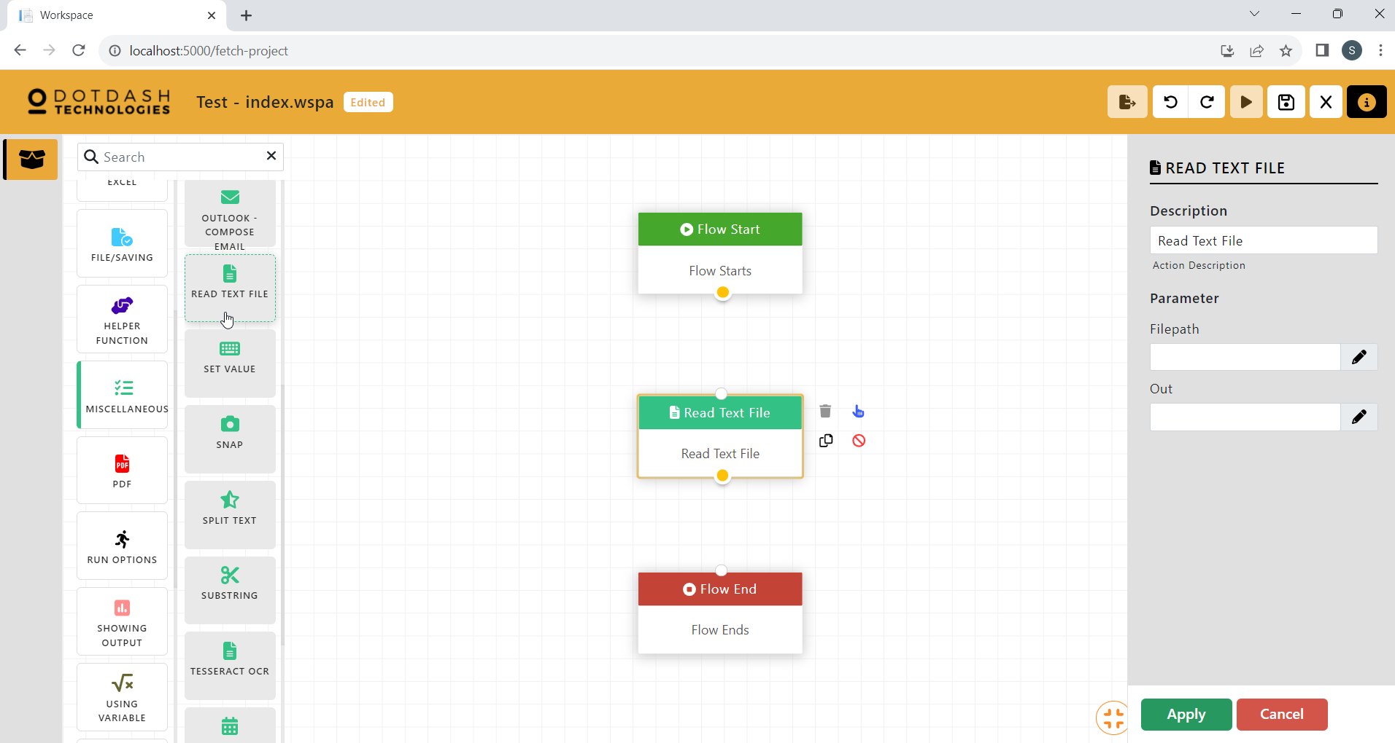

Function: This action is able to read a text file and store it with a variable.

| Parameter | Description |
| --- | --- |
| Filepath | The file path of the file. |
| Out | The variable to store the output. |

#### Set Value

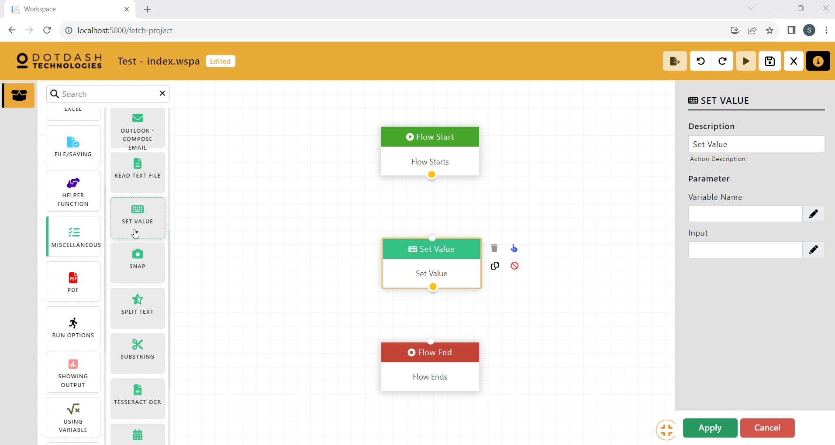

Function: This action is able to set a value and store it into a variable for next use.

| Parameter | Description |
| --- | --- |
| Variable Name | The variable to store the value. |
| Input | The value of the variable. |

#### Snap

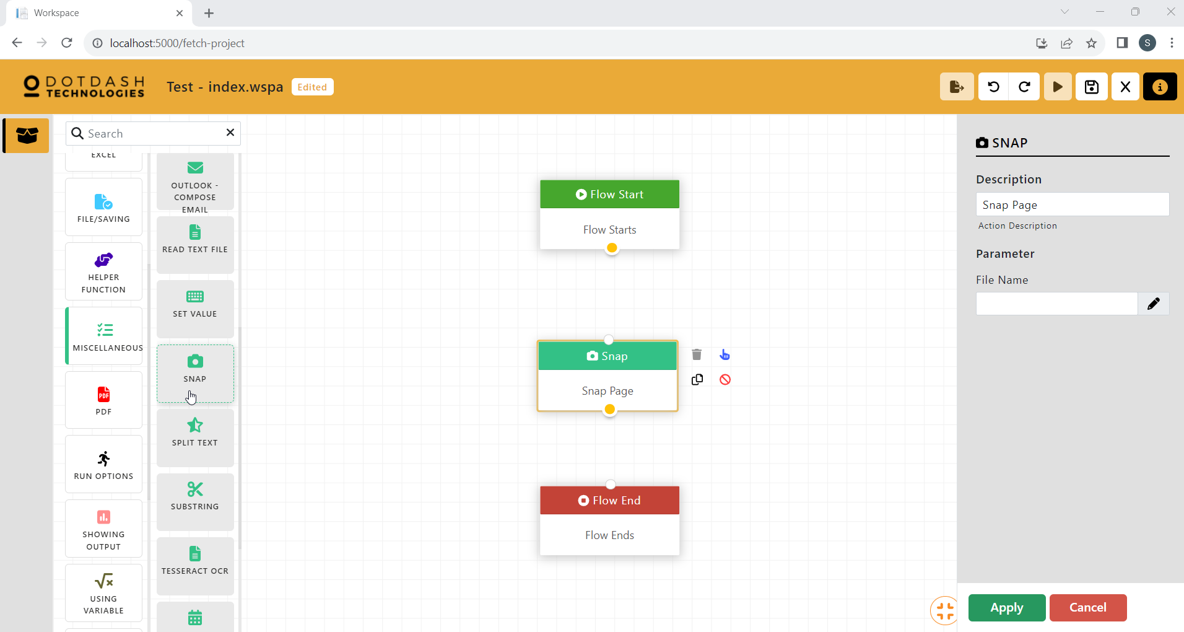

Function: This action is able to snap a whole screen as a picture.

| Parameter | Description |
| --- | --- |
| File Name | The name of the file. |

#### Split Text

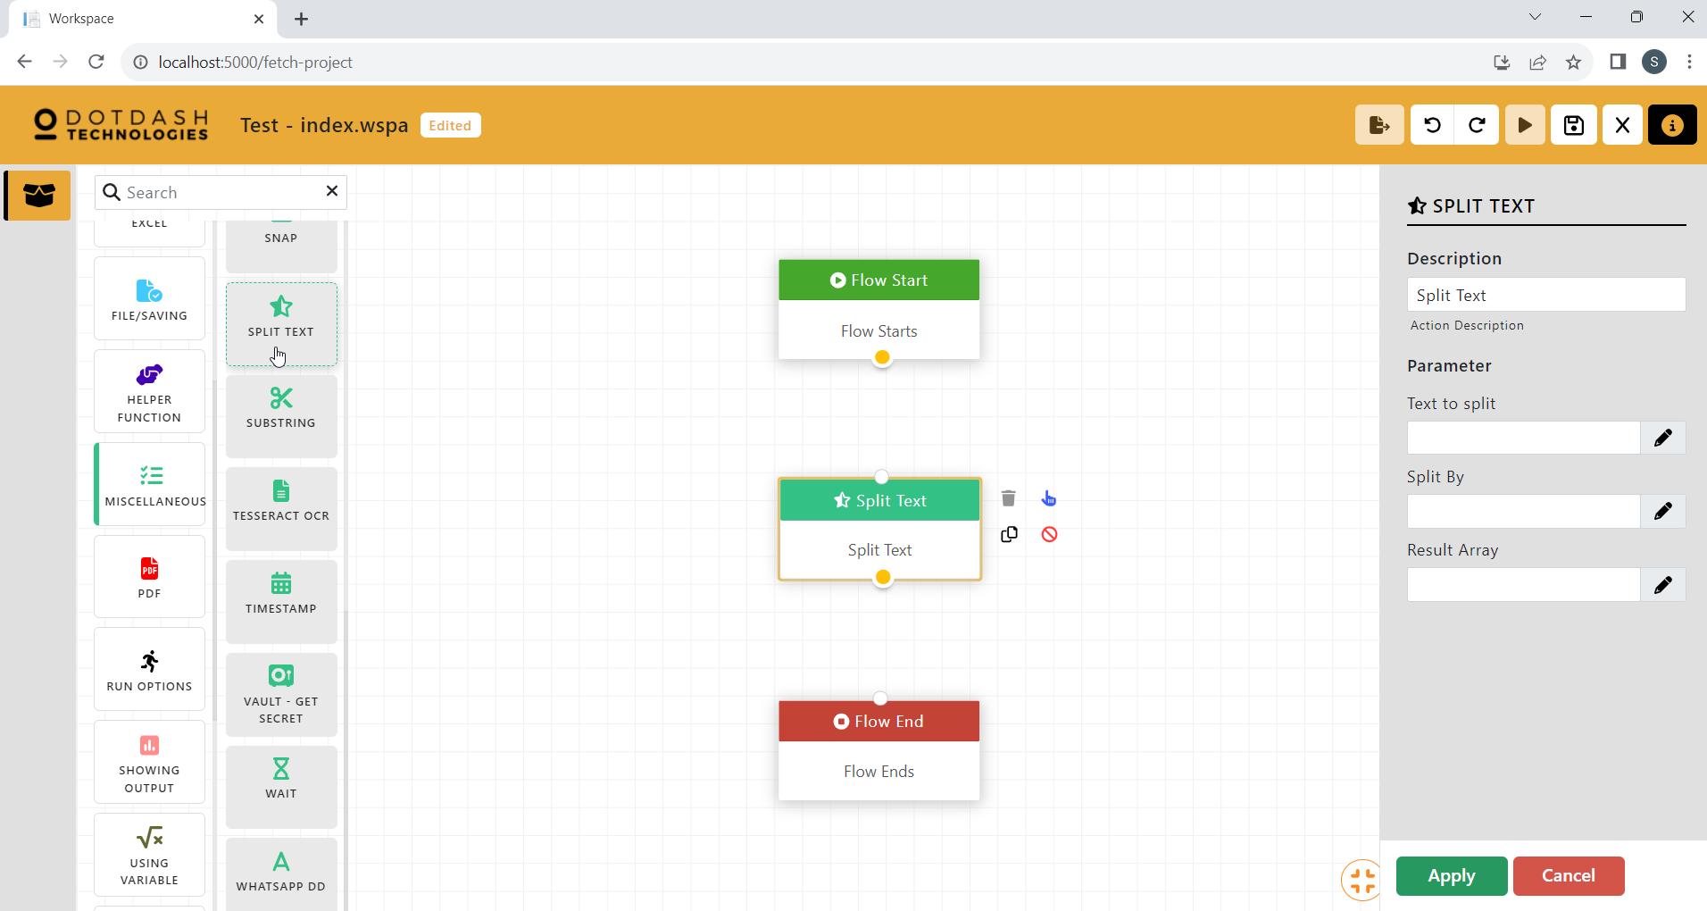

Function: This function can split the text with any character.

| Parameter | Description |
| --- | --- |
| Text to split | The text to be split |
| Split By | The character to be used to split the tet |
| Result Array | The array to store the result |

#### Substring

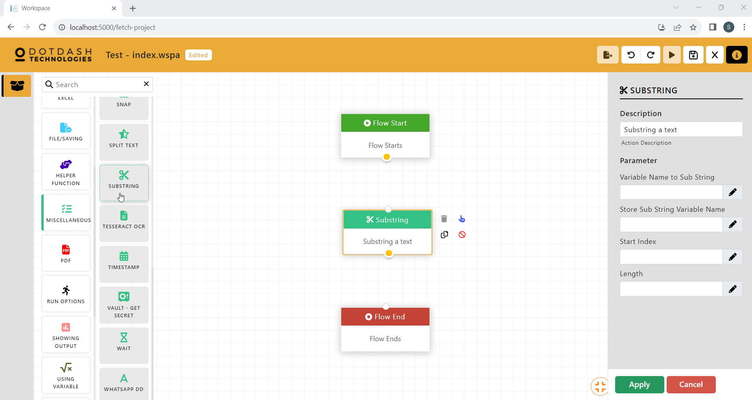

Function: This function is to get the substring from a line of text.

| Parameter | Description |
| --- | --- |
| Variable Name to Sub String | The line of text. |
| Store Sub String Variable Name | The variable to store the substring. |
| Start Index | The starting index of the substring. |
| Length | The length of the substring. |

#### Tesseract OCR

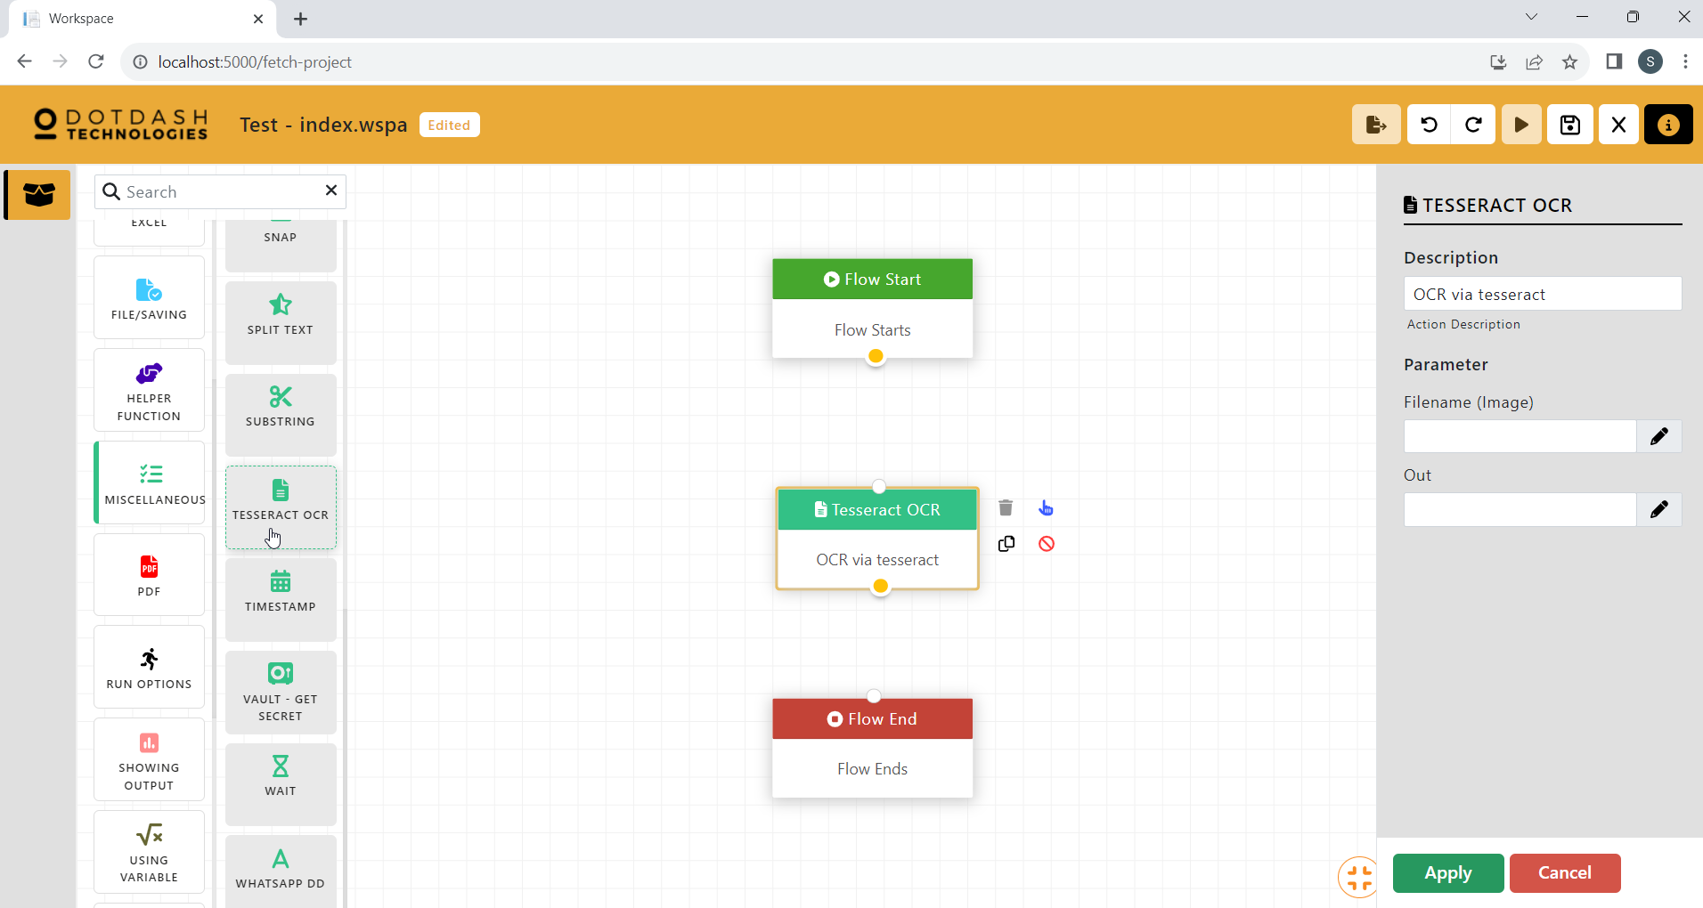

Function: To use Tesseract OCR

| Parameter | Description |
| --- | --- |
| Filename (Image) | The file path of the image. |
| Out | The variable to store the output. |

#### Timestamp

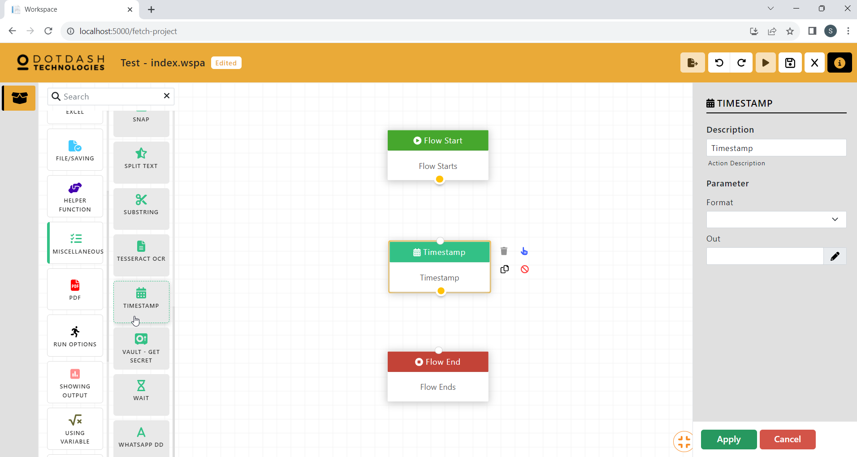

Function: This action is able to generate date and time.

| Parameter | Description |
| --- | --- |
| Format | The format of the timestamp. |
| Out | The variable to store the output. |

#### Vault - Get Secret

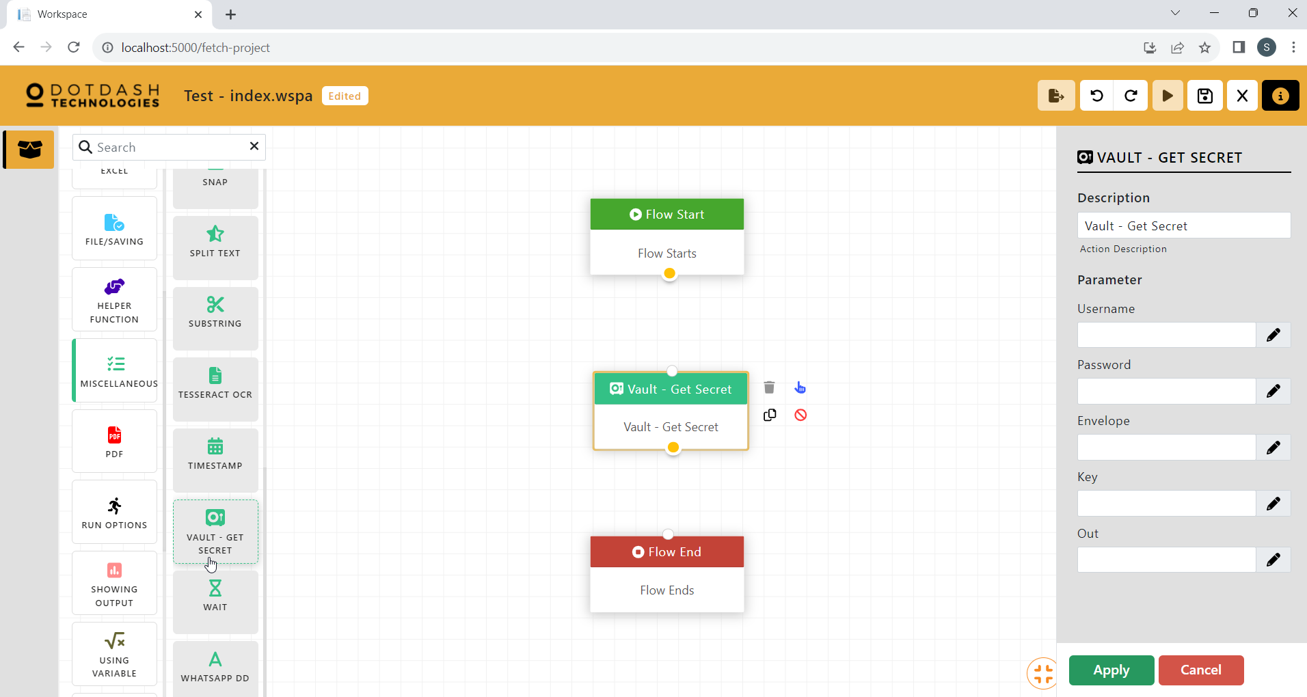

Function: This action is able to protect the confidential data such as username and password from getting by others.

| Parameter | Description |
| --- | --- |
| Username | The username of Central account. |
| Password | The password of Central account. |
| Envelope | The envelope that store the secret. |
| Key | The key to access the envelope. |
| Out | The variable to store the output. |

#### Wait

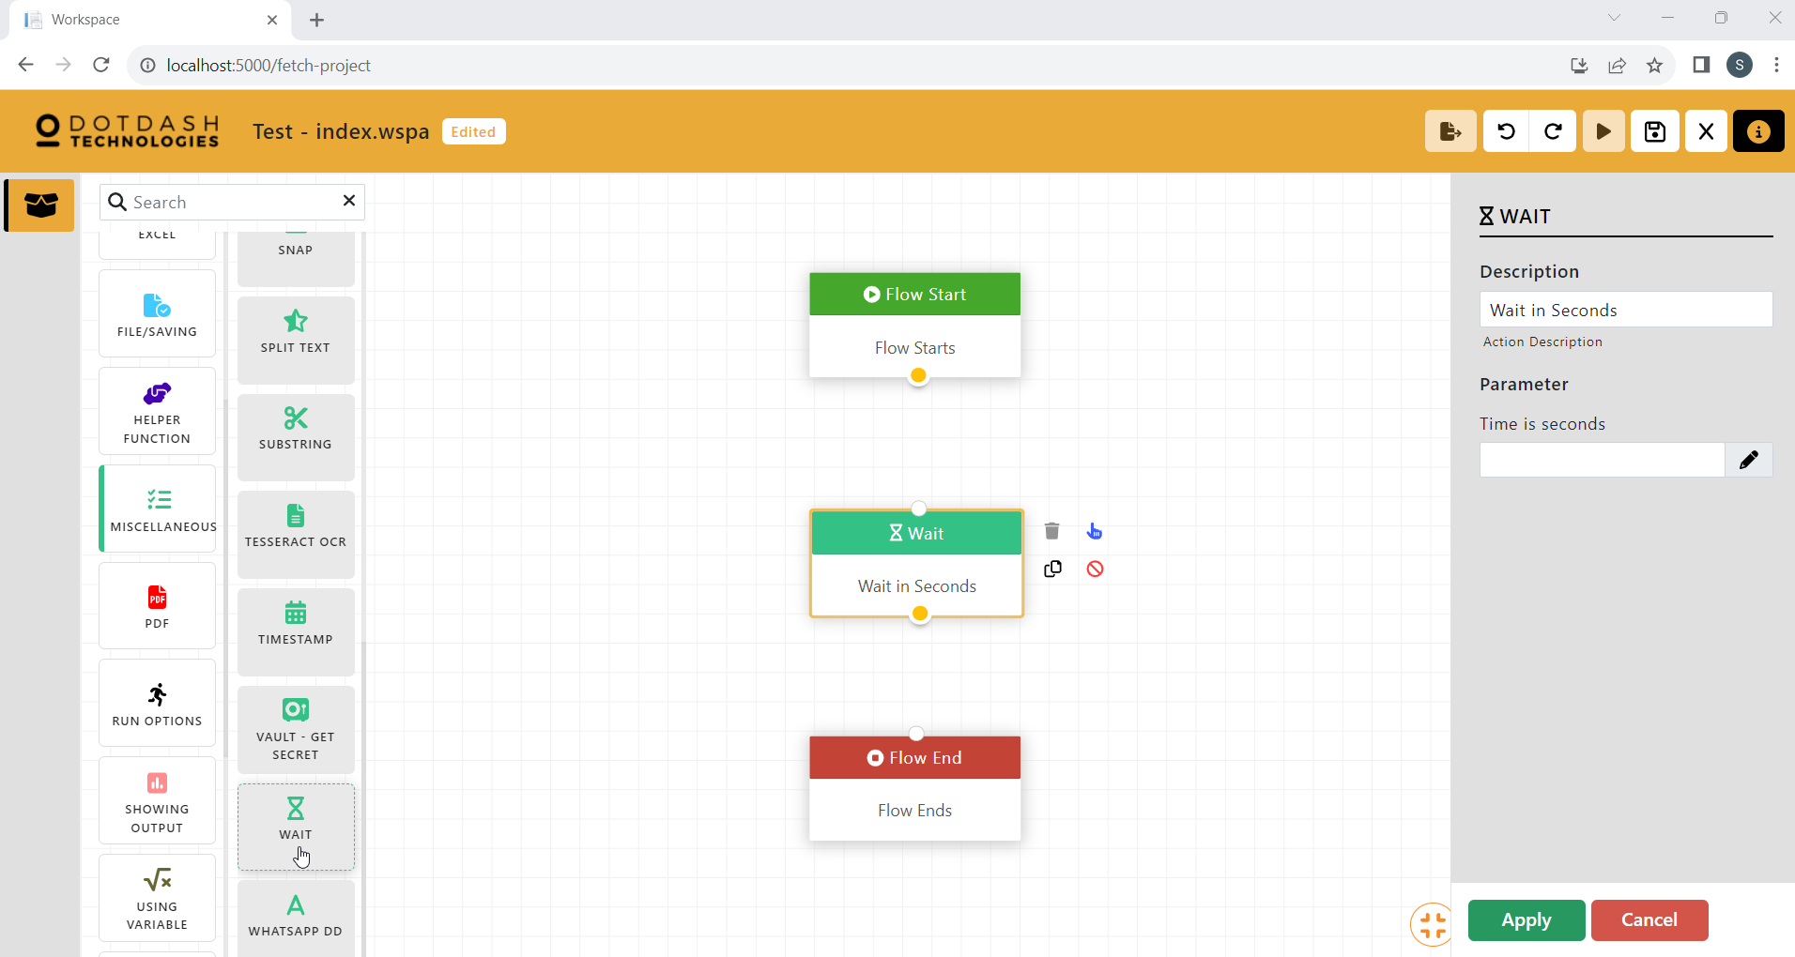

Function: To wait before going to the next action

| Parameter | Description |
| --- | --- |
| Time in seconds | The seconds to wait. |

#### Whatsapp DD (Not included in the download)

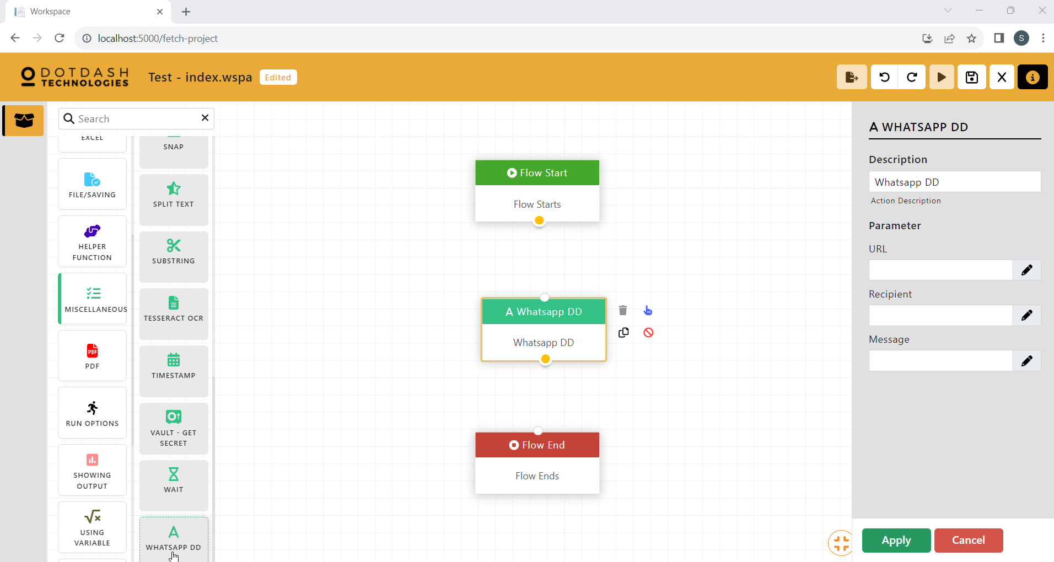

Function: To use the WhatsApp API

| Parameter | Description |
| --- | --- |
| URL | The URL of the WhatsApp API. |
| Recipient | The recipient of the message. |
| Message | The message to be sent. |

### PDF

#### Print PDF - Excel

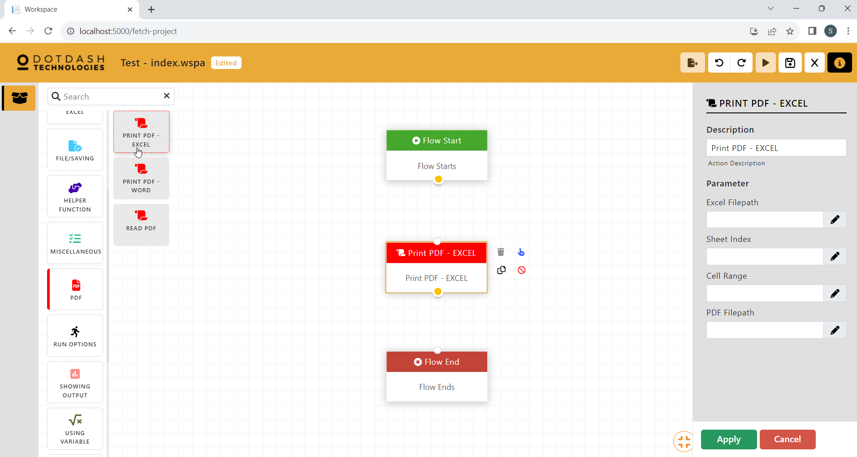

Function: To print a cell range of an excel to PDF

| Parameter | Description |
| --- | --- |
| Excel FIlename | The file path of the excel file. |
| Sheetname | The name of the excel sheet. |
| Cell Range | The range of cells to be printed to PDF. |
| PDF Filepath | The file path of the generated PDF file. |

#### Print PDF - Word

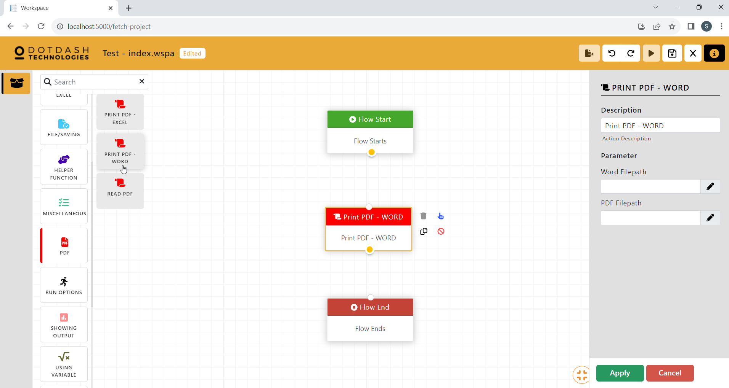

Function:

| Parameter | Description |
| --- | --- |
| Word Filepath | The file path of the Word file. |
| PDF Filepath | The file path of the generated PDF file. |

#### Read PDF

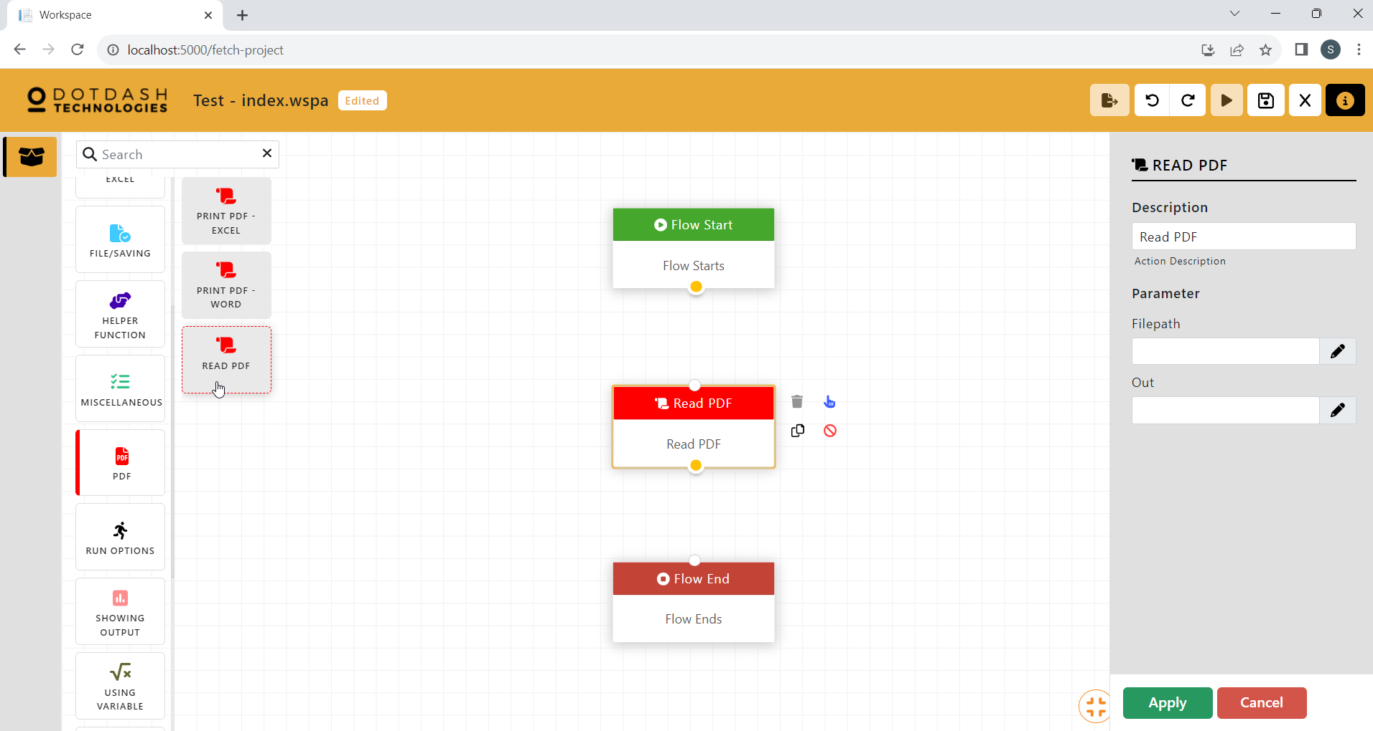

Function: Read the PDF

| Parameter | Description |
| --- | --- |
| Filepath | The file path of the PDF file. |
| Out | The variable to store the data. |

### Run Options

### Showing Outputs

#### Echo

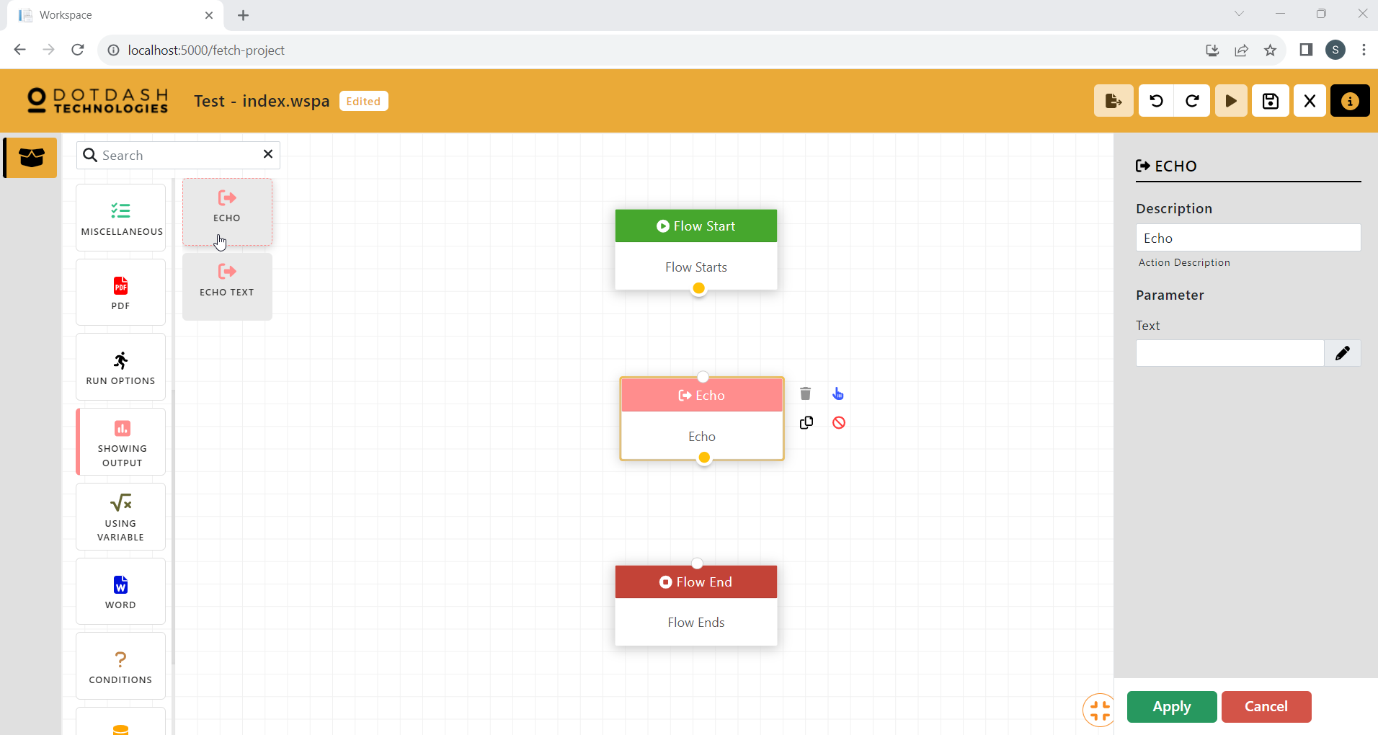

Function: Echo text or variable that was set at previous action.

| Parameter | Description |
| --- | --- |
| Text | The variable which stores the data that need to be output to the log. |

#### Echo Text

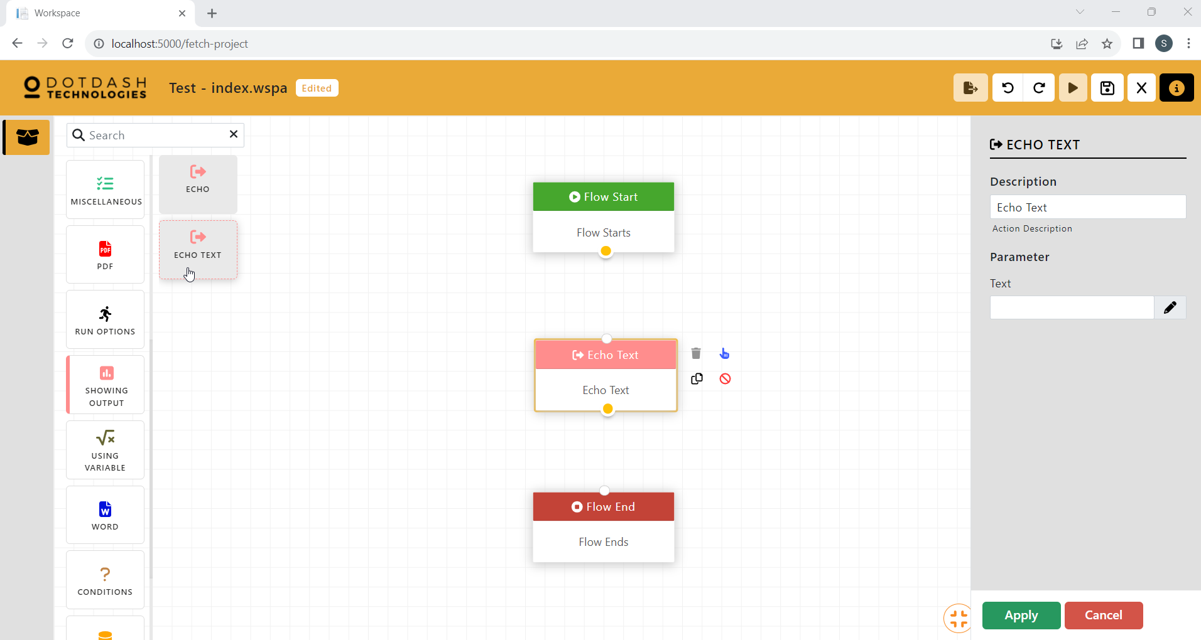

Function: Echo the text

| Parameter | Description |
| --- | --- |
| Text | The string of text that need to be output to the log. |

### Using Variable

### Word

#### Create Word Doc

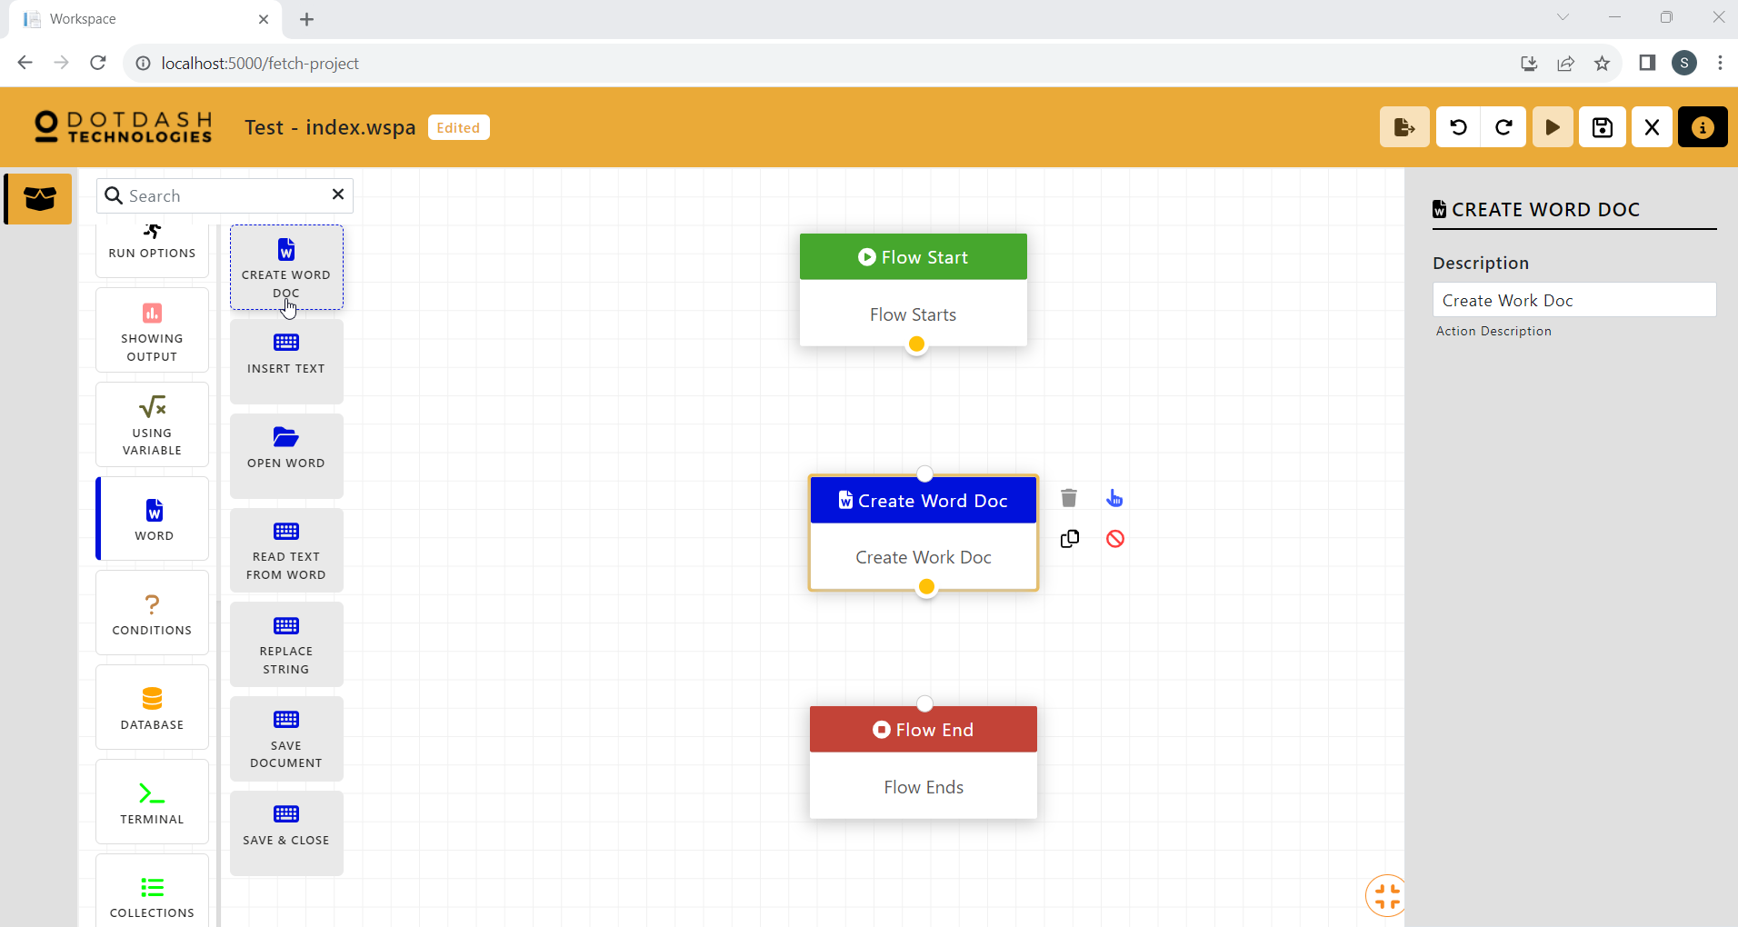

Function: Create a Word file for you.

#### Insert Text

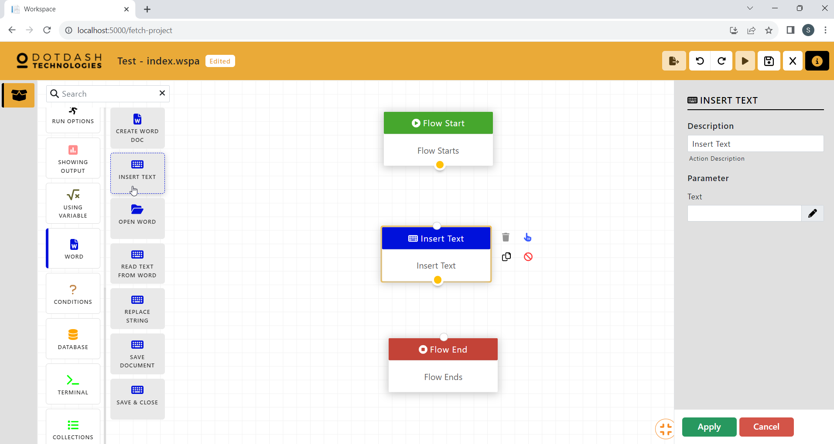

Function: Insert text to Word file

| Parameter | Description |
| --- | --- |
| Text | The string of text to be insert into the opened Word file |

#### Open Word

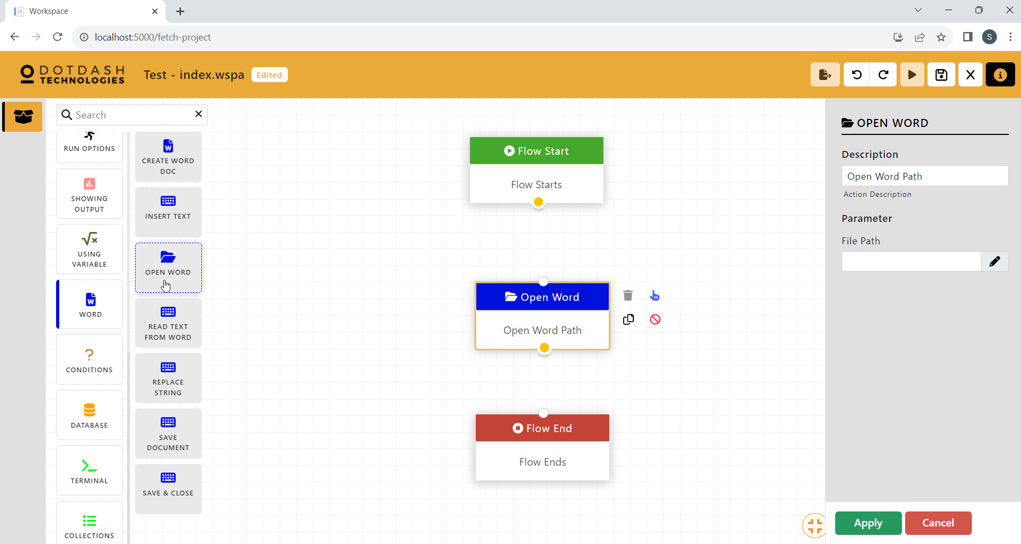

Function: Open the Word file.

| Parameter | Description |
| --- | --- |
| File Path | The file path of the Word file. |

#### Read Text From Word

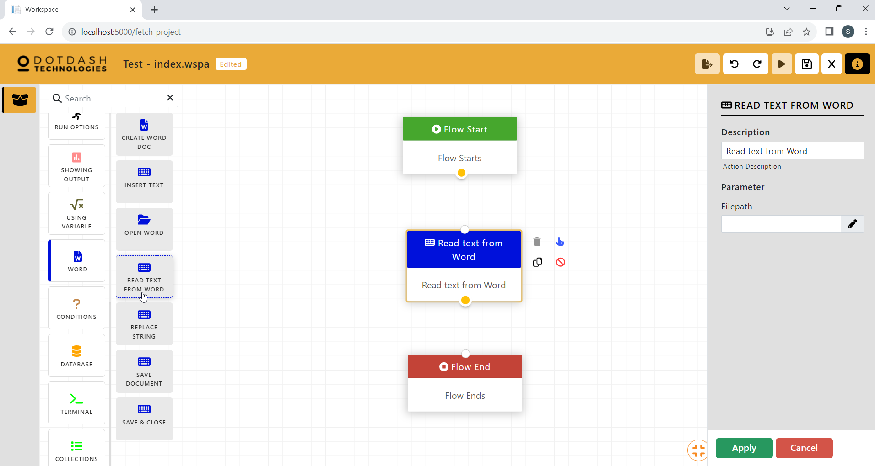

Function: Read text inside the Word file.

| Parameter | Description |
| --- | --- |
| Filepath | File path of the Word file. |

#### Replace String

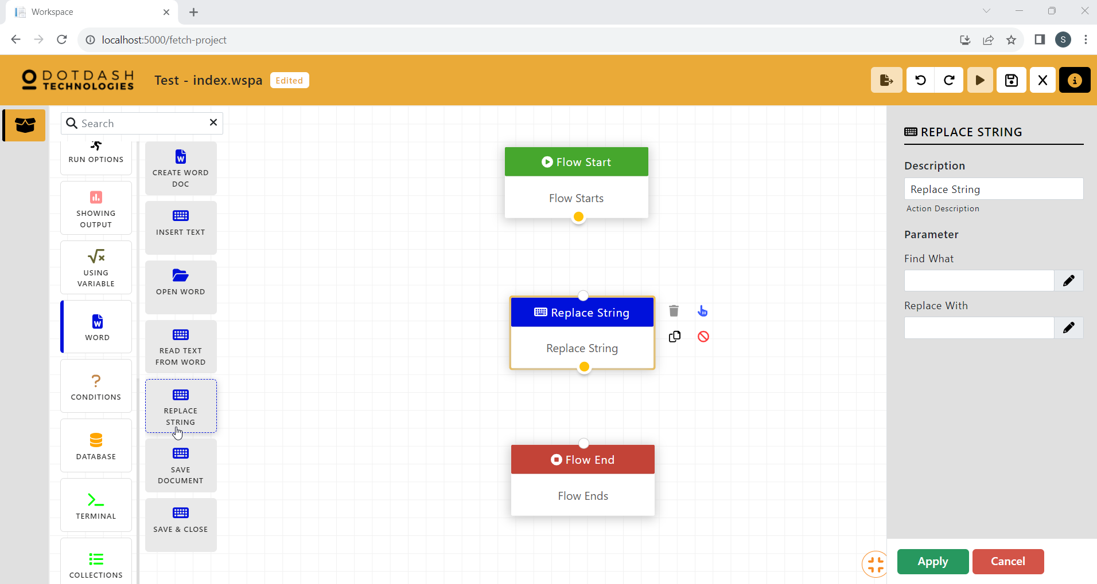

Function: Replace string inside the word.

| Parameter | Description |
| --- | --- |
| Find What | The string of text to be replaced. |
| Replace With | The string of text to replace with. |

#### Save Document

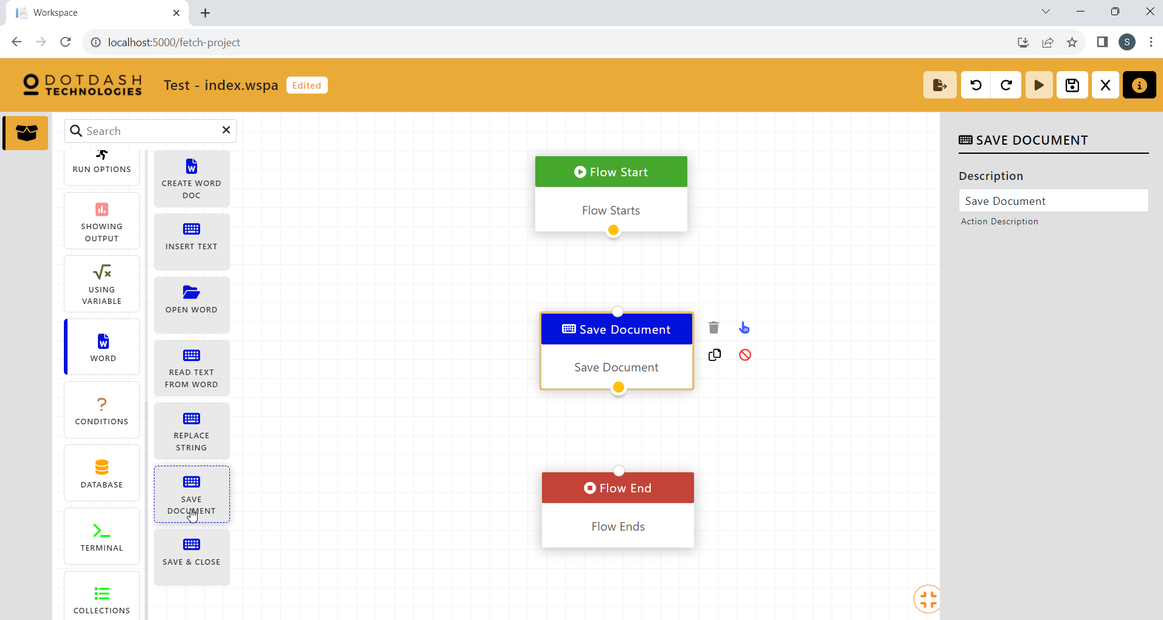

Function: Save the document.

#### Save & Close

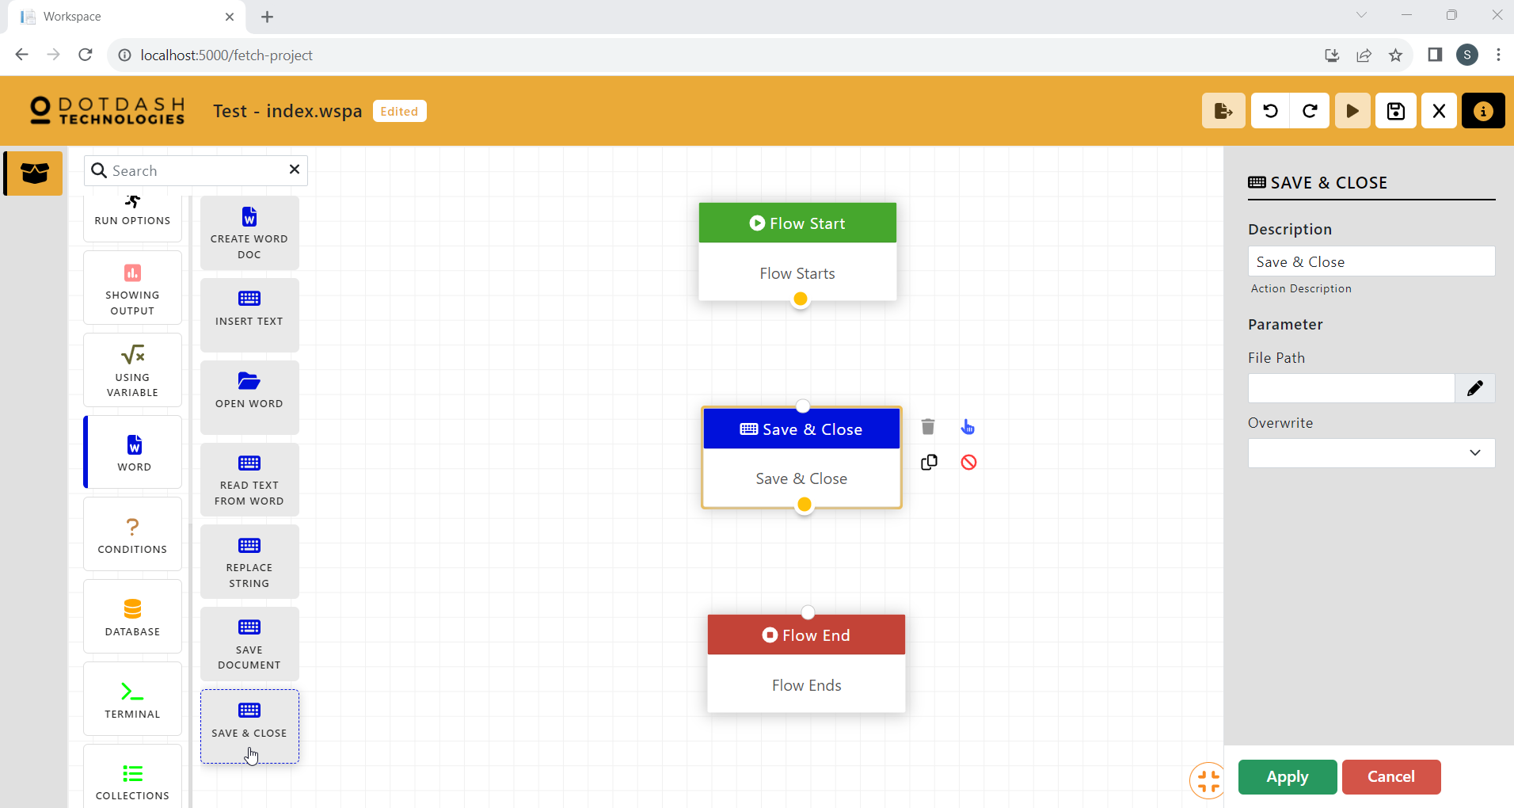

Function: Save the document and close it.

| Parameter | Description |
| --- | --- |
| File Path | File path of the Word file. |
| Overwrite | An option to overwrite any existing file with the same name. |

### Conditions

#### Ifelse

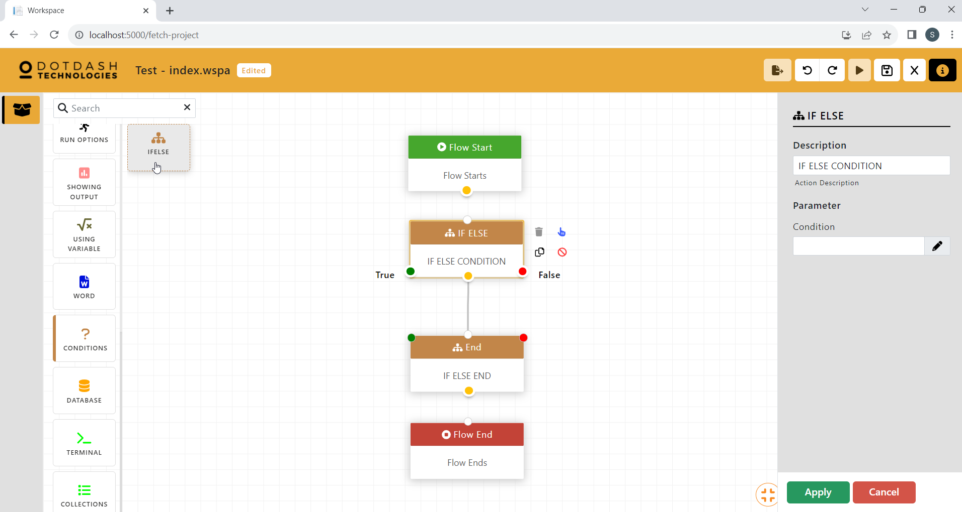

Function: If not then else

| Parameter | Description |
| --- | --- |
| Condition | The condition for the if-else. |

### Database

#### Select From Database

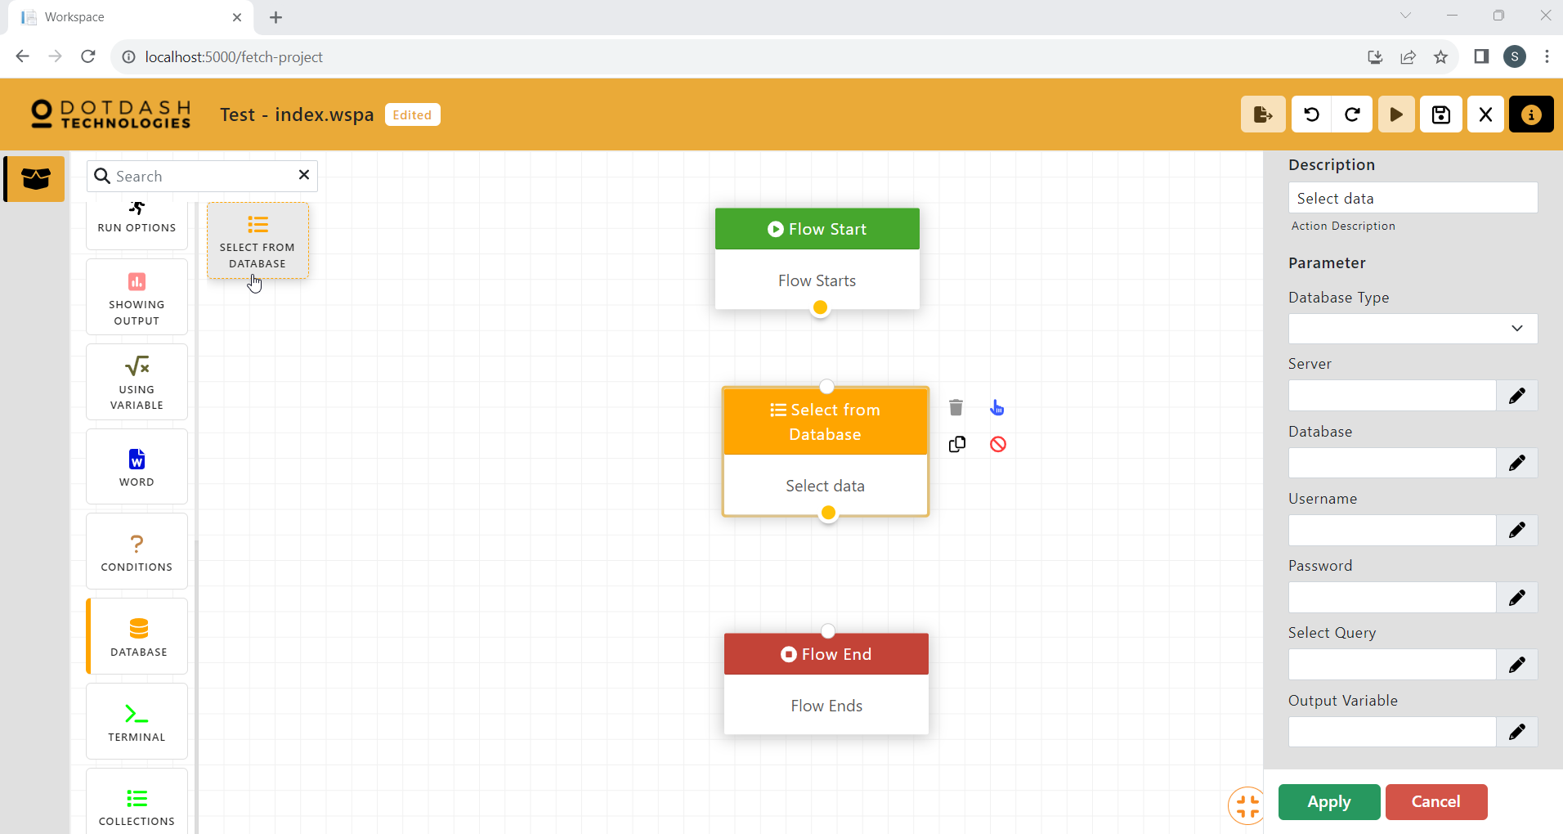

Function: Select from database table

| Parameter | Description |
| --- | --- |
| Database Type | Type of the database. |
| Server | Server name. |
| Database | Database name. |
| Username | Database login username. |
| Password | Database login password. |
| Select Query | Query to select from database table. |
| Output Variable | Output to display select query. |

### Terminal

#### Capture Screen

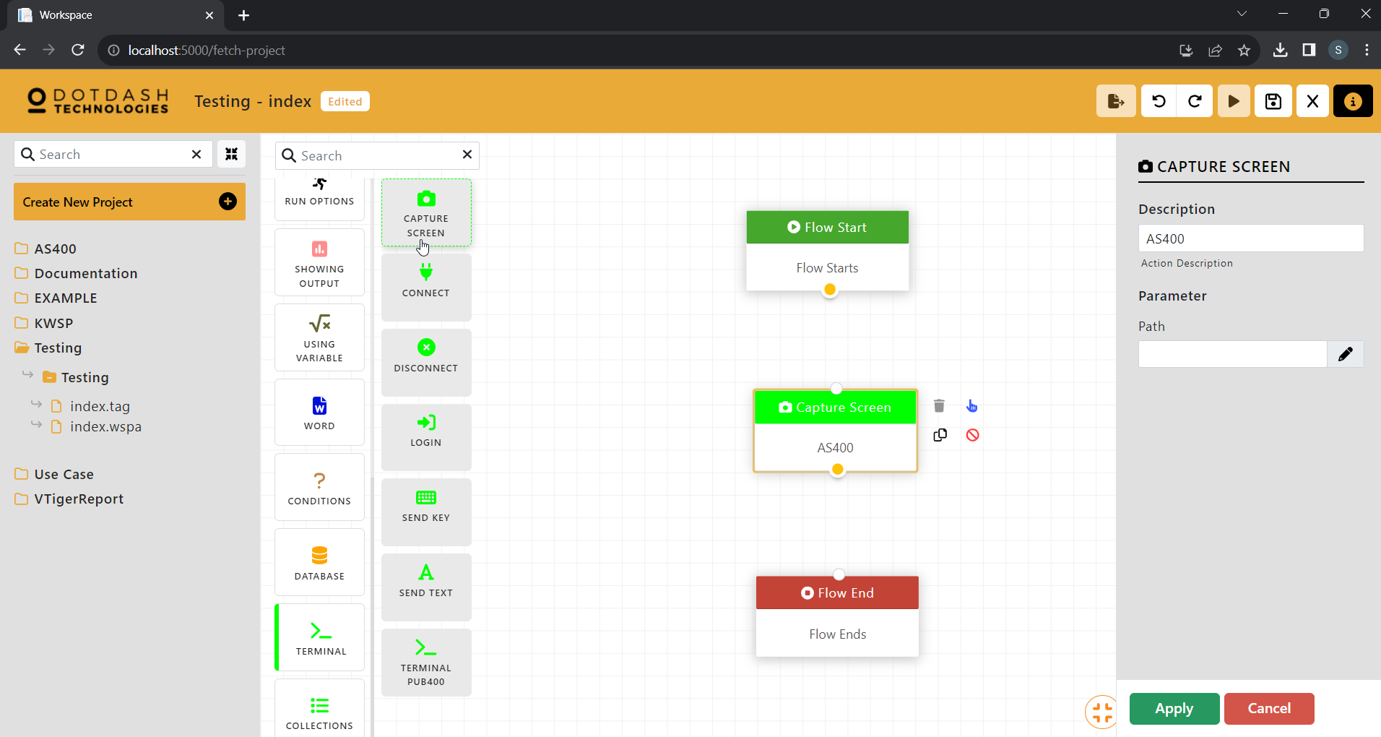

Function:

| Parameter | Description |
| --- | --- |
| Path |  |

#### Connect

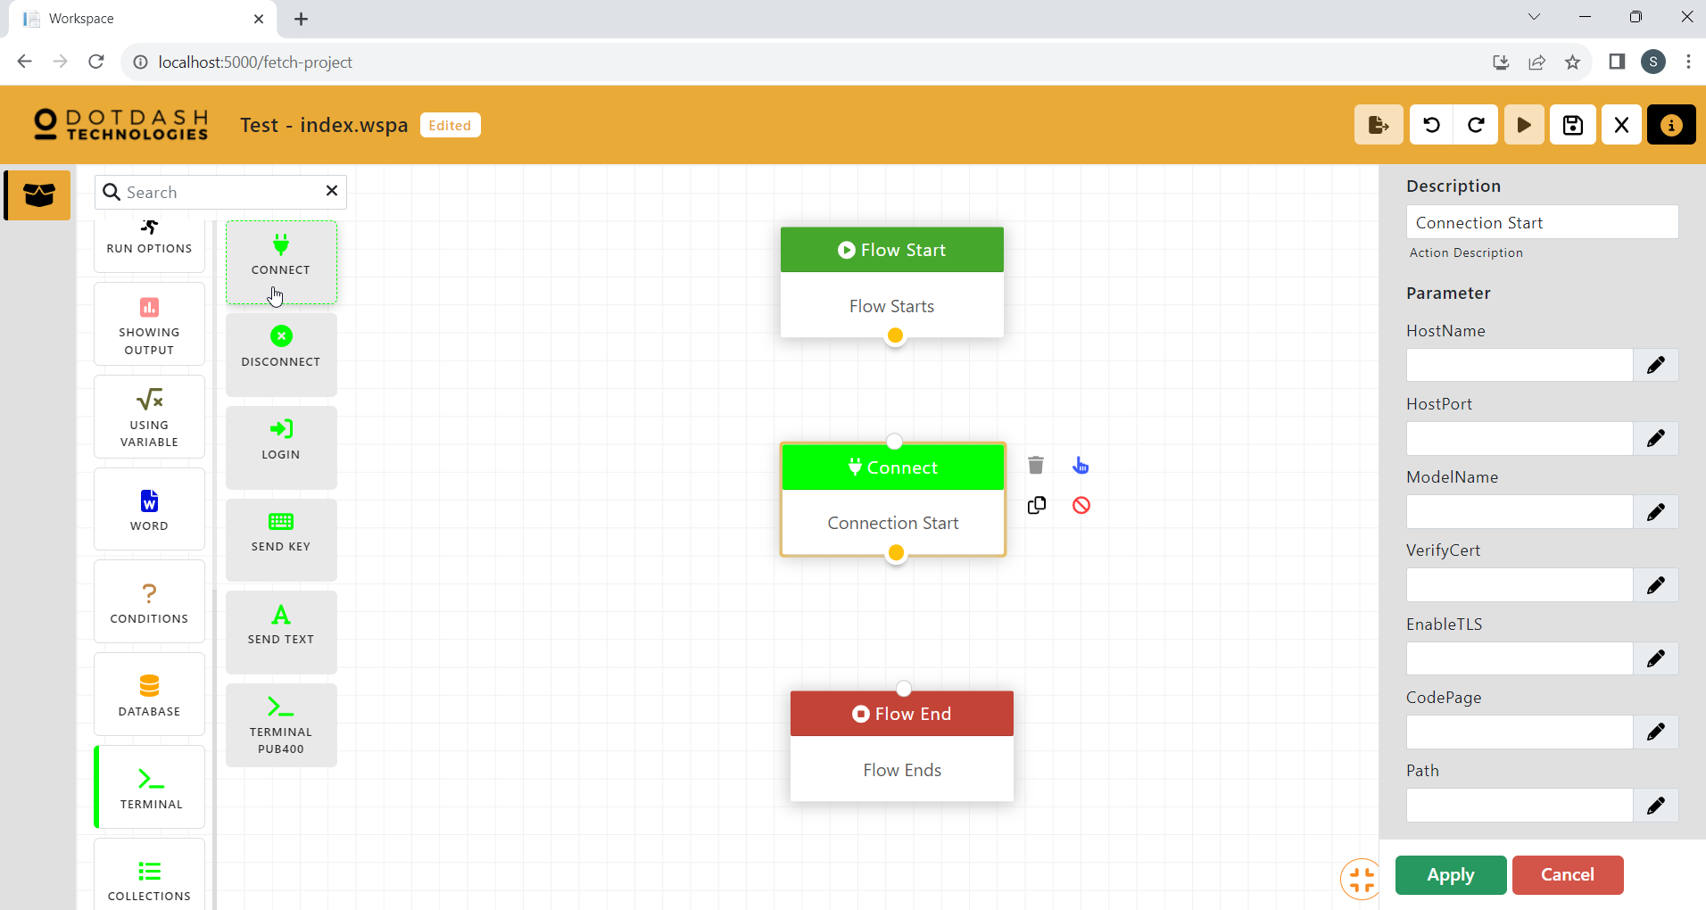

Function:

| Parameter | Description |
| --- | --- |
| HostName |  |
| HostPort |  |
| ModelName |  |
| VerifyCert |  |
| EnableTLS |  |
| CodePage |  |
| Path |  |

#### Disconnect

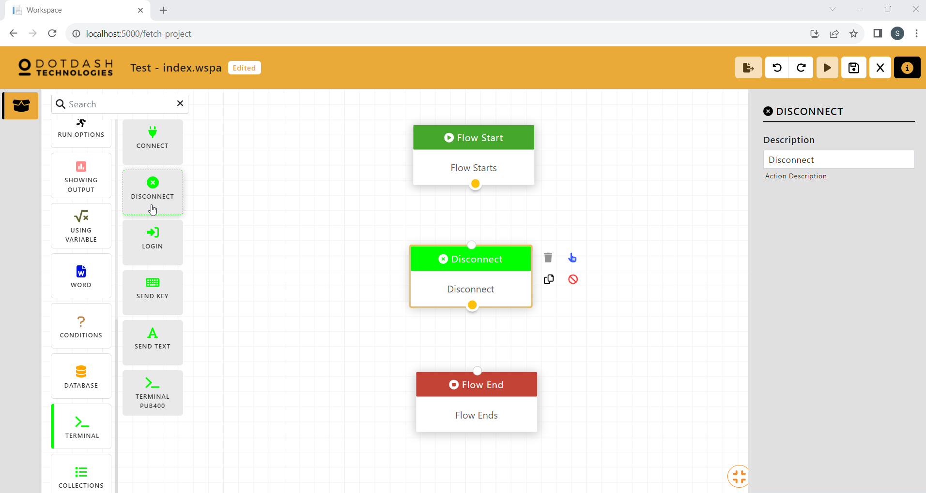

Function:

#### Login

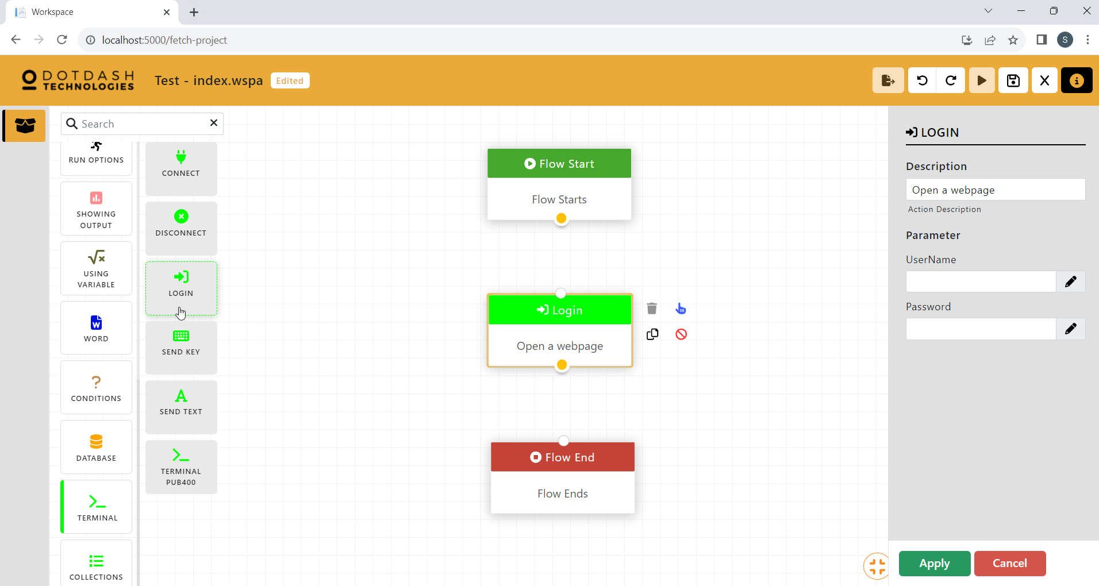

Function:

| Parameter | Description |
| --- | --- |
| UserName |  |
| Password |  |

#### Send Key

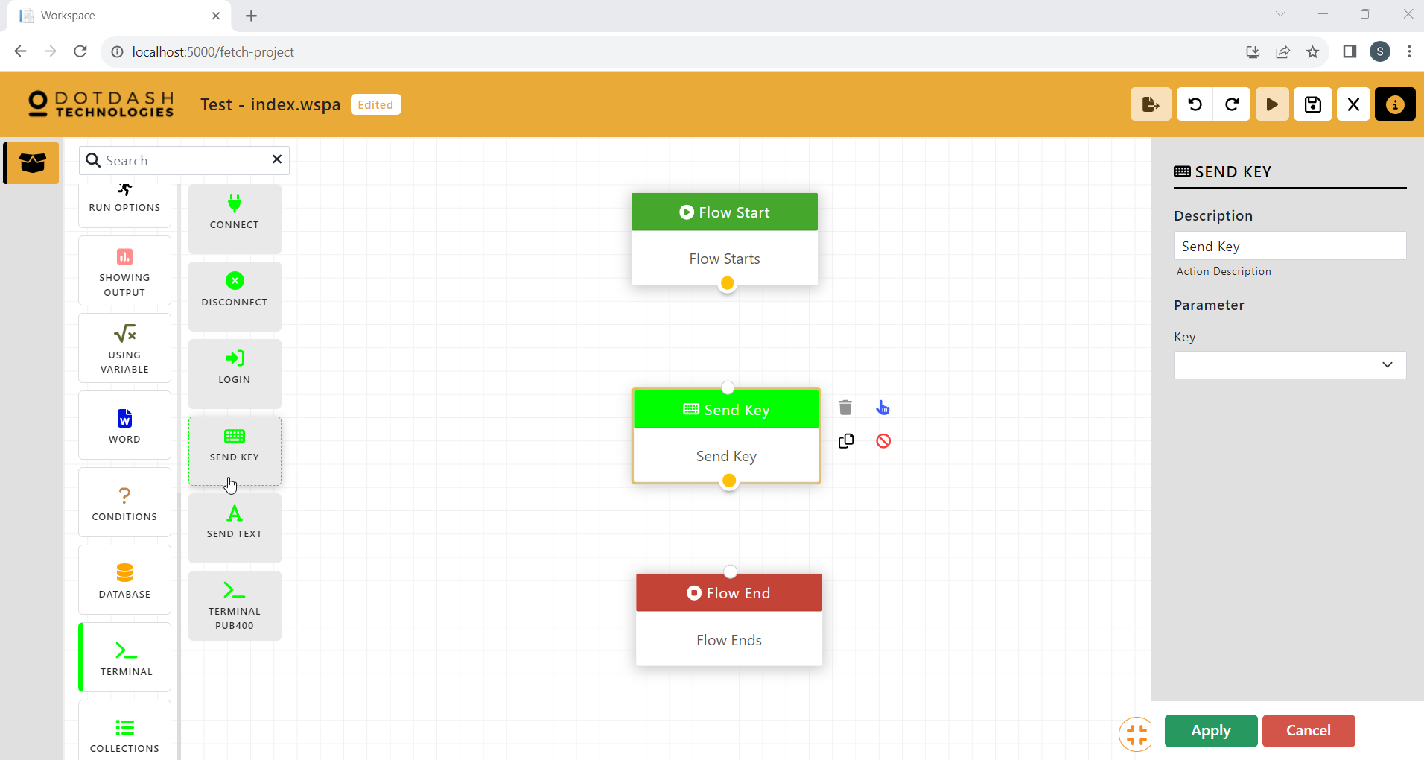

Function:

| Parameter | Description |
| --- | --- |
| Key |  |

#### Send Text

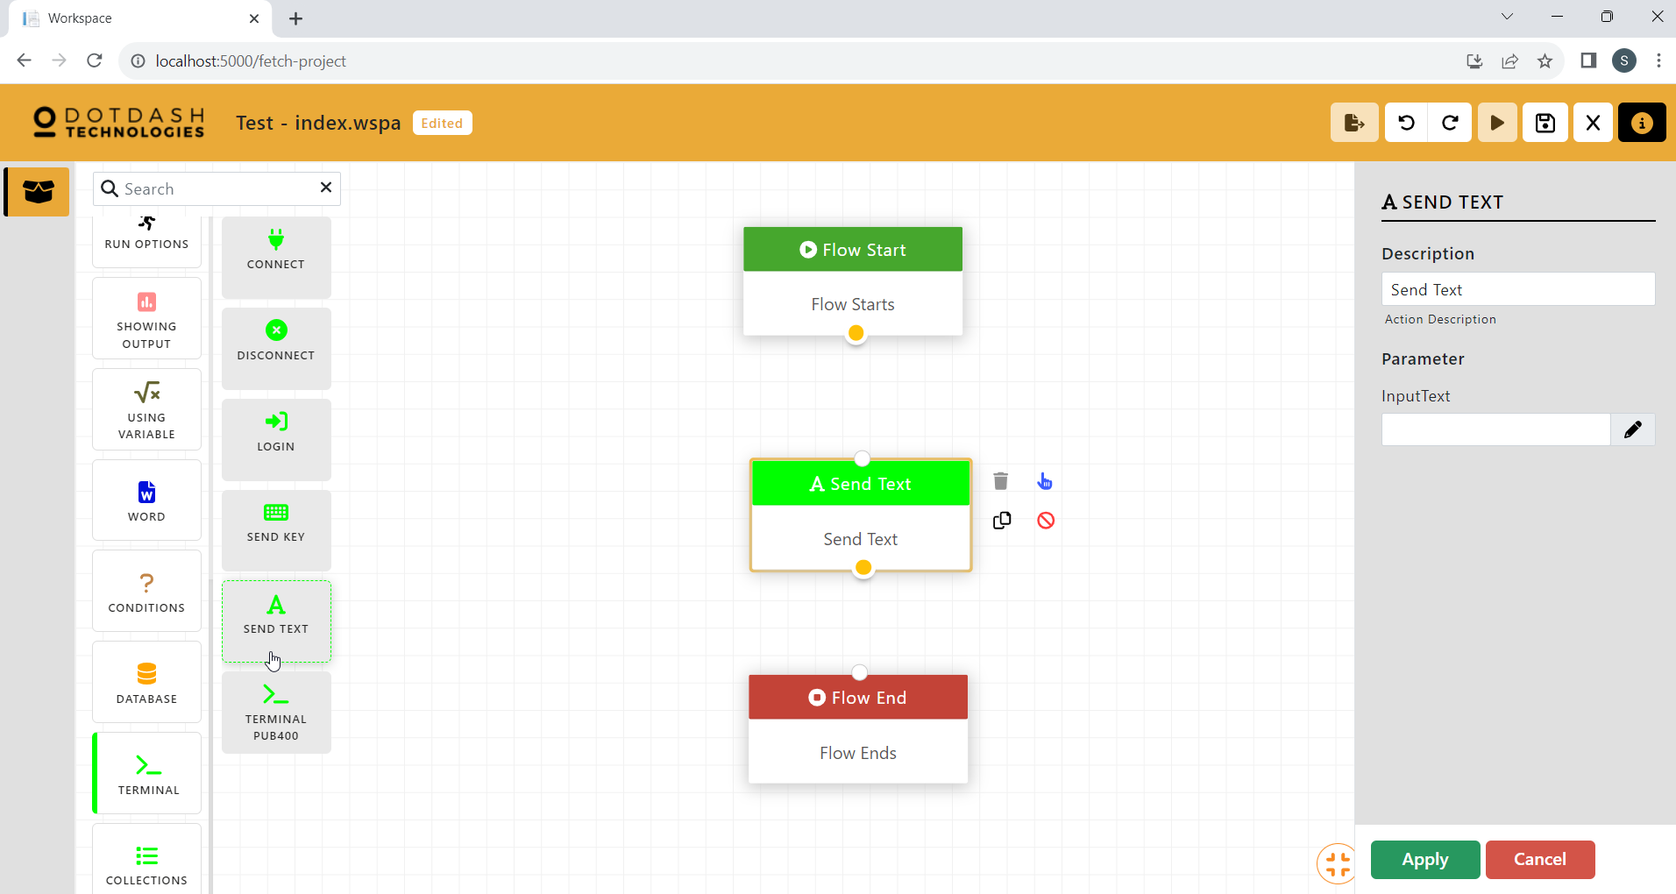

Function:

| Parameter | Description |
| --- | --- |
| InputText |  |

#### Terminal PUB400

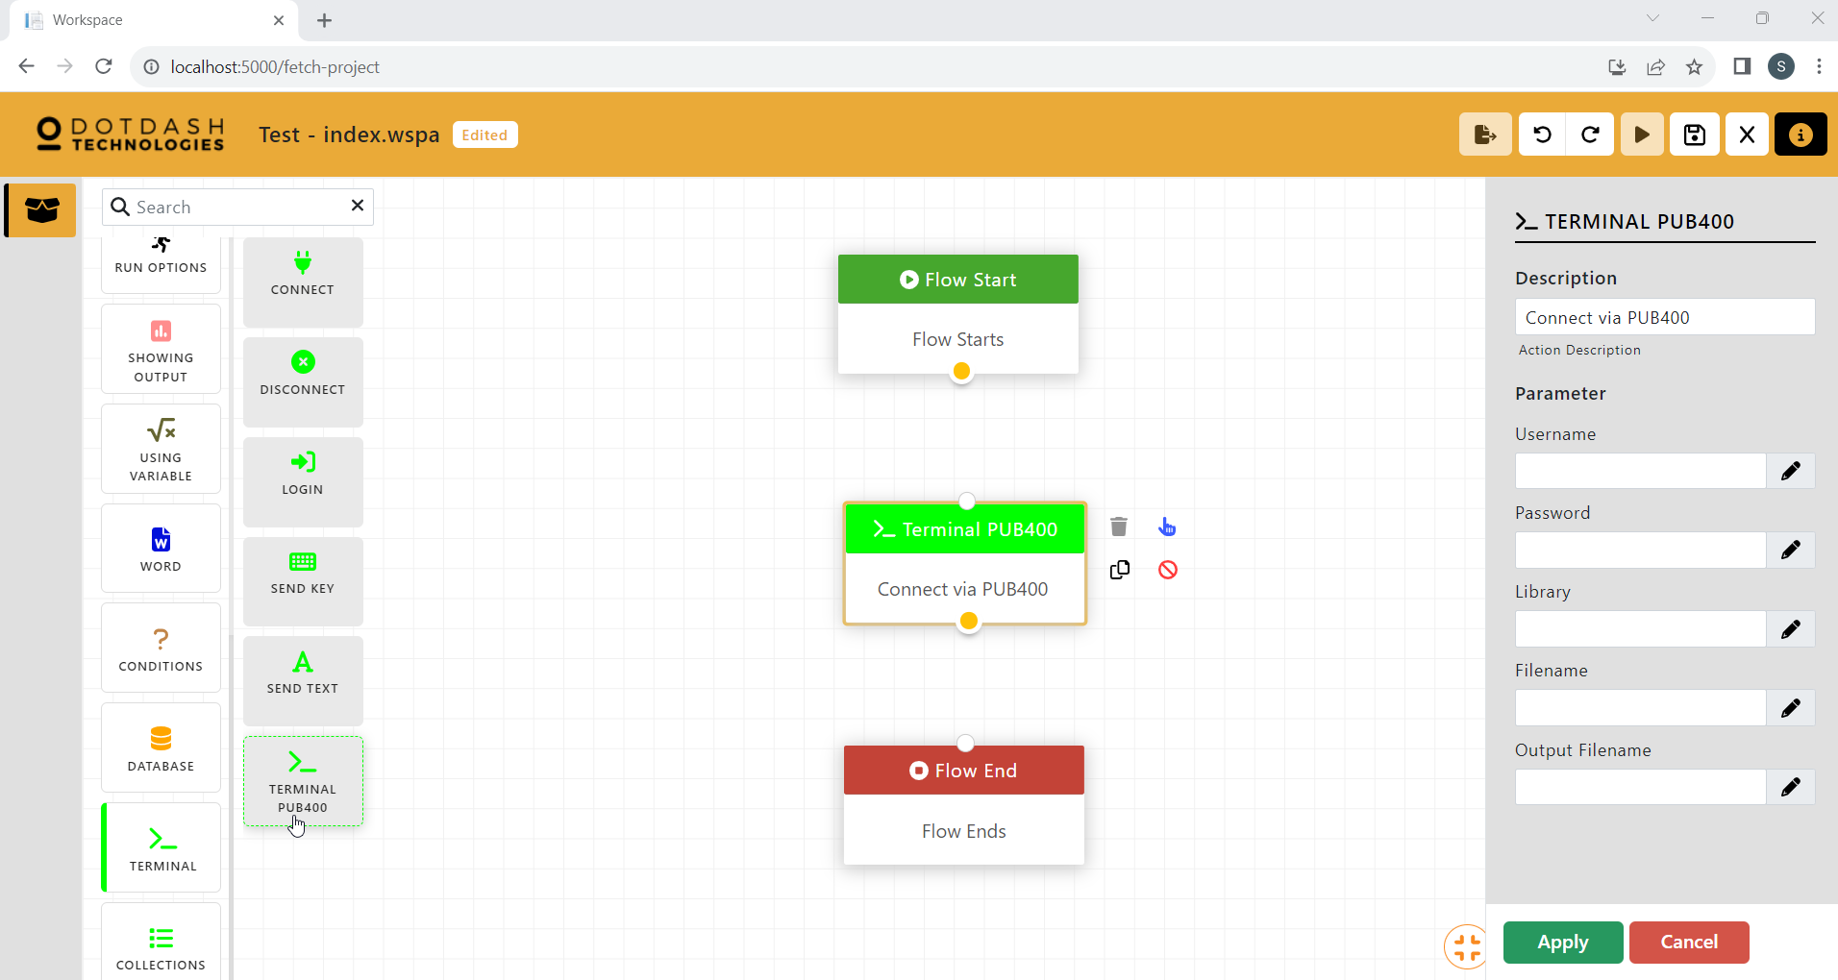

Function:

| Parameter | Description |
| --- | --- |
| Username |  |
| Password |  |
| Library |  |
| Filename |  |
| OutputFIlename |  |

### Collections

#### Create List

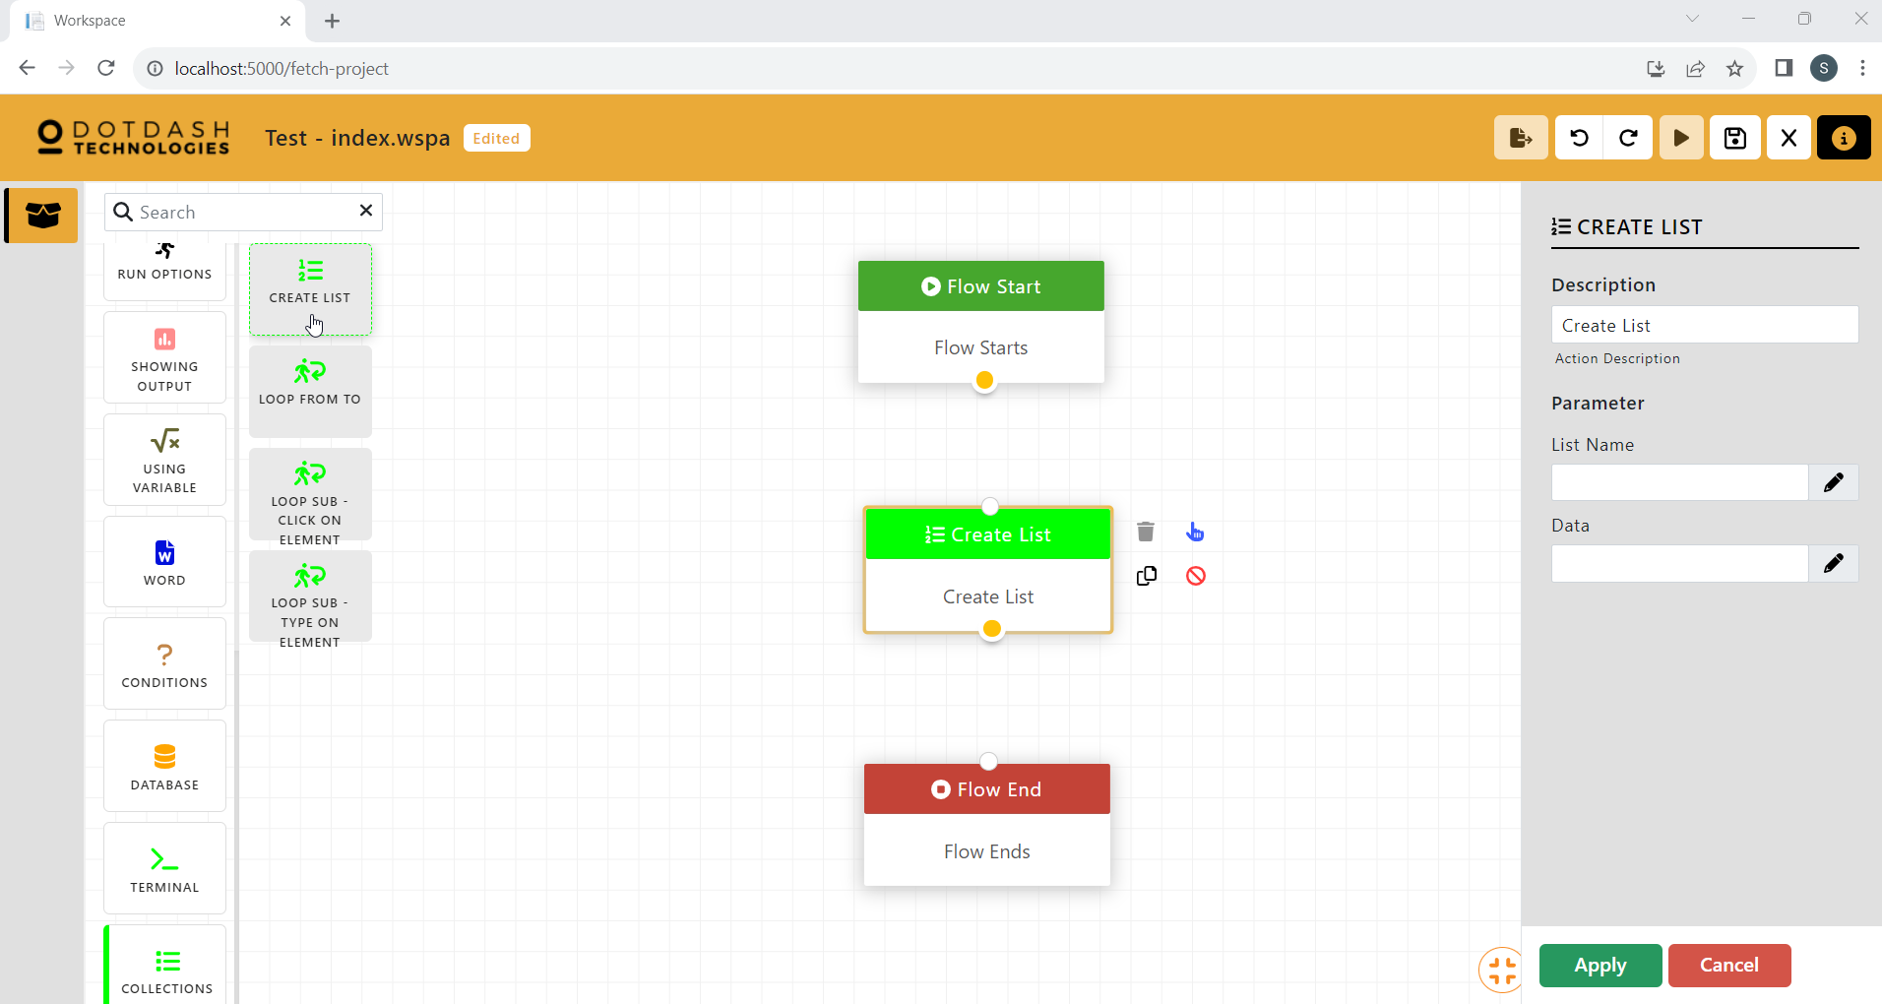

Function: To create a list of data

| Parameter | Description |
| --- | --- |
| List Name | The name of the list |
| Data | The data to store in the list |

#### Loop From To

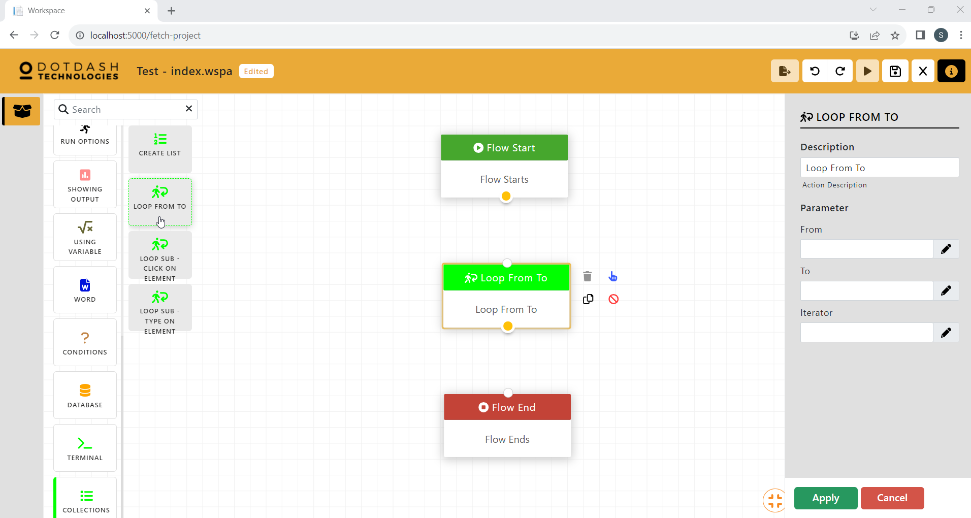

Function: To create a loop

| Parameter | Description |
| --- | --- |
| From |  |
| To |  |
| Iterator |  |

#### Loop Sub - Click On Element

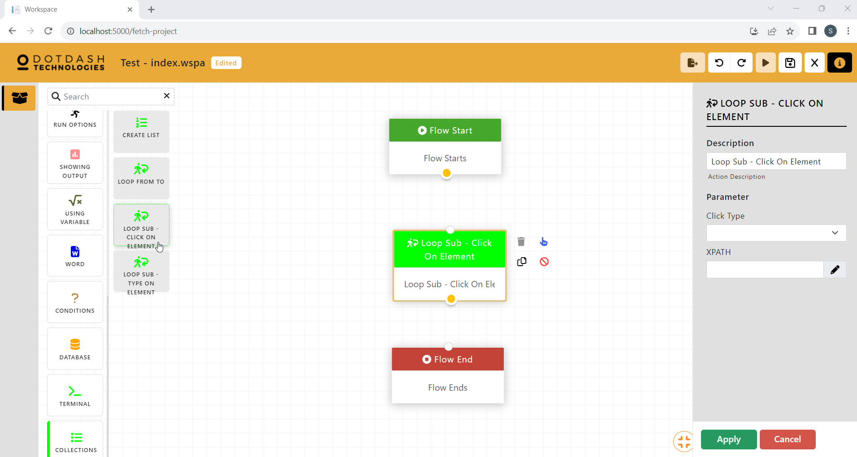

Function: Click on XPATH

| Parameter | Description |
| --- | --- |
| Click Type | Left click, right click or double click. |
| XPATH | XPATH to click. |

#### Loop Sub - Type On Element

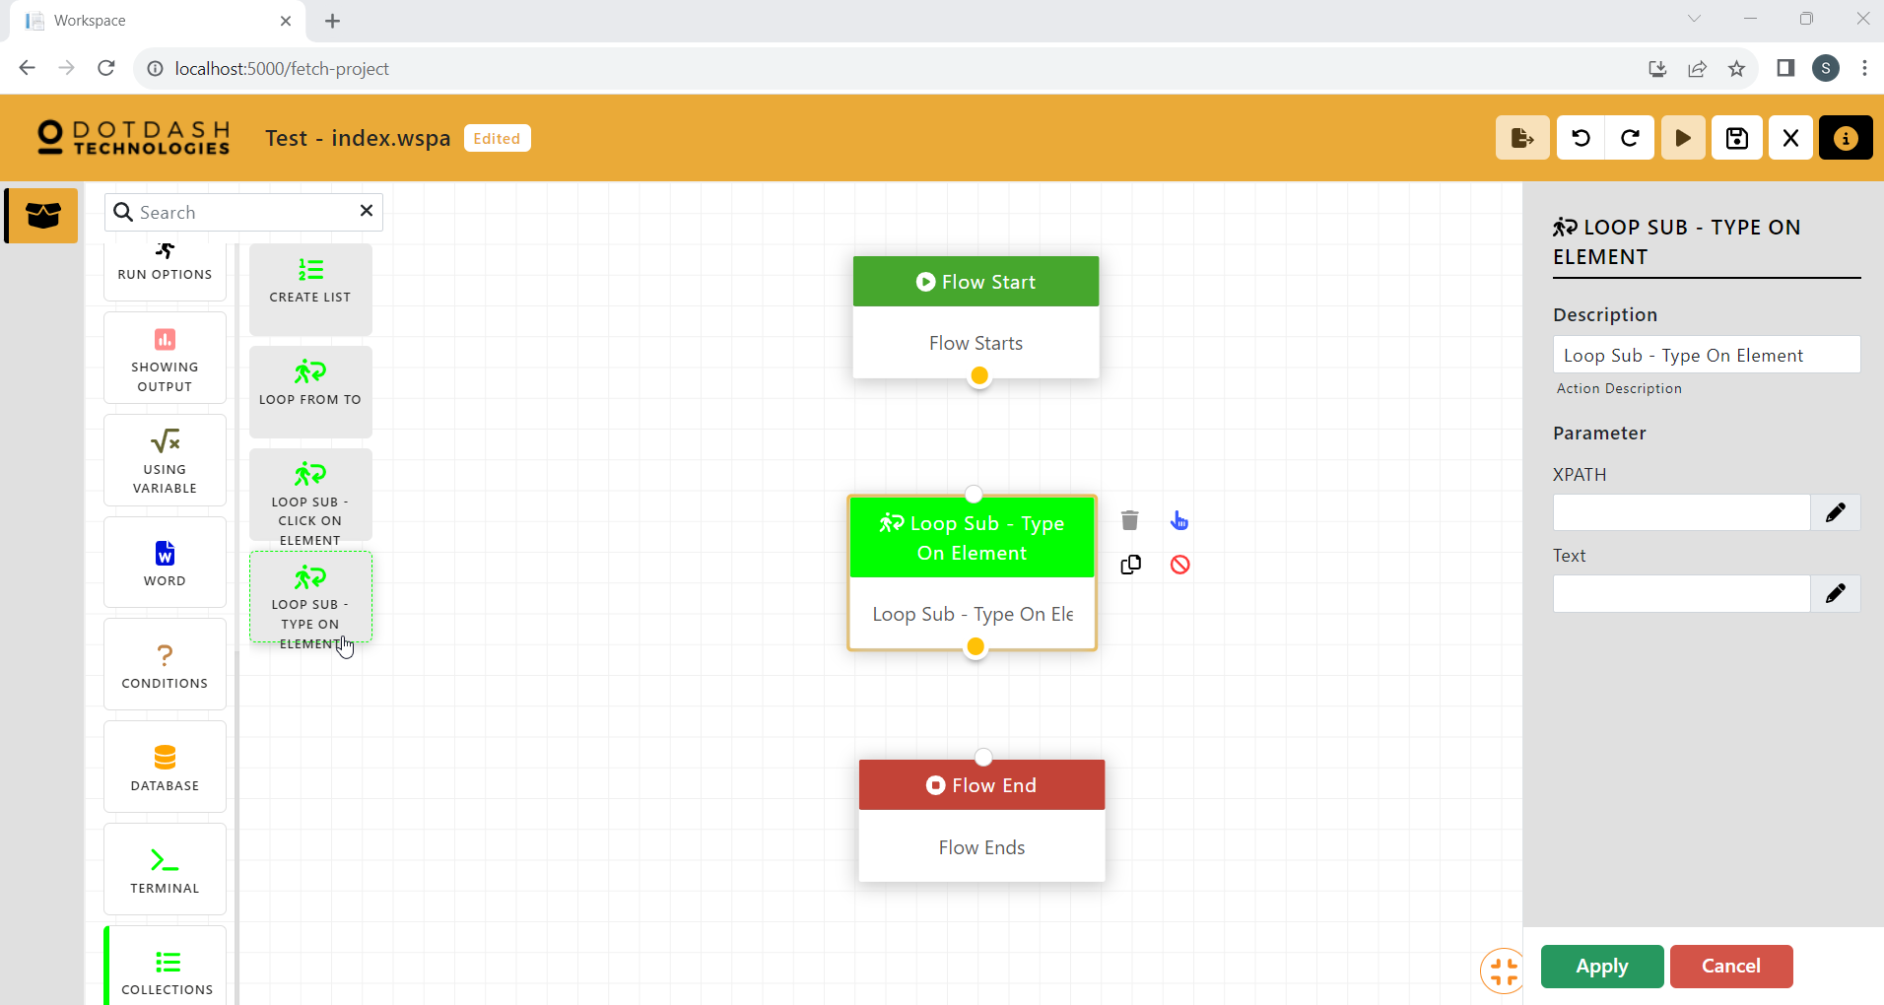

Function: Type array to web element

| Parameter | Description |
| --- | --- |
| XPATH | XPATH of the input bar. |
| Text | Text to type on XPATH. |

#### 

# **Central**

After you have started your bot go to this website (<https://centralapps.azurewebsites.net/login>).

## **Login Page**

Key in your username and password then press login.

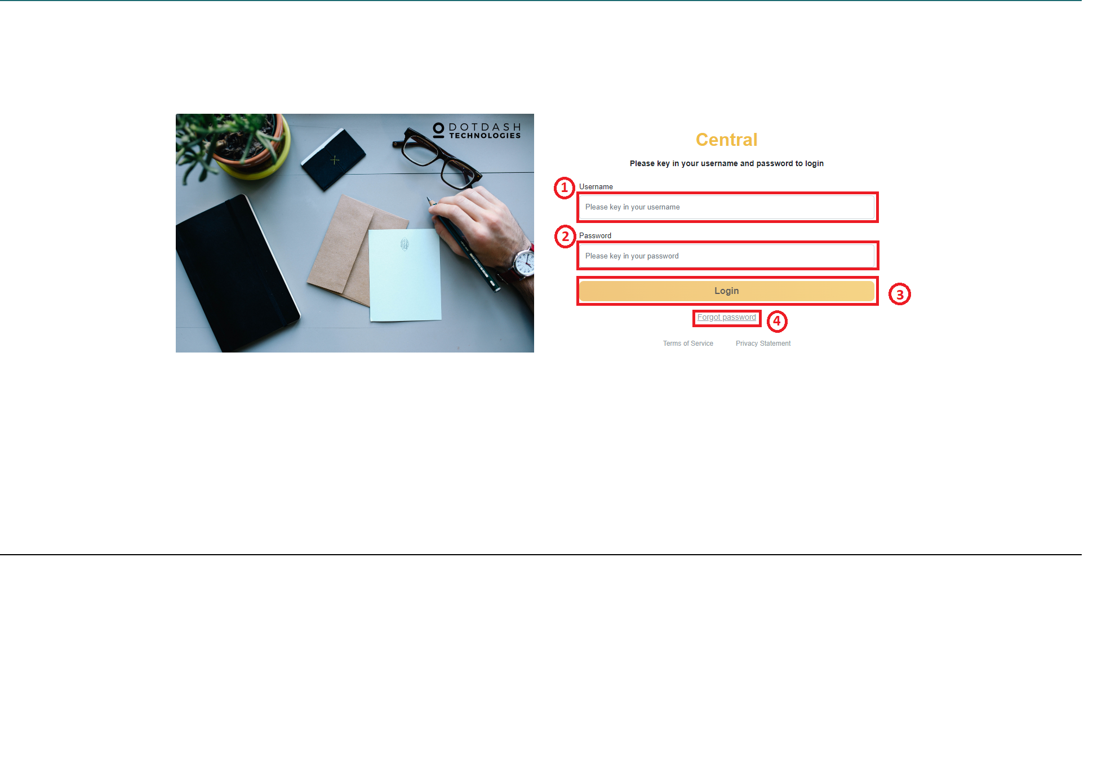

| 1. | Username | Type your Central username. |
| --- | --- | --- |
| 2. | Password | Type your Central password. |
| 3. | Login | Click Login after you have typed in your username and password. |
| 4. | Forgot Password | Redirect you to change your password. |

## **Home Page**

You will be redirected to this Home Page. This page is to let you see what the status of the bot runs on one day.

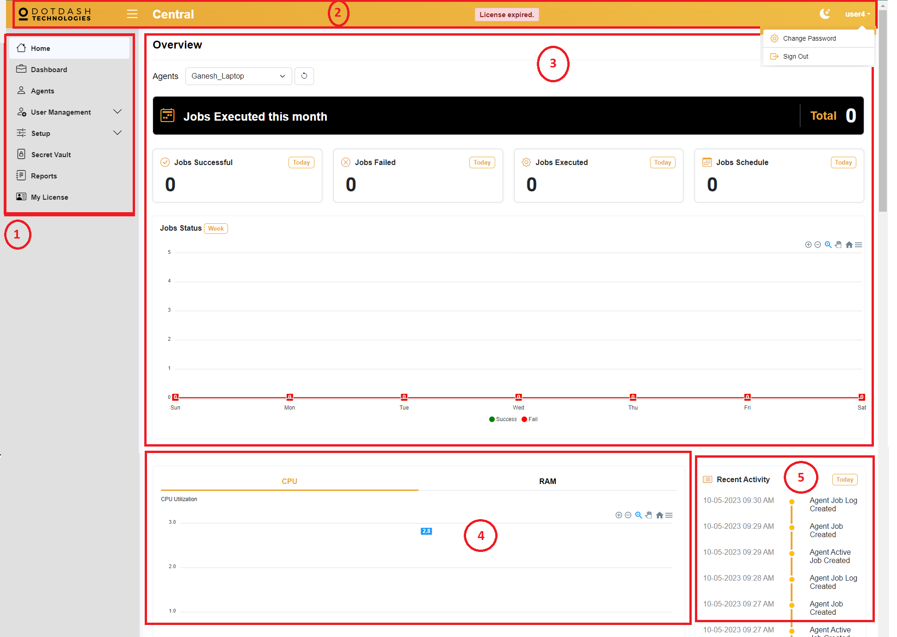

| 1. | Sidebar | You are able to go to another page by clicking the page you want to go to, then you will be redirected to the page. |
| --- | --- | --- |
| 2. | Navigation bar | Navigation bar only lets you do some basic functions such as hide the sidebar by clicking the menu icon on the left side of the “Central”. Other than that, you are able to change the whole UI from light mode to dark mode by clicking the moon icon. The right side of the moon icon is your username, after clicking it you can change your account password or sign out your account. |
| 3. | Overview | This part is to see all the tasks status that ran on your bot. |
| 4. | Utilizations | Here you can see your laptop’s CPU utilization and also RAM utilization after your laptop ran the tasks. |
| 5. | Recent Activity | This is the activity where someone makes changes on the Agents page. |

## **Dashboard Page**

This page lets you see what tasks are the tasks that run on each bot.

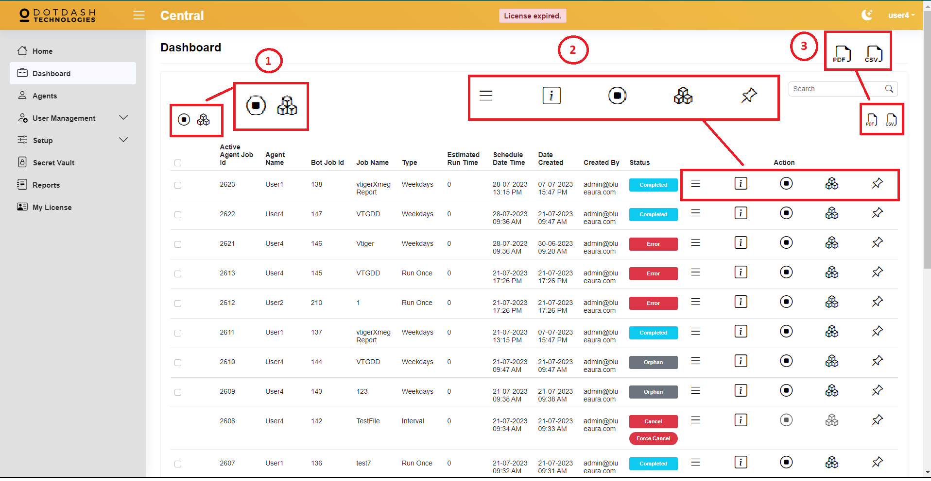

| 1. | Force Cancel & Force Complete | These two functions need you to check one of the items or check all the items before you force cancel or force complete. |
| --- | --- | --- |
| 2. | Actions | **Show Details**  To show what task’s status. For example, was the task submitted, was the task completed, was task running, was the task having error or was the task queuing. |
| **Show Output**  To show the output of the task’s running flow. |
| **Force Cancel**  If you want the task to be canceled, you can cancel the job. |
| **Force Complete**  Is almost the same as force cancel because you can force stop the running job. |
| **Acknowledgement**  You can write remarks for the task. |
| 3. | Download Report | **PDF**  Download the report as PDF format.  **CSV**  Download the report as CSV format. |

## **Agents Page**

This page is the page to schedule your jobs.

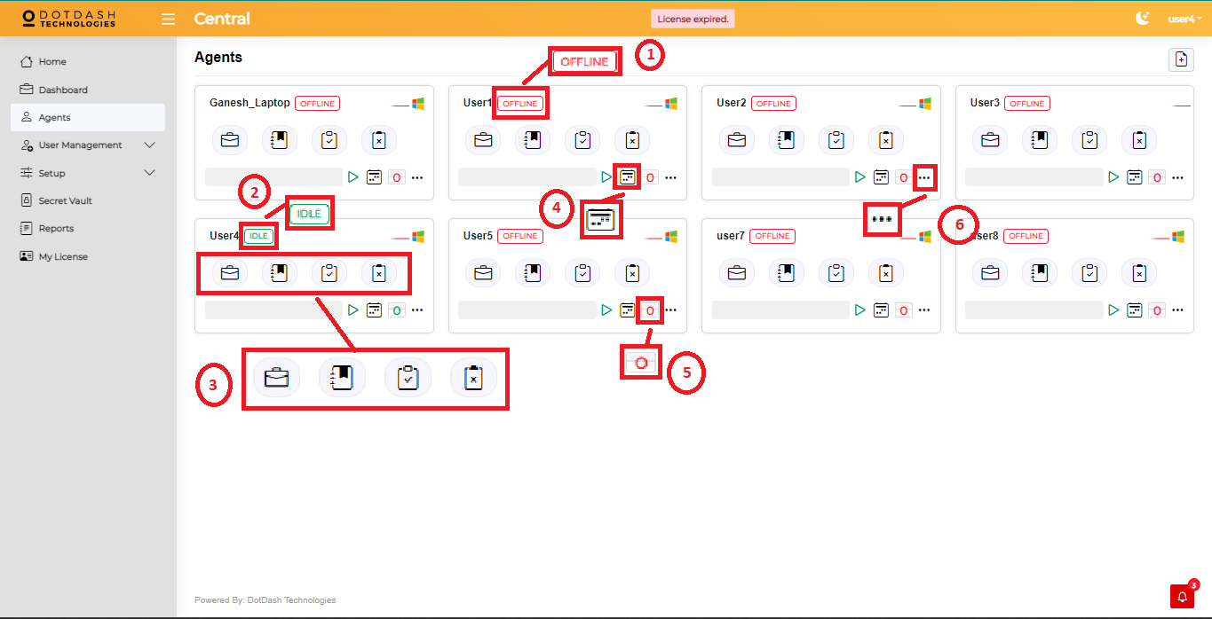

| 1. | OFFLINE | If your bot is not opened, your user’s agent will show you that you are offline. |
| --- | --- | --- |
| 2. | IDLE | If your bot is online you will see the green color border and green color IDLE text beside your bot name. |
| 3. | Actions | **New Job**  To create a new job that you want to schedule. |
| **Schedule Job**  To see what tasks or jobs that you scheduled. |
| **Result**  To see what are the output of the jobs or tasks you created. Failed or Completed or even queuing. |
| **Failed**  To see what are the failed jobs or tasks. |
| 4. | Today's Job | This will show you the job that needs to run today. |
| 5. | Countdown | This countdown is set to 10 seconds and it will refresh the bot every 10 seconds. |
| 6. | More | After clicking the more button, it will have a pop up that shows your agent’s details. |

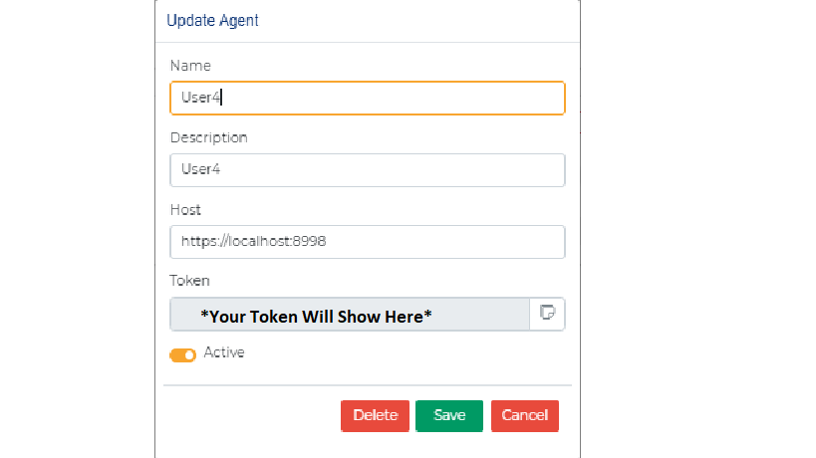

More Pop up

## 

## 

## **User Management > Users**

This page is all the users that are registered to the central.

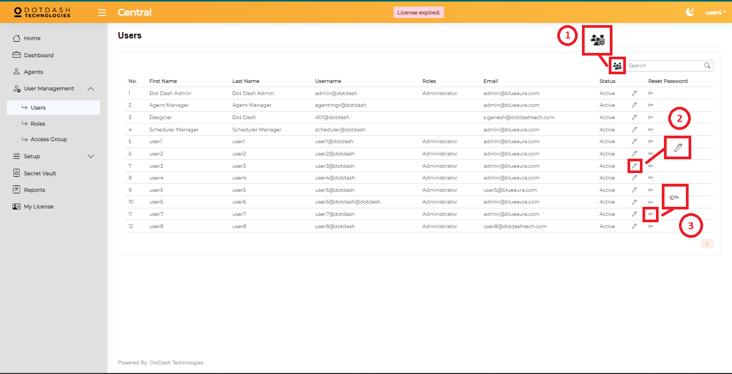

| 1. | Add New User | After clicking the add new user, it will pop up to let you write all the information. |
| --- | --- | --- |
| 2. | Edit User | It will have a pop up to let you edit the user, by clicking the pen button. |
| 3. | Change Password | It will have a pop up to let you change the password of the central. |

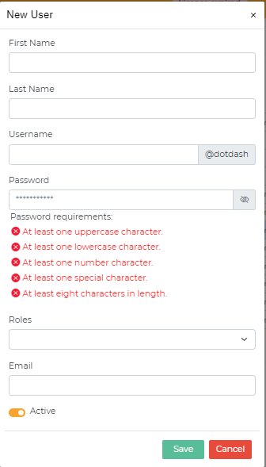

Add New User Pop Up

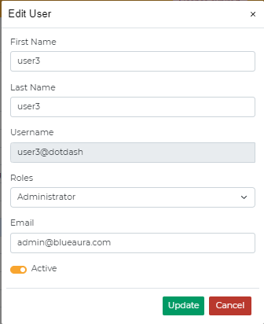

Edit User Pop Up

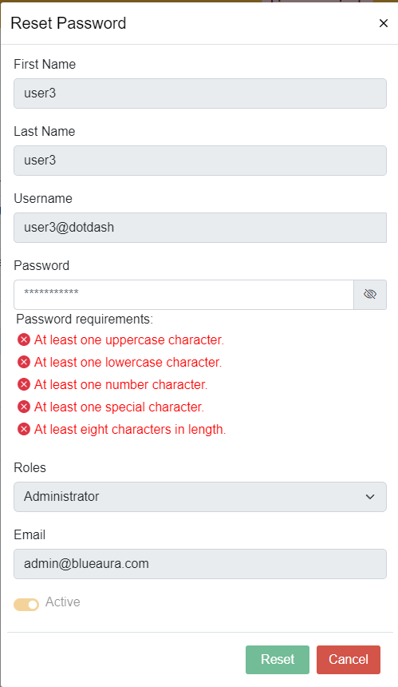

Change Password Pop Up

## **User Management > Roles**

This page is to create and edit user roles.

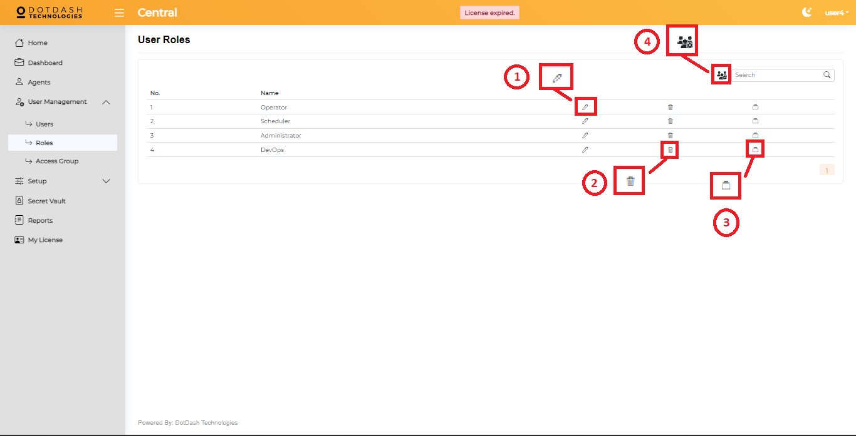

| 1. | Edit | Edit the name of the role. |
| --- | --- | --- |
| 2. | Delete | Delete the role that you do not want. |
| 3. | Access Group | Assign what access group that the role can access. |

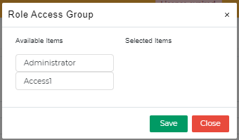

Access Group Pop Up

## 

## **User Management > Access Group**

This page is to assign the page to which the users can access to what page.

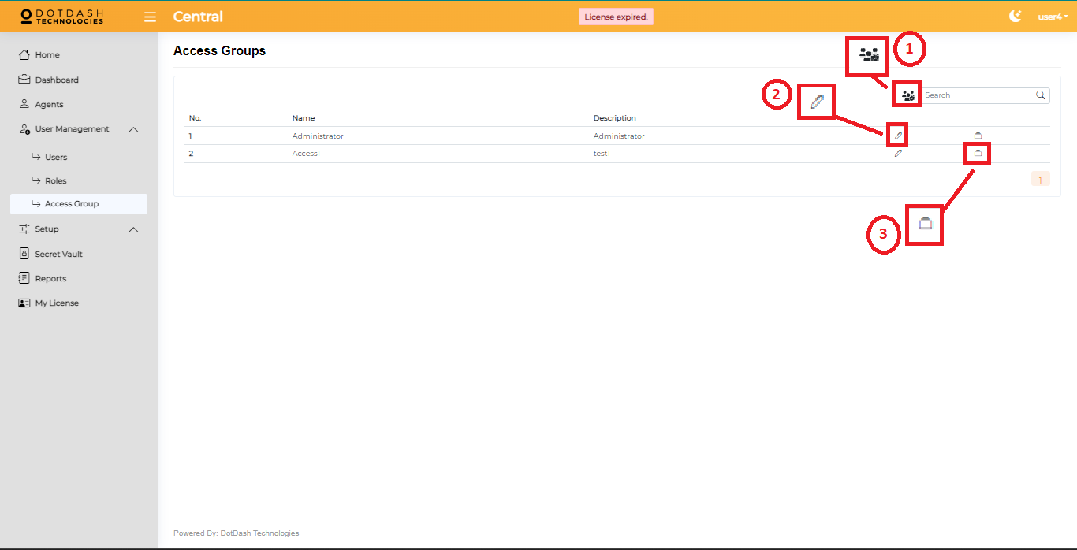

| 1. | Add new access group | Add a new access group for different users. |
| --- | --- | --- |
| 2. | Edit | Edit the name and description to specify different access groups. |
| 3. | Pages | Assign different pages to different access groups to let the users of the access group only can access those pages. |

## **Setup > Public Holiday**

This page is to set the public holiday to let the bot know which day is a public holiday.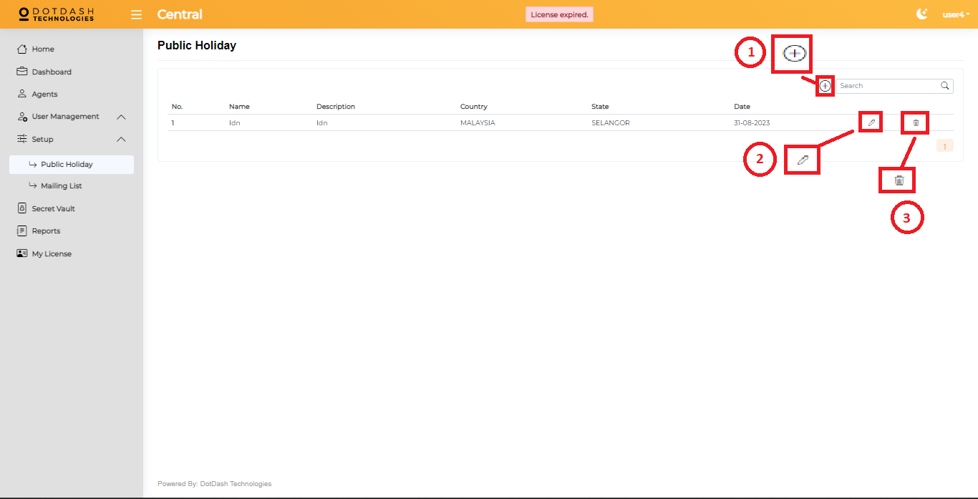

| 1. | Add public holiday | You can add a public holiday to here to let the bot know the day is a public holiday. If you set a public holiday then the bot will not run on that day unless you click run on the public holiday on the “Agents” page > New job. |
| --- | --- | --- |
| 2. | Edit | Edit the details of the public holiday you set. |
| 3. | Delete | Delete the public holiday you have set. |

## **Setup > Mailing List**

This page is to set a group to put a list of emails.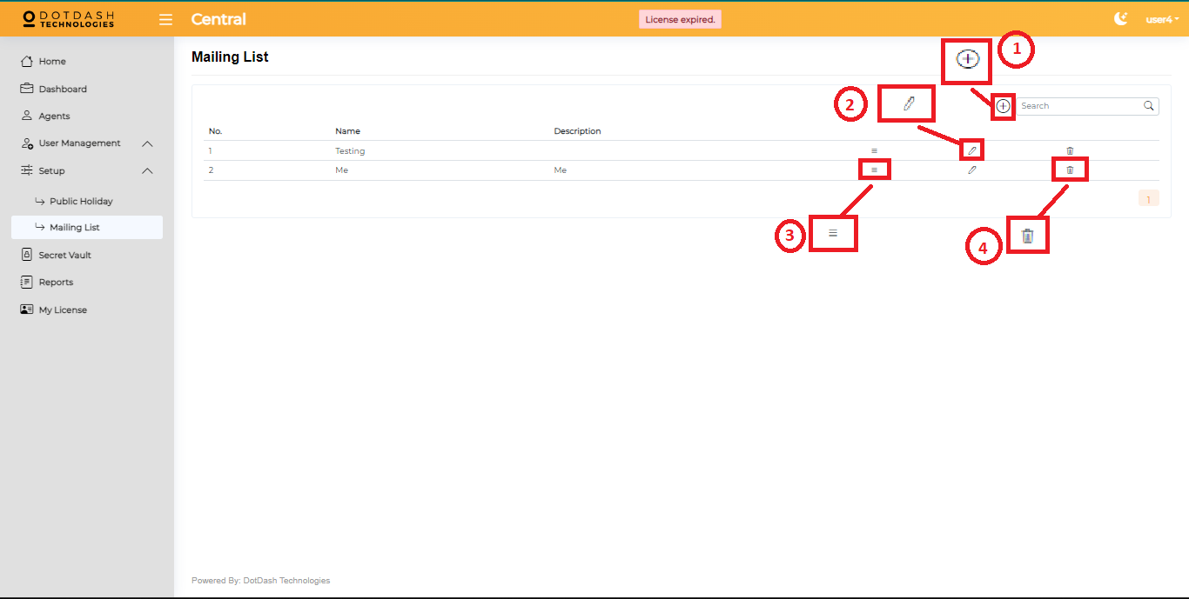

| 1. | Add new mailing list | You can add a new mailing list to put more than one email inside the mailing list. You are able to choose a mailing list on the “Agents” page > New Job. It will send the error message to all the lists of emails inside the mailing list. |
| --- | --- | --- |
| 2. | Show details | After you click on this show details button It will show you a list of emails that are inside a mailing list. |
| 3. | Edit | Edit the name and description to specify a different mailing list. |
| 4. | Delete | Delete the unwanted mailing list. |

### 

### **Show Details**

This page is to put your email that you want the error message to be sent to.

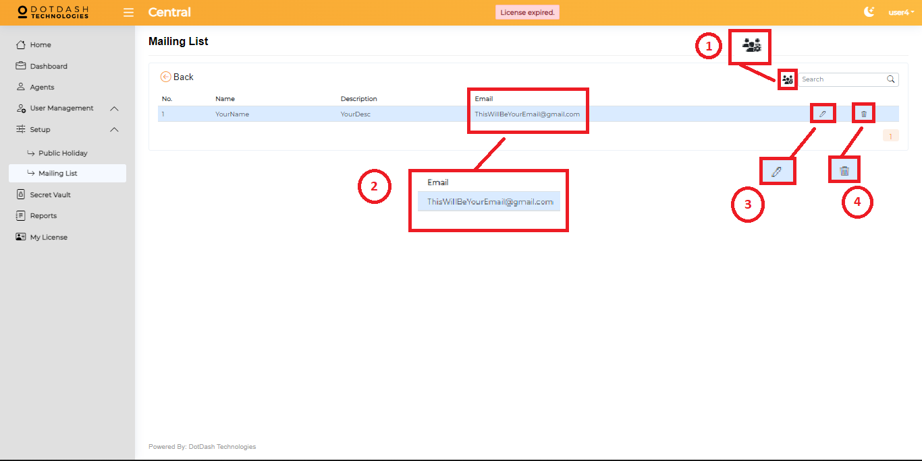

| 1. | Add new email | Add a new email that you want the error message to be sent to. |
| --- | --- | --- |
| 2. | Email | This email will receive the error message if the job or task was failed. |
| 3. | Edit | Edit the name, description and email. |
| 4. | Delete | Delete the email you don't want the error message to send to. |

## 

## **Secret Vault**

This page is to put your secret, password or something that you want it to be hidden. Workspace has the action called “Vault - Get Secret”, this action will get what secret set on this page.

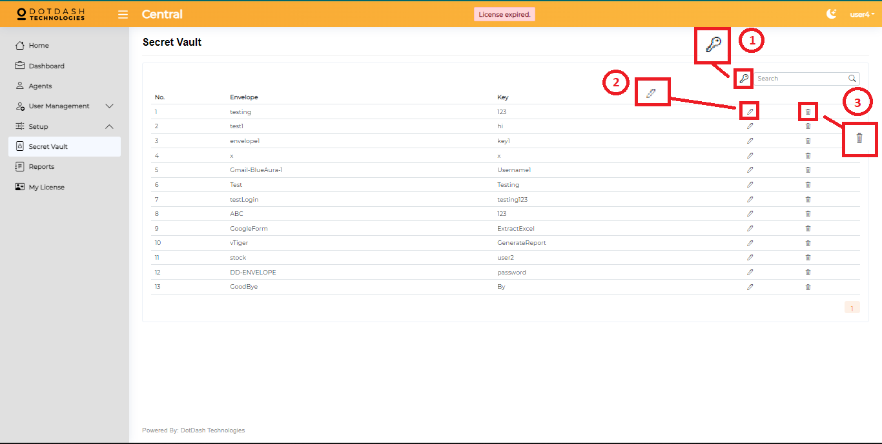

| 1. | Add new secret | You can add a new secret to hide and use on workspace’s action. |
| --- | --- | --- |
| 2. | Edit secret | Edit the secret you want to change, change the secret or envelope or even the key. |
| 3. | Delete secret | Delete the unwanted secret. |

## 

## 

## **Reporting page**

This page is to generate reports of different parts.

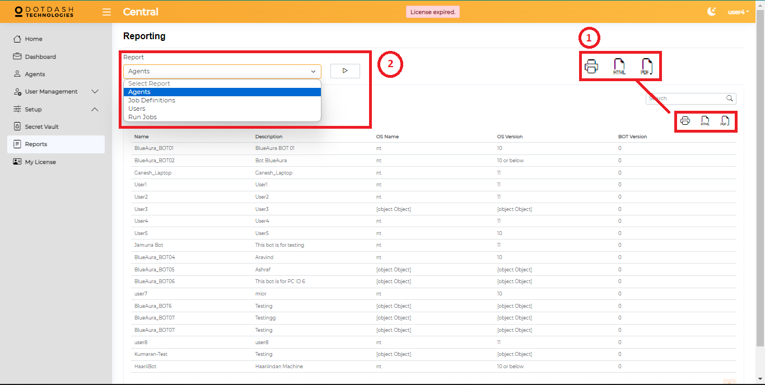

| 1. | Get Report | **Print**  You can print out the report you want.  **HTML**  Download the report as HTML format.  **PDF**  Download the report as PDF format. |
| --- | --- | --- |
| 2. | Reports | You can get different parts of the reports. For example, Agents, Job Definitions, Users and Run Jobs reports. |

## 

## 

## **My License page**

This page is to review the central details.

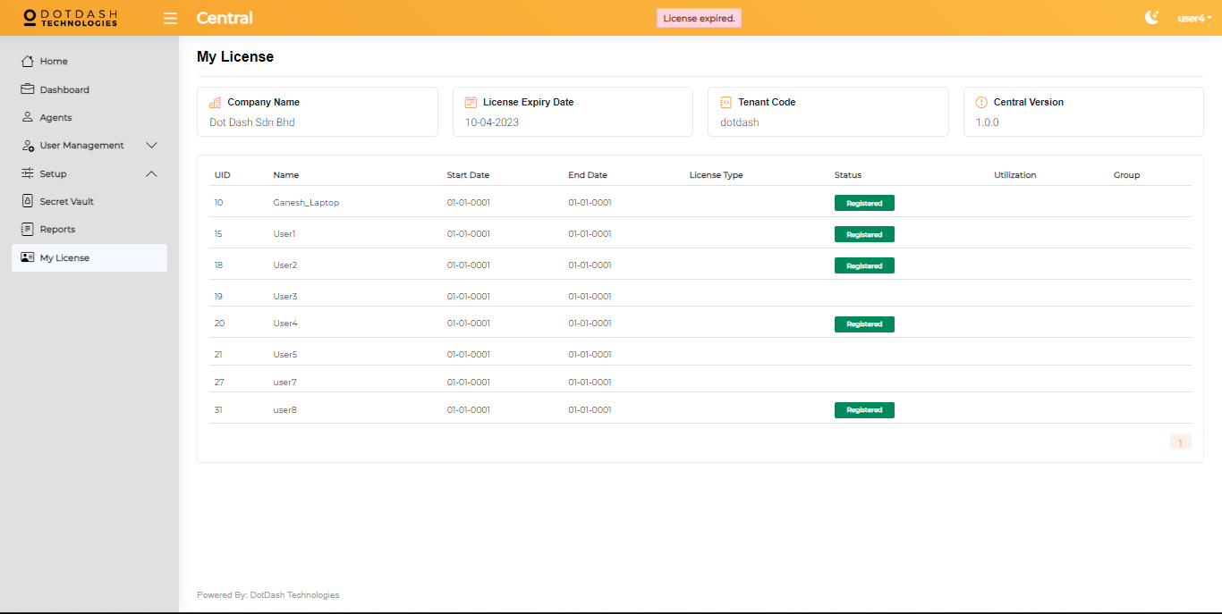

You are able to review the company name, license expiry date, tenant code and central version. Other than that, you are also able to review all the users license status.

# 

# 

# **Bot**

1. Double click “ddbot.exe” which is located in the folder “C:\DDRPA\BOT\app”. An icon will appear in the hidden icon tray.

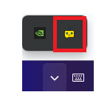

*Image 10 ddbot icon*

1. Double click “RPAAgentManager.WorkerService.exe” which is located in the folder “C:\DDRPA\BOT\app\ddbotmanager\”. A command prompt will appear, minimize it.
2. In Central, the bot status should become “Idle”.

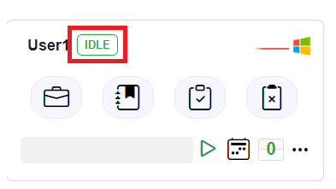

*Image 11 Bot status*

## **Additional Functions**

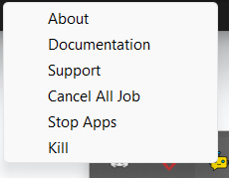

1. **About:** This is just showing you the bot’s details.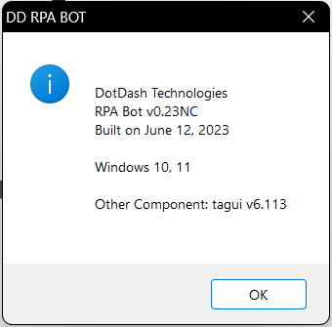
2. **Documentation:** Redirect you to the DotDash Technologies website.
3. **Support:** You will see a pop up message showing you the support details.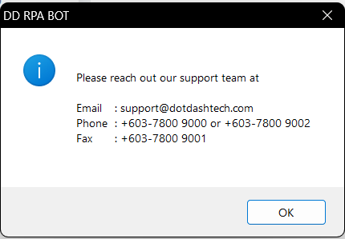
4. **Cancel All Job:** If your job results are showing you the job is in queue and the job does not start, there might be any hidden job not completely run but you are not able to see it, you can just click this cancel all jobs to cancel all the jobs that are stuck.
5. **Stop Apps:** Stop the bot and you will see the pop up message. You can just leave it until it auto closes.

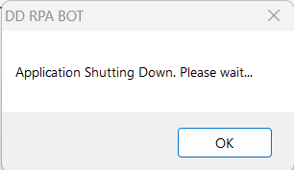

1. **Kill:** Kill is to kill the bot and close the bot, it will close the bot and not pop up a message.